Annexe 1
de la circulaire du directeur des contributions
ECHA - n° 3 du 2020

Description de tous les champs du fichier AEOI_FATCA_V3.0 à envoyer pour l’échange FATCA.

Introduction

Ce document sert à décrire les différentes balises définies dans le schéma « AEOI_FATCA » v 3.0.

Le document a été généré en automatique sur base du schéma l’XSD. L’ACD impose cependant quelques restrictions supplémentaires qui sont documentées dans la circulaire ECHA - n° 3 au chapitre « 3. Caractéristiques du rapport à envoyer ».

L’enveloppe AEOI_FATCA avec les renseignements de contact et le message de type « ZeroReporting » ont évolué de la version 2.0 vers la version 3.0.

La sous-structure FATCA reste inchangée par rapport au schéma AEOI_FATCA version 2.0.

Schema AEOI_FATCA_V3.0.xsd

schema location: | AEOI_FATCA_V3.0.xsd
attributeFormDefault: | unqualified
elementFormDefault: | qualified
targetNamespace: | urn:lu:etat:acd:aeoi_fatca:v3.0

Elements | Complex types
AEOI_LUX | AEOI_FATCA

schema location: | FATCA_LUX_V2.0.xsd
attributeFormDefault: | unqualified
elementFormDefault: | qualified
targetNamespace: | urn:lu:etat:acd:fatca:v2.0

Elements | Complex types | Simple types
FATCA_LUX | AccountHolder_Type | FatcaAcctHolderType_EnumType
 | AdditionalData_Type | FatcaAcctPoolReportType_EnumType
 | CARRef_Type | FatcaDocTypeIndic_EnumType
 | CorrectableAccountReport_Type | FatcaFilerCategory_EnumType
 | CorrectableNilReport_Type | FatcaPaymentType_EnumType
 | CorrectablePoolReport_Type
 | CorrectableReportOrganisation_Type
 | DocSpec_Type
 | Fatca_Type
 | FIAccountNumber_Type
 | Payment_Type
 | SubstantialOwner_Type

schema location: | AEOI_LUX_V3.0.xsd
attributeFormDefault: | unqualified
elementFormDefault: | qualified
targetNamespace: | urn:lu:etat:acd:aeoi_lux:v3.0

Complex types | Simple types
AEOI_ADDRESS | City
AEOI_Depositor | EmailAddress
AEOI_PERSON | FirstName
AEOI_ReportingFI_Type | GIIN_Identifier_Type
 | Id_with_Extension_Type
 | Identifier_Extension_Type
 | Name
 | Number
 | PersonalIdentificationNumber
 | POBOX
 | PostalCode
 | ReportingPeriod
 | ReportRefId_Type
 | Street
 | Telephone
 | ZeroReport

schema location: | isofatcatypes_v1.1.xsd
attributeFormDefault: | unqualified
elementFormDefault: | qualified
targetNamespace: | urn:oecd:ties:isofatcatypes:v1

Simple types
CountryCode_Type
currCode_Type

schema location: | stffatcatypes_v2.0.xsd
attributeFormDefault: | unqualified
elementFormDefault: | qualified
targetNamespace: | urn:oecd:ties:stffatcatypes:v2

Complex types | Simple types
Address_Type | MessageType_EnumType
AddressFix_Type | StringMax10_Type
MessageSpec_Type | StringMax200_Type
MonAmnt_Type | StringMax4000_Type
NameOrganisation_Type | StringMin1Max200_Type
NamePerson_Type | TwoDigFract_Type
OrganisationParty_Type
PersonParty_Type
TIN_Type

schema location: | oecdtypes_v4.2.xsd
attributeFormDefault: | unqualified
elementFormDefault: | qualified
targetNamespace: | urn:oecd:ties:stf:v4

Simple types
AcctNumberType_EnumType
OECDLegalAddressType_EnumType
OECDNameType_EnumType

schema location: | ISO_COUNTRY_CODES_V2.0.xsd
attributeFormDefault: | unqualified
elementFormDefault: | qualified
targetNamespace: | urn:lu:etat:acd:aeoi:iso_cntry:v2

Simple types
CountryCode_Type

element AEOI_LUX
diagram | 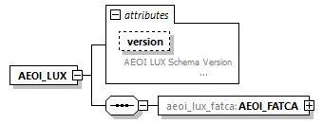
namespace | urn:lu:etat:acd:aeoi_fatca:v3.0
properties | content complex
children | aeoi_lux_fatca:AEOI_FATCA
attributes | Name Type Use Default Fixed Annotation  version xsd:string documentation AEOI LUX Schema Version
source | <xsd:element name="AEOI_LUX">  <xsd:complexType>  <xsd:annotation>  <xsd:documentation>The report - must contain one type of report format in the scope of the automatic exchange of information. It defines the purpose an use of the XML.  Currently supported reports: FATCA, CRS/DAC2  </xsd:documentation>  </xsd:annotation>  <xsd:sequence>  <xsd:element name="AEOI_FATCA" type="aeoi_lux_fatca:AEOI_FATCA"/>  </xsd:sequence>  <xsd:attribute name="version" type="xsd:string">  <xsd:annotation>  <xsd:documentation xml:lang="en">AEOI LUX Schema Version  </xsd:documentation>  </xsd:annotation>  </xsd:attribute>  </xsd:complexType>  </xsd:element>

attribute AEOI_LUX/@version
type | xsd:string
annotation | documentation  AEOI LUX Schema Version
source | <xsd:attribute name="version" type="xsd:string">  <xsd:annotation>  <xsd:documentation xml:lang="en">AEOI LUX Schema Version  </xsd:documentation>  </xsd:annotation>  </xsd:attribute>

element AEOI_LUX/AEOI_FATCA
diagram | 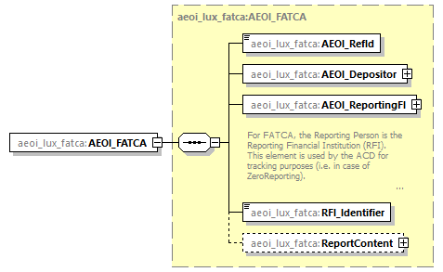
namespace | urn:lu:etat:acd:aeoi_fatca:v3.0
type | aeoi_lux_fatca:AEOI_FATCA
properties | content complex
children | aeoi_lux_fatca:AEOI_RefId aeoi_lux_fatca:AEOI_Depositor aeoi_lux_fatca:AEOI_ReportingFI aeoi_lux_fatca:RFI_Identifier aeoi_lux_fatca:ReportContent
source | <xsd:element name="AEOI_FATCA" type="aeoi_lux_fatca:AEOI_FATCA"/>

complexType AEOI_FATCA
diagram | 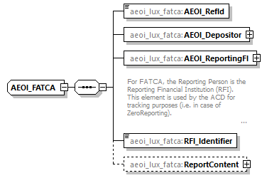
namespace | urn:lu:etat:acd:aeoi_fatca:v3.0
children | aeoi_lux_fatca:AEOI_RefId aeoi_lux_fatca:AEOI_Depositor aeoi_lux_fatca:AEOI_ReportingFI aeoi_lux_fatca:RFI_Identifier aeoi_lux_fatca:ReportContent
used by | element AEOI_LUX/AEOI_FATCA
source | <xsd:complexType name="AEOI_FATCA">  <xsd:sequence minOccurs="1" maxOccurs="1">  <!-- Report Reference Identificator -->  <xsd:element name="AEOI_RefId" type="aeoi:ReportRefId_Type" minOccurs="1" maxOccurs="1"/>  <xsd:element name="AEOI_Depositor" type="aeoi:AEOI_Depositor" minOccurs="1" maxOccurs="1"/>  <xsd:element name="AEOI_ReportingFI" type="aeoi:AEOI_ReportingFI_Type" minOccurs="1" maxOccurs="1">  <xsd:annotation>  <xsd:documentation>  For FATCA, the Reporting Person is the Reporting Financial Institution (RFI).  This element is used by the ACD for tracking purposes (i.e. in case of ZeroReporting).  </xsd:documentation>  </xsd:annotation>  </xsd:element>  <!-- The GIIN is specific Identifier for the FATCA and absolutely mandatory -->  <xsd:element name="RFI_Identifier" type="aeoi:GIIN_Identifier_Type" minOccurs="1" maxOccurs="1"/>  <!-- The Deposit and report is optional, but if one is existing the other is required -->  <xsd:element name="ReportContent" minOccurs="0" maxOccurs="1">  <xsd:complexType>  <xsd:sequence minOccurs="1" maxOccurs="1">  <xsd:element name="ReportingPeriod" type="aeoi:ReportingPeriod" minOccurs="1" maxOccurs="1"/>  <xsd:choice minOccurs="1" maxOccurs="1">  <xsd:element ref="fatca:FATCA_LUX"/>  <xsd:element name="ZeroReporting" type="aeoi:ZeroReport"/>  </xsd:choice>  </xsd:sequence>  </xsd:complexType>  </xsd:element>  </xsd:sequence>  </xsd:complexType>

element AEOI_FATCA/AEOI_RefId
diagram | 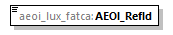
namespace | urn:lu:etat:acd:aeoi_fatca:v3.0
type | aeoi:ReportRefId_Type
properties | content simple
facets | Kind Value Annotation  minLength 1  maxLength 100
source | <xsd:element name="AEOI_RefId" type="aeoi:ReportRefId_Type" minOccurs="1" maxOccurs="1"/>

element AEOI_FATCA/AEOI_Depositor
diagram | 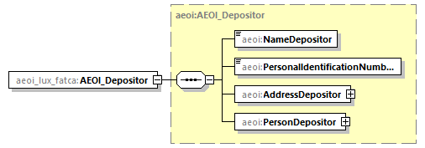
namespace | urn:lu:etat:acd:aeoi_fatca:v3.0
type | aeoi:AEOI_Depositor
properties | content complex
children | aeoi:NameDepositor aeoi:PersonalIdentificationNumberDepositor aeoi:AddressDepositor aeoi:PersonDepositor
source | <xsd:element name="AEOI_Depositor" type="aeoi:AEOI_Depositor" minOccurs="1" maxOccurs="1"/>

element AEOI_FATCA/AEOI_ReportingFI
diagram | 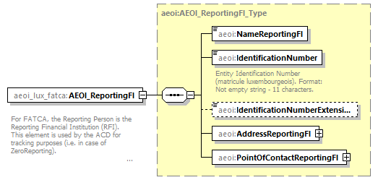
namespace | urn:lu:etat:acd:aeoi_fatca:v3.0
type | aeoi:AEOI_ReportingFI_Type
properties | content complex
children | aeoi:NameReportingFI aeoi:IdentificationNumber aeoi:IdentificationNumberExtension aeoi:AddressReportingFI aeoi:PointOfContactReportingFI
annotation | documentation  For FATCA, the Reporting Person is the Reporting Financial Institution (RFI).  This element is used by the ACD for tracking purposes (i.e. in case of ZeroReporting).
source | <xsd:element name="AEOI_ReportingFI" type="aeoi:AEOI_ReportingFI_Type" minOccurs="1" maxOccurs="1">  <xsd:annotation>  <xsd:documentation>  For FATCA, the Reporting Person is the Reporting Financial Institution (RFI).  This element is used by the ACD for tracking purposes (i.e. in case of ZeroReporting).  </xsd:documentation>  </xsd:annotation>  </xsd:element>

element AEOI_FATCA/RFI_Identifier
diagram | 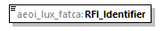
namespace | urn:lu:etat:acd:aeoi_fatca:v3.0
type | aeoi:GIIN_Identifier_Type
properties | content simple
facets | Kind Value Annotation  pattern ([A-NP-Z0-9]{6})(\.)([A-NP-Z0-9]{5})(\.)([A-Z]){2}(\.)(\d){3}
source | <xsd:element name="RFI_Identifier" type="aeoi:GIIN_Identifier_Type" minOccurs="1" maxOccurs="1"/>

element AEOI_FATCA/ReportContent
diagram | 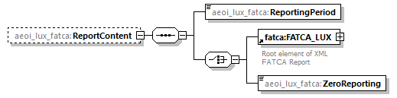
namespace | urn:lu:etat:acd:aeoi_fatca:v3.0
properties | minOcc 0  maxOcc 1  content complex
children | aeoi_lux_fatca:ReportingPeriod ftc:FATCA_LUX aeoi_lux_fatca:ZeroReporting
source | <xsd:element name="ReportContent" minOccurs="0" maxOccurs="1">  <xsd:complexType>  <xsd:sequence minOccurs="1" maxOccurs="1">  <xsd:element name="ReportingPeriod" type="aeoi:ReportingPeriod" minOccurs="1" maxOccurs="1"/>  <xsd:choice minOccurs="1" maxOccurs="1">  <xsd:element ref="fatca:FATCA_LUX"/>  <xsd:element name="ZeroReporting" type="aeoi:ZeroReport"/>  </xsd:choice>  </xsd:sequence>  </xsd:complexType>  </xsd:element>

element AEOI_FATCA/ReportContent/ReportingPeriod
diagram | 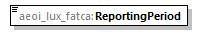
namespace | urn:lu:etat:acd:aeoi_fatca:v3.0
type | aeoi:ReportingPeriod
properties | content simple
facets | Kind Value Annotation  pattern ((2)[0-9]{3})(-)([0-1][0-9])(-)(([0-3])([0-9]))
source | <xsd:element name="ReportingPeriod" type="aeoi:ReportingPeriod" minOccurs="1" maxOccurs="1"/>

element AEOI_FATCA/ReportContent/ZeroReporting
diagram | 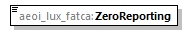
namespace | urn:lu:etat:acd:aeoi_fatca:v3.0
type | aeoi:ZeroReport
properties | content simple
facets | Kind Value Annotation  pattern true|1
source | <xsd:element name="ZeroReporting" type="aeoi:ZeroReport"/>

element FATCA_LUX
diagram | 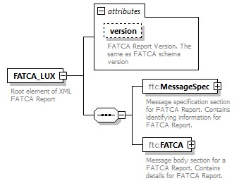
namespace | urn:lu:etat:acd:fatca:v2.0
properties | content complex
children | ftc:MessageSpec ftc:FATCA
used by | element AEOI_FATCA/ReportContent
attributes | Name Type Use Default Fixed Annotation  version sfa:StringMax10_Type documentation FATCA Report Version. The same as FATCA schema version
annotation | documentation  Root element of XML FATCA Report
source | <xsd:element name="FATCA_LUX">  <xsd:annotation>  <xsd:documentation xml:lang="en">Root element of XML FATCA Report</xsd:documentation>  </xsd:annotation>  <xsd:complexType>  <xsd:sequence>  <xsd:element name="MessageSpec" type="sfa:MessageSpec_Type">  <xsd:annotation>  <xsd:documentation xml:lang="en">Message specification section for FATCA Report. Contains identifying information for FATCA Report.</xsd:documentation>  </xsd:annotation>  </xsd:element>  <!-- restriction in Luxemburg: only one Report Body is allowed -->  <xsd:element name="FATCA" type="ftc:Fatca_Type">  <xsd:annotation>  <xsd:documentation xml:lang="en">Message body section for a FATCA Report. Contains details for FATCA Report.</xsd:documentation>  </xsd:annotation>  </xsd:element>  </xsd:sequence>  <xsd:attribute name="version" type="sfa:StringMax10_Type">  <xsd:annotation>  <xsd:documentation xml:lang="en">FATCA Report Version. The same as FATCA schema version</xsd:documentation>  </xsd:annotation>  </xsd:attribute>  </xsd:complexType>  </xsd:element>

attribute FATCA_LUX/@version
type | sfa:StringMax10_Type
facets | Kind Value Annotation  minLength 0  maxLength 10
annotation | documentation  FATCA Report Version. The same as FATCA schema version
source | <xsd:attribute name="version" type="sfa:StringMax10_Type">  <xsd:annotation>  <xsd:documentation xml:lang="en">FATCA Report Version. The same as FATCA schema version</xsd:documentation>  </xsd:annotation>  </xsd:attribute>

element FATCA_LUX/MessageSpec
diagram | 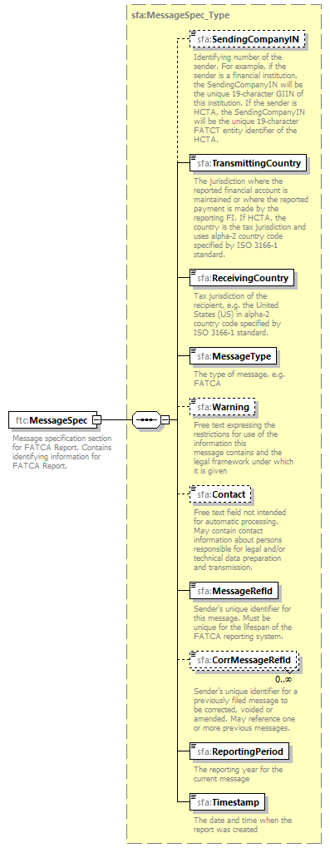
namespace | urn:lu:etat:acd:fatca:v2.0
type | sfa:MessageSpec_Type
properties | content complex
children | sfa:SendingCompanyIN sfa:TransmittingCountry sfa:ReceivingCountry sfa:MessageType sfa:Warning sfa:Contact sfa:MessageRefId sfa:CorrMessageRefId sfa:ReportingPeriod sfa:Timestamp
annotation | documentation  Message specification section for FATCA Report. Contains identifying information for FATCA Report.
source | <xsd:element name="MessageSpec" type="sfa:MessageSpec_Type">  <xsd:annotation>  <xsd:documentation xml:lang="en">Message specification section for FATCA Report. Contains identifying information for FATCA Report.</xsd:documentation>  </xsd:annotation>  </xsd:element>

element FATCA_LUX/FATCA
diagram | 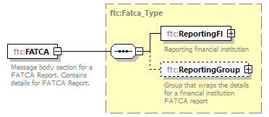
namespace | urn:lu:etat:acd:fatca:v2.0
type | ftc:Fatca_Type
properties | content complex
children | ftc:ReportingFI ftc:ReportingGroup
annotation | documentation  Message body section for a FATCA Report. Contains details for FATCA Report.
source | <xsd:element name="FATCA" type="ftc:Fatca_Type">  <xsd:annotation>  <xsd:documentation xml:lang="en">Message body section for a FATCA Report. Contains details for FATCA Report.</xsd:documentation>  </xsd:annotation>  </xsd:element>

complexType AccountHolder_Type
diagram | 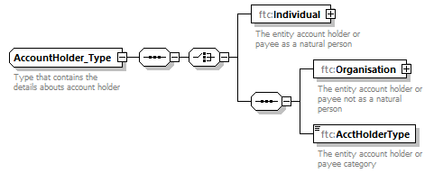
namespace | urn:lu:etat:acd:fatca:v2.0
children | ftc:Individual ftc:Organisation ftc:AcctHolderType
used by | element CorrectableAccountReport_Type/AccountHolder
annotation | documentation  Type that contains the details abouts account holder
source | <xsd:complexType name="AccountHolder_Type">  <xsd:annotation>  <xsd:documentation xml:lang="en">Type that contains the details abouts account holder</xsd:documentation>  </xsd:annotation>  <xsd:sequence>  <xsd:choice>  <xsd:element name="Individual" type="sfa:PersonParty_Type">  <xsd:annotation>  <xsd:documentation xml:lang="en">The entity account holder or payee as a natural person</xsd:documentation>  </xsd:annotation>  </xsd:element>  <xsd:sequence>  <xsd:element name="Organisation" type="sfa:OrganisationParty_Type">  <xsd:annotation>  <xsd:documentation xml:lang="en">The entity account holder or payee not as a natural person</xsd:documentation>  </xsd:annotation>  </xsd:element>  <xsd:element name="AcctHolderType" type="ftc:FatcaAcctHolderType_EnumType">  <xsd:annotation>  <xsd:documentation xml:lang="en">The entity account holder or payee category</xsd:documentation>  </xsd:annotation>  </xsd:element>  </xsd:sequence>  </xsd:choice>  </xsd:sequence>  </xsd:complexType>

element AccountHolder_Type/Individual
diagram | 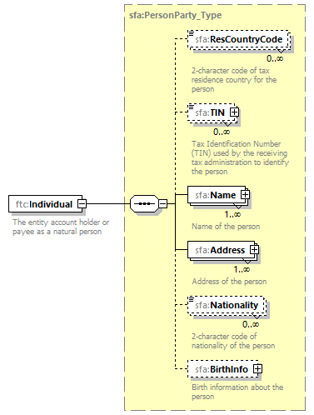
namespace | urn:lu:etat:acd:fatca:v2.0
type | sfa:PersonParty_Type
properties | content complex
children | sfa:ResCountryCode sfa:TIN sfa:Name sfa:Address sfa:Nationality sfa:BirthInfo
annotation | documentation  The entity account holder or payee as a natural person
source | <xsd:element name="Individual" type="sfa:PersonParty_Type">  <xsd:annotation>  <xsd:documentation xml:lang="en">The entity account holder or payee as a natural person</xsd:documentation>  </xsd:annotation>  </xsd:element>

element AccountHolder_Type/Organisation
diagram | 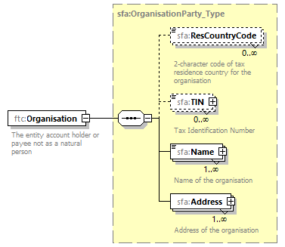
namespace | urn:lu:etat:acd:fatca:v2.0
type | sfa:OrganisationParty_Type
properties | content complex
children | sfa:ResCountryCode sfa:TIN sfa:Name sfa:Address
annotation | documentation  The entity account holder or payee not as a natural person
source | <xsd:element name="Organisation" type="sfa:OrganisationParty_Type">  <xsd:annotation>  <xsd:documentation xml:lang="en">The entity account holder or payee not as a natural person</xsd:documentation>  </xsd:annotation>  </xsd:element>

element AccountHolder_Type/AcctHolderType
diagram | 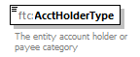
namespace | urn:lu:etat:acd:fatca:v2.0
type | ftc:FatcaAcctHolderType_EnumType
properties | content simple
facets | Kind Value Annotation  enumeration FATCA101 documentation Owner-Documented FFI with specified U.S. owner(s)  enumeration FATCA102 documentation Passive NFFE with substantial U.S. owner(s)  enumeration FATCA103 documentation Non-Participating FFI  enumeration FATCA104 documentation Specified U.S. Person  enumeration FATCA105 documentation Direct Reporting NFFE  enumeration FATCA106 documentation For U.S. Government Use Only (Attention to FIs and HCTAs: Restricted, Do Not Use)
annotation | documentation  The entity account holder or payee category
source | <xsd:element name="AcctHolderType" type="ftc:FatcaAcctHolderType_EnumType">  <xsd:annotation>  <xsd:documentation xml:lang="en">The entity account holder or payee category</xsd:documentation>  </xsd:annotation>  </xsd:element>

complexType AdditionalData_Type
diagram | 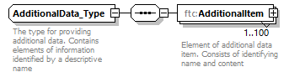
namespace | urn:lu:etat:acd:fatca:v2.0
children | ftc:AdditionalItem
used by | element CorrectableAccountReport_Type/AdditionalData
annotation | documentation  The type for providing additional data. Contains elements of information identified by a descriptive name
source | <xsd:complexType name="AdditionalData_Type">  <xsd:annotation>  <xsd:documentation>The type for providing additional data. Contains elements of information identified by a descriptive name</xsd:documentation>  </xsd:annotation>  <xsd:sequence>  <xsd:element name="AdditionalItem" minOccurs="1" maxOccurs="100">  <xsd:annotation>  <xsd:documentation>Element of additional data item. Consists of identifying name and content</xsd:documentation>  </xsd:annotation>  <xsd:complexType>  <xsd:sequence>  <xsd:element name="ItemName" type="sfa:StringMax200_Type">  <xsd:annotation>  <xsd:documentation xml:lang="en">Identifying name of the additional data item</xsd:documentation>  </xsd:annotation>  </xsd:element>  <xsd:element name="ItemContent" type="sfa:StringMax4000_Type">  <xsd:annotation>  <xsd:documentation xml:lang="en">Content of the additional data item</xsd:documentation>  </xsd:annotation>  </xsd:element>  </xsd:sequence>  </xsd:complexType>  </xsd:element>  </xsd:sequence>  </xsd:complexType>

element AdditionalData_Type/AdditionalItem
diagram | 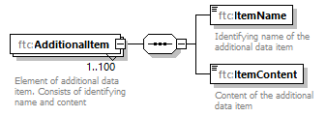
namespace | urn:lu:etat:acd:fatca:v2.0
properties | minOcc 1  maxOcc 100  content complex
children | ftc:ItemName ftc:ItemContent
annotation | documentation  Element of additional data item. Consists of identifying name and content
source | <xsd:element name="AdditionalItem" minOccurs="1" maxOccurs="100">  <xsd:annotation>  <xsd:documentation>Element of additional data item. Consists of identifying name and content</xsd:documentation>  </xsd:annotation>  <xsd:complexType>  <xsd:sequence>  <xsd:element name="ItemName" type="sfa:StringMax200_Type">  <xsd:annotation>  <xsd:documentation xml:lang="en">Identifying name of the additional data item</xsd:documentation>  </xsd:annotation>  </xsd:element>  <xsd:element name="ItemContent" type="sfa:StringMax4000_Type">  <xsd:annotation>  <xsd:documentation xml:lang="en">Content of the additional data item</xsd:documentation>  </xsd:annotation>  </xsd:element>  </xsd:sequence>  </xsd:complexType>  </xsd:element>

element AdditionalData_Type/AdditionalItem/ItemName
diagram | 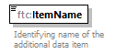
namespace | urn:lu:etat:acd:fatca:v2.0
type | sfa:StringMax200_Type
properties | content simple
facets | Kind Value Annotation  minLength 0  maxLength 200
annotation | documentation  Identifying name of the additional data item
source | <xsd:element name="ItemName" type="sfa:StringMax200_Type">  <xsd:annotation>  <xsd:documentation xml:lang="en">Identifying name of the additional data item</xsd:documentation>  </xsd:annotation>  </xsd:element>

element AdditionalData_Type/AdditionalItem/ItemContent
diagram | 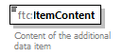
namespace | urn:lu:etat:acd:fatca:v2.0
type | sfa:StringMax4000_Type
properties | content simple
facets | Kind Value Annotation  minLength 0  maxLength 4000
annotation | documentation  Content of the additional data item
source | <xsd:element name="ItemContent" type="sfa:StringMax4000_Type">  <xsd:annotation>  <xsd:documentation xml:lang="en">Content of the additional data item</xsd:documentation>  </xsd:annotation>  </xsd:element>

complexType CARRef_Type
diagram | 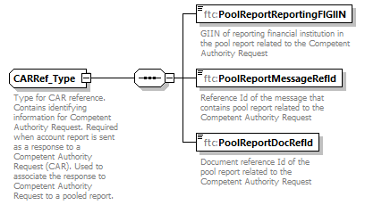
namespace | urn:lu:etat:acd:fatca:v2.0
children | ftc:PoolReportReportingFIGIIN ftc:PoolReportMessageRefId ftc:PoolReportDocRefId
used by | element CorrectableAccountReport_Type/CARRef
annotation | documentation  Type for CAR reference. Contains identifying information for Competent Authority Request. Required when account report is sent as a response to a Competent Authority Request (CAR). Used to associate the response to Competent Authority Request to a pooled report.
source | <xsd:complexType name="CARRef_Type">  <xsd:annotation>  <xsd:documentation>Type for CAR reference. Contains identifying information for Competent Authority Request. Required when account report is sent as a response to a Competent Authority Request (CAR). Used to associate the response to Competent Authority Request to a pooled report.</xsd:documentation>  </xsd:annotation>  <xsd:sequence>  <xsd:element name="PoolReportReportingFIGIIN" type="sfa:StringMax200_Type">  <xsd:annotation>  <xsd:documentation xml:lang="en">GIIN of reporting financial institution in the pool report related to the Competent Authority Request</xsd:documentation>  </xsd:annotation>  </xsd:element>  <xsd:element name="PoolReportMessageRefId" type="sfa:StringMax200_Type">  <xsd:annotation>  <xsd:documentation xml:lang="en">Reference Id of the message that contains pool report related to the Competent Authority Request</xsd:documentation>  </xsd:annotation>  </xsd:element>  <xsd:element name="PoolReportDocRefId" type="sfa:StringMax200_Type">  <xsd:annotation>  <xsd:documentation xml:lang="en">Document reference Id of the pool report related to the Competent Authority Request</xsd:documentation>  </xsd:annotation>  </xsd:element>  </xsd:sequence>  </xsd:complexType>

element CARRef_Type/PoolReportReportingFIGIIN
diagram | 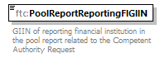
namespace | urn:lu:etat:acd:fatca:v2.0
type | sfa:StringMax200_Type
properties | content simple
facets | Kind Value Annotation  minLength 0  maxLength 200
annotation | documentation  GIIN of reporting financial institution in the pool report related to the Competent Authority Request
source | <xsd:element name="PoolReportReportingFIGIIN" type="sfa:StringMax200_Type">  <xsd:annotation>  <xsd:documentation xml:lang="en">GIIN of reporting financial institution in the pool report related to the Competent Authority Request</xsd:documentation>  </xsd:annotation>  </xsd:element>

element CARRef_Type/PoolReportMessageRefId
diagram | 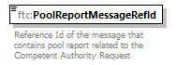
namespace | urn:lu:etat:acd:fatca:v2.0
type | sfa:StringMax200_Type
properties | content simple
facets | Kind Value Annotation  minLength 0  maxLength 200
annotation | documentation  Reference Id of the message that contains pool report related to the Competent Authority Request
source | <xsd:element name="PoolReportMessageRefId" type="sfa:StringMax200_Type">  <xsd:annotation>  <xsd:documentation xml:lang="en">Reference Id of the message that contains pool report related to the Competent Authority Request</xsd:documentation>  </xsd:annotation>  </xsd:element>

element CARRef_Type/PoolReportDocRefId
diagram | 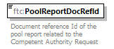
namespace | urn:lu:etat:acd:fatca:v2.0
type | sfa:StringMax200_Type
properties | content simple
facets | Kind Value Annotation  minLength 0  maxLength 200
annotation | documentation  Document reference Id of the pool report related to the Competent Authority Request
source | <xsd:element name="PoolReportDocRefId" type="sfa:StringMax200_Type">  <xsd:annotation>  <xsd:documentation xml:lang="en">Document reference Id of the pool report related to the Competent Authority Request</xsd:documentation>  </xsd:annotation>  </xsd:element>

complexType CorrectableAccountReport_Type
diagram | 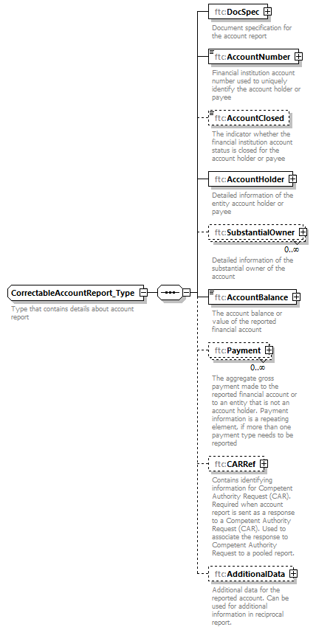
namespace | urn:lu:etat:acd:fatca:v2.0
children | ftc:DocSpec ftc:AccountNumber ftc:AccountClosed ftc:AccountHolder ftc:SubstantialOwner ftc:AccountBalance ftc:Payment ftc:CARRef ftc:AdditionalData
used by | element Fatca_Type/ReportingGroup/AccountReport
annotation | documentation  Type that contains details about account report
source | <xsd:complexType name="CorrectableAccountReport_Type">  <xsd:annotation>  <xsd:documentation xml:lang="en">Type that contains details about account report</xsd:documentation>  </xsd:annotation>  <xsd:sequence>  <xsd:element name="DocSpec" type="ftc:DocSpec_Type">  <xsd:annotation>  <xsd:documentation xml:lang="en">Document specification for the account report</xsd:documentation>  </xsd:annotation>  </xsd:element>  <xsd:element name="AccountNumber" type="ftc:FIAccountNumber_Type">  <xsd:annotation>  <xsd:documentation xml:lang="en">Financial institution account number used to uniquely identify the account holder or payee</xsd:documentation>  </xsd:annotation>  </xsd:element>  <xsd:element name="AccountClosed" type="xsd:boolean" minOccurs="0">  <xsd:annotation>  <xsd:documentation xml:lang="en">The indicator whether the financial institution account status is closed for the account holder or payee</xsd:documentation>  </xsd:annotation>  </xsd:element>  <xsd:element name="AccountHolder" type="ftc:AccountHolder_Type">  <xsd:annotation>  <xsd:documentation xml:lang="en">Detailed information of the entity account holder or payee</xsd:documentation>  </xsd:annotation>  </xsd:element>  <xsd:element name="SubstantialOwner" type="ftc:SubstantialOwner_Type" minOccurs="0" maxOccurs="unbounded">  <xsd:annotation>  <xsd:documentation xml:lang="en">Detailed information of the substantial owner of the account</xsd:documentation>  </xsd:annotation>  </xsd:element>  <xsd:element name="AccountBalance" type="sfa:MonAmnt_Type">  <xsd:annotation>  <xsd:documentation>The account balance or value of the reported financial account</xsd:documentation>  </xsd:annotation>  </xsd:element>  <xsd:element name="Payment" type="ftc:Payment_Type" minOccurs="0" maxOccurs="unbounded">  <xsd:annotation>  <xsd:documentation xml:lang="en">The aggregate gross payment made to the reported financial account or to an entity that is not an account holder. Payment information is a repeating element, if more than one payment type needs to be reported</xsd:documentation>  </xsd:annotation>  </xsd:element>  <xsd:element name="CARRef" type="ftc:CARRef_Type" minOccurs="0">  <xsd:annotation>  <xsd:documentation xml:lang="en">Contains identifying information for Competent Authority Request (CAR). Required when account report is sent as a response to a Competent Authority Request (CAR). Used to associate the response to Competent Authority Request to a pooled report.</xsd:documentation>  </xsd:annotation>  </xsd:element>  <xsd:element name="AdditionalData" type="ftc:AdditionalData_Type" minOccurs="0">  <xsd:annotation>  <xsd:documentation xml:lang="en">Additional data for the reported account. Can be used for additional information in reciprocal report.</xsd:documentation>  </xsd:annotation>  </xsd:element>  </xsd:sequence>  </xsd:complexType>

element CorrectableAccountReport_Type/DocSpec
diagram | 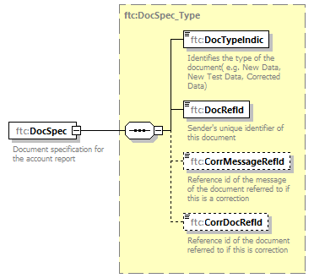
namespace | urn:lu:etat:acd:fatca:v2.0
type | ftc:DocSpec_Type
properties | content complex
children | ftc:DocTypeIndic ftc:DocRefId ftc:CorrMessageRefId ftc:CorrDocRefId
annotation | documentation  Document specification for the account report
source | <xsd:element name="DocSpec" type="ftc:DocSpec_Type">  <xsd:annotation>  <xsd:documentation xml:lang="en">Document specification for the account report</xsd:documentation>  </xsd:annotation>  </xsd:element>

element CorrectableAccountReport_Type/AccountNumber
diagram | 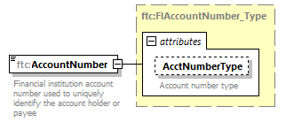
namespace | urn:lu:etat:acd:fatca:v2.0
type | ftc:FIAccountNumber_Type
properties | content complex
facets | Kind Value Annotation  minLength 0  maxLength 200
attributes | Name Type Use Default Fixed Annotation  AcctNumberType stf:AcctNumberType_EnumType optional documentation Account number type
annotation | documentation  Financial institution account number used to uniquely identify the account holder or payee
source | <xsd:element name="AccountNumber" type="ftc:FIAccountNumber_Type">  <xsd:annotation>  <xsd:documentation xml:lang="en">Financial institution account number used to uniquely identify the account holder or payee</xsd:documentation>  </xsd:annotation>  </xsd:element>

element CorrectableAccountReport_Type/AccountClosed
diagram | 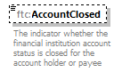
namespace | urn:lu:etat:acd:fatca:v2.0
type | xsd:boolean
properties | minOcc 0  maxOcc 1  content simple
annotation | documentation  The indicator whether the financial institution account status is closed for the account holder or payee
source | <xsd:element name="AccountClosed" type="xsd:boolean" minOccurs="0">  <xsd:annotation>  <xsd:documentation xml:lang="en">The indicator whether the financial institution account status is closed for the account holder or payee</xsd:documentation>  </xsd:annotation>  </xsd:element>

element CorrectableAccountReport_Type/AccountHolder
diagram | 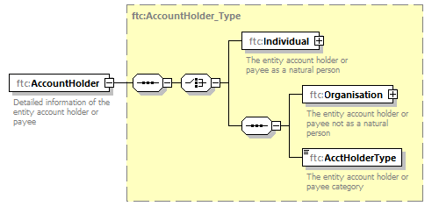
namespace | urn:lu:etat:acd:fatca:v2.0
type | ftc:AccountHolder_Type
properties | content complex
children | ftc:Individual ftc:Organisation ftc:AcctHolderType
annotation | documentation  Detailed information of the entity account holder or payee
source | <xsd:element name="AccountHolder" type="ftc:AccountHolder_Type">  <xsd:annotation>  <xsd:documentation xml:lang="en">Detailed information of the entity account holder or payee</xsd:documentation>  </xsd:annotation>  </xsd:element>

element CorrectableAccountReport_Type/SubstantialOwner
diagram | 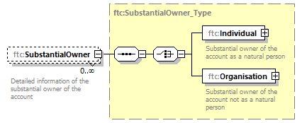
namespace | urn:lu:etat:acd:fatca:v2.0
type | ftc:SubstantialOwner_Type
properties | minOcc 0  maxOcc unbounded  content complex
children | ftc:Individual ftc:Organisation
annotation | documentation  Detailed information of the substantial owner of the account
source | <xsd:element name="SubstantialOwner" type="ftc:SubstantialOwner_Type" minOccurs="0" maxOccurs="unbounded">  <xsd:annotation>  <xsd:documentation xml:lang="en">Detailed information of the substantial owner of the account</xsd:documentation>  </xsd:annotation>  </xsd:element>

element CorrectableAccountReport_Type/AccountBalance
diagram | 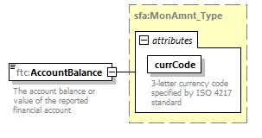
namespace | urn:lu:etat:acd:fatca:v2.0
type | sfa:MonAmnt_Type
properties | content complex
facets | Kind Value Annotation  fractionDigits 2
attributes | Name Type Use Default Fixed Annotation  currCode iso:currCode_Type required documentation 3-letter currency code specified by ISO 4217 standard
annotation | documentation  The account balance or value of the reported financial account
source | <xsd:element name="AccountBalance" type="sfa:MonAmnt_Type">  <xsd:annotation>  <xsd:documentation>The account balance or value of the reported financial account</xsd:documentation>  </xsd:annotation>  </xsd:element>

element CorrectableAccountReport_Type/Payment
diagram | 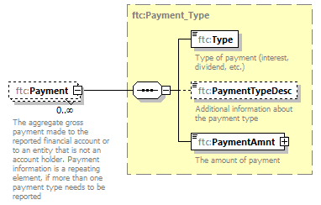
namespace | urn:lu:etat:acd:fatca:v2.0
type | ftc:Payment_Type
properties | minOcc 0  maxOcc unbounded  content complex
children | ftc:Type ftc:PaymentTypeDesc ftc:PaymentAmnt
annotation | documentation  The aggregate gross payment made to the reported financial account or to an entity that is not an account holder. Payment information is a repeating element, if more than one payment type needs to be reported
source | <xsd:element name="Payment" type="ftc:Payment_Type" minOccurs="0" maxOccurs="unbounded">  <xsd:annotation>  <xsd:documentation xml:lang="en">The aggregate gross payment made to the reported financial account or to an entity that is not an account holder. Payment information is a repeating element, if more than one payment type needs to be reported</xsd:documentation>  </xsd:annotation>  </xsd:element>

element CorrectableAccountReport_Type/CARRef
diagram | 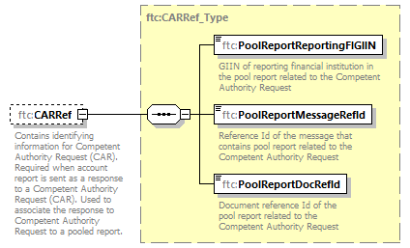
namespace | urn:lu:etat:acd:fatca:v2.0
type | ftc:CARRef_Type
properties | minOcc 0  maxOcc 1  content complex
children | ftc:PoolReportReportingFIGIIN ftc:PoolReportMessageRefId ftc:PoolReportDocRefId
annotation | documentation  Contains identifying information for Competent Authority Request (CAR). Required when account report is sent as a response to a Competent Authority Request (CAR). Used to associate the response to Competent Authority Request to a pooled report.
source | <xsd:element name="CARRef" type="ftc:CARRef_Type" minOccurs="0">  <xsd:annotation>  <xsd:documentation xml:lang="en">Contains identifying information for Competent Authority Request (CAR). Required when account report is sent as a response to a Competent Authority Request (CAR). Used to associate the response to Competent Authority Request to a pooled report.</xsd:documentation>  </xsd:annotation>  </xsd:element>

element CorrectableAccountReport_Type/AdditionalData
diagram | 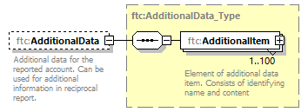
namespace | urn:lu:etat:acd:fatca:v2.0
type | ftc:AdditionalData_Type
properties | minOcc 0  maxOcc 1  content complex
children | ftc:AdditionalItem
annotation | documentation  Additional data for the reported account. Can be used for additional information in reciprocal report.
source | <xsd:element name="AdditionalData" type="ftc:AdditionalData_Type" minOccurs="0">  <xsd:annotation>  <xsd:documentation xml:lang="en">Additional data for the reported account. Can be used for additional information in reciprocal report.</xsd:documentation>  </xsd:annotation>  </xsd:element>

complexType CorrectableNilReport_Type
diagram | 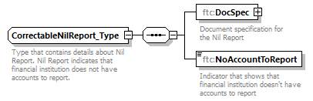
namespace | urn:lu:etat:acd:fatca:v2.0
children | ftc:DocSpec ftc:NoAccountToReport
used by | element Fatca_Type/ReportingGroup/NilReport
annotation | documentation  Type that contains details about Nil Report. Nil Report indicates that financial institution does not have accounts to report.
source | <xsd:complexType name="CorrectableNilReport_Type">  <xsd:annotation>  <xsd:documentation xml:lang="en">Type that contains details about Nil Report. Nil Report indicates that financial institution does not have accounts to report.</xsd:documentation>  </xsd:annotation>  <xsd:sequence>  <xsd:element name="DocSpec" type="ftc:DocSpec_Type">  <xsd:annotation>  <xsd:documentation xml:lang="en">Document specification for the Nil Report</xsd:documentation>  </xsd:annotation>  </xsd:element>  <xsd:element name="NoAccountToReport" type="xsd:string" fixed="yes">  <xsd:annotation>  <xsd:documentation xml:lang="en">Indicator that shows that financial institution doesn't have accounts to report</xsd:documentation>  </xsd:annotation>  </xsd:element>  </xsd:sequence>  </xsd:complexType>

element CorrectableNilReport_Type/DocSpec
diagram | 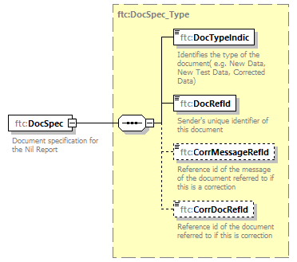
namespace | urn:lu:etat:acd:fatca:v2.0
type | ftc:DocSpec_Type
properties | content complex
children | ftc:DocTypeIndic ftc:DocRefId ftc:CorrMessageRefId ftc:CorrDocRefId
annotation | documentation  Document specification for the Nil Report
source | <xsd:element name="DocSpec" type="ftc:DocSpec_Type">  <xsd:annotation>  <xsd:documentation xml:lang="en">Document specification for the Nil Report</xsd:documentation>  </xsd:annotation>  </xsd:element>

element CorrectableNilReport_Type/NoAccountToReport
diagram | 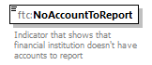
namespace | urn:lu:etat:acd:fatca:v2.0
type | xsd:string
properties | content simple  fixed yes
annotation | documentation  Indicator that shows that financial institution doesn't have accounts to report
source | <xsd:element name="NoAccountToReport" type="xsd:string" fixed="yes">  <xsd:annotation>  <xsd:documentation xml:lang="en">Indicator that shows that financial institution doesn't have accounts to report</xsd:documentation>  </xsd:annotation>  </xsd:element>

complexType CorrectablePoolReport_Type
diagram | 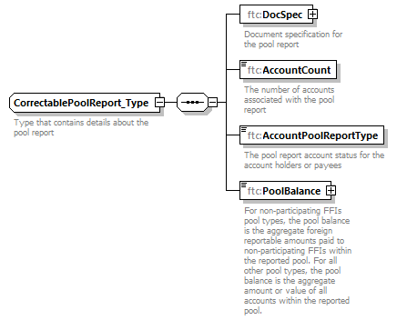
namespace | urn:lu:etat:acd:fatca:v2.0
children | ftc:DocSpec ftc:AccountCount ftc:AccountPoolReportType ftc:PoolBalance
used by | element Fatca_Type/ReportingGroup/PoolReport
annotation | documentation  Type that contains details about the pool report
source | <xsd:complexType name="CorrectablePoolReport_Type">  <xsd:annotation>  <xsd:documentation xml:lang="en">Type that contains details about the pool report</xsd:documentation>  </xsd:annotation>  <xsd:sequence>  <xsd:element name="DocSpec" type="ftc:DocSpec_Type">  <xsd:annotation>  <xsd:documentation xml:lang="en">Document specification for the pool report</xsd:documentation>  </xsd:annotation>  </xsd:element>  <xsd:element name="AccountCount" type="xsd:positiveInteger">  <xsd:annotation>  <xsd:documentation xml:lang="en">The number of accounts associated with the pool report</xsd:documentation>  </xsd:annotation>  </xsd:element>  <xsd:element name="AccountPoolReportType" type="ftc:FatcaAcctPoolReportType_EnumType">  <xsd:annotation>  <xsd:documentation xml:lang="en">The pool report account status for the account holders or payees</xsd:documentation>  </xsd:annotation>  </xsd:element>  <xsd:element name="PoolBalance" type="sfa:MonAmnt_Type">  <xsd:annotation>  <xsd:documentation xml:lang="en">For non-participating FFIs pool types, the pool balance is the aggregate foreign reportable amounts paid to non-participating FFIs within the reported pool. For all other pool types, the pool balance is the aggregate amount or value of all accounts within the reported pool.</xsd:documentation>  </xsd:annotation>  </xsd:element>  </xsd:sequence>  </xsd:complexType>

element CorrectablePoolReport_Type/DocSpec
diagram | 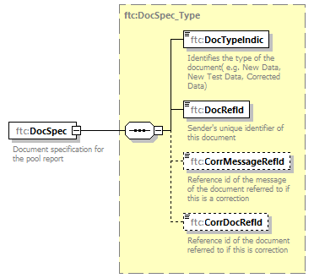
namespace | urn:lu:etat:acd:fatca:v2.0
type | ftc:DocSpec_Type
properties | content complex
children | ftc:DocTypeIndic ftc:DocRefId ftc:CorrMessageRefId ftc:CorrDocRefId
annotation | documentation  Document specification for the pool report
source | <xsd:element name="DocSpec" type="ftc:DocSpec_Type">  <xsd:annotation>  <xsd:documentation xml:lang="en">Document specification for the pool report</xsd:documentation>  </xsd:annotation>  </xsd:element>

element CorrectablePoolReport_Type/AccountCount
diagram | 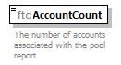
namespace | urn:lu:etat:acd:fatca:v2.0
type | xsd:positiveInteger
properties | content simple
annotation | documentation  The number of accounts associated with the pool report
source | <xsd:element name="AccountCount" type="xsd:positiveInteger">  <xsd:annotation>  <xsd:documentation xml:lang="en">The number of accounts associated with the pool report</xsd:documentation>  </xsd:annotation>  </xsd:element>

element CorrectablePoolReport_Type/AccountPoolReportType
diagram | 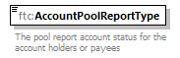
namespace | urn:lu:etat:acd:fatca:v2.0
type | ftc:FatcaAcctPoolReportType_EnumType
properties | content simple
facets | Kind Value Annotation  enumeration FATCA201 documentation Recalcitrant account holders with U.S. Indicia  enumeration FATCA202 documentation Recalcitrant account holders without US Indicia  enumeration FATCA203 documentation Dormant accounts  enumeration FATCA204 documentation Non-participating FFIs  enumeration FATCA205 documentation Recalcitrant account holders that are U.S. persons  enumeration FATCA206 documentation Recalcitrant account holders that are passive NFFEs
annotation | documentation  The pool report account status for the account holders or payees
source | <xsd:element name="AccountPoolReportType" type="ftc:FatcaAcctPoolReportType_EnumType">  <xsd:annotation>  <xsd:documentation xml:lang="en">The pool report account status for the account holders or payees</xsd:documentation>  </xsd:annotation>  </xsd:element>

element CorrectablePoolReport_Type/PoolBalance
diagram | 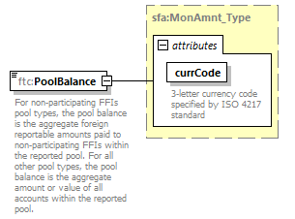
namespace | urn:lu:etat:acd:fatca:v2.0
type | sfa:MonAmnt_Type
properties | content complex
facets | Kind Value Annotation  fractionDigits 2
attributes | Name Type Use Default Fixed Annotation  currCode iso:currCode_Type required documentation 3-letter currency code specified by ISO 4217 standard
annotation | documentation  For non-participating FFIs pool types, the pool balance is the aggregate foreign reportable amounts paid to non-participating FFIs within the reported pool. For all other pool types, the pool balance is the aggregate amount or value of all accounts within the reported pool.
source | <xsd:element name="PoolBalance" type="sfa:MonAmnt_Type">  <xsd:annotation>  <xsd:documentation xml:lang="en">For non-participating FFIs pool types, the pool balance is the aggregate foreign reportable amounts paid to non-participating FFIs within the reported pool. For all other pool types, the pool balance is the aggregate amount or value of all accounts within the reported pool.</xsd:documentation>  </xsd:annotation>  </xsd:element>

complexType CorrectableReportOrganisation_Type
diagram | 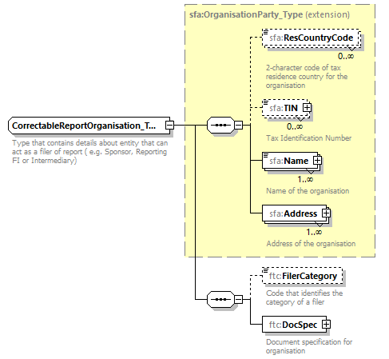
namespace | urn:lu:etat:acd:fatca:v2.0
type | extension of sfa:OrganisationParty_Type
properties | base sfa:OrganisationParty_Type
children | sfa:ResCountryCode sfa:TIN sfa:Name sfa:Address ftc:FilerCategory ftc:DocSpec
used by | elements Fatca_Type/ReportingGroup/Intermediary Fatca_Type/ReportingFI Fatca_Type/ReportingGroup/Sponsor
annotation | documentation  Type that contains details about entity that can act as a filer of report ( e.g. Sponsor, Reporting FI or Intermediary)
source | <xsd:complexType name="CorrectableReportOrganisation_Type">  <xsd:annotation>  <xsd:documentation xml:lang="en">Type that contains details about entity that can act as a filer of report ( e.g. Sponsor, Reporting FI or Intermediary)</xsd:documentation>  </xsd:annotation>  <xsd:complexContent>  <xsd:extension base="sfa:OrganisationParty_Type">  <xsd:sequence>  <xsd:element name="FilerCategory" type="ftc:FatcaFilerCategory_EnumType" minOccurs="0">  <xsd:annotation>  <xsd:documentation xml:lang="en">Code that identifies the category of a filer</xsd:documentation>  </xsd:annotation>  </xsd:element>  <xsd:element name="DocSpec" type="ftc:DocSpec_Type">  <xsd:annotation>  <xsd:documentation xml:lang="en">Document specification for organisation</xsd:documentation>  </xsd:annotation>  </xsd:element>  </xsd:sequence>  </xsd:extension>  </xsd:complexContent>  </xsd:complexType>

element CorrectableReportOrganisation_Type/FilerCategory
diagram | 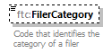
namespace | urn:lu:etat:acd:fatca:v2.0
type | ftc:FatcaFilerCategory_EnumType
properties | minOcc 0  maxOcc 1  content simple
facets | Kind Value Annotation  enumeration FATCA601 documentation PFFI (other than a Reporting Model 2 FFI and including a U.S. branch of a PFFI not treated as a U.S. person)  enumeration FATCA602 documentation RDC FFI  enumeration FATCA603 documentation Limited Branch or Limited FFI  enumeration FATCA604 documentation Reporting Model 2 FFI  enumeration FATCA605 documentation QI, WP, or WT  enumeration FATCA606 documentation Direct Reporting NFFE  enumeration FATCA607 documentation Sponsoring Entity of a Sponsored FFI  enumeration FATCA608 documentation Sponsoring Entity of a Sponsored Direct Reporting NFFE  enumeration FATCA609 documentation Trustee of a Trustee-Documented Trust  enumeration FATCA610 documentation Withholding Agent (including a U.S. branch of a PFFI, Reporting Model 1 FFI, Reporting Model 2 FFI, or RDC FFI treated as a U.S. person and a U.S. branch of a Reporting Model 1 FFI (including any other RDC FFI) or Limited FFI that is not treated as a U.S. person)  enumeration FATCA611 documentation Territory Financial Institution treated as a U.S. person
annotation | documentation  Code that identifies the category of a filer
source | <xsd:element name="FilerCategory" type="ftc:FatcaFilerCategory_EnumType" minOccurs="0">  <xsd:annotation>  <xsd:documentation xml:lang="en">Code that identifies the category of a filer</xsd:documentation>  </xsd:annotation>  </xsd:element>

element CorrectableReportOrganisation_Type/DocSpec
diagram | 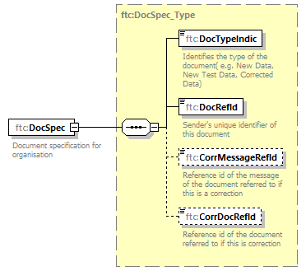
namespace | urn:lu:etat:acd:fatca:v2.0
type | ftc:DocSpec_Type
properties | content complex
children | ftc:DocTypeIndic ftc:DocRefId ftc:CorrMessageRefId ftc:CorrDocRefId
annotation | documentation  Document specification for organisation
source | <xsd:element name="DocSpec" type="ftc:DocSpec_Type">  <xsd:annotation>  <xsd:documentation xml:lang="en">Document specification for organisation</xsd:documentation>  </xsd:annotation>  </xsd:element>

complexType DocSpec_Type
diagram | 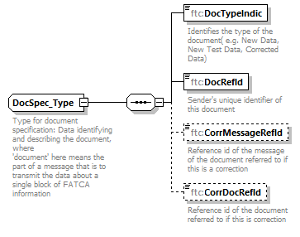
namespace | urn:lu:etat:acd:fatca:v2.0
children | ftc:DocTypeIndic ftc:DocRefId ftc:CorrMessageRefId ftc:CorrDocRefId
used by | elements CorrectableReportOrganisation_Type/DocSpec CorrectablePoolReport_Type/DocSpec CorrectableAccountReport_Type/DocSpec CorrectableNilReport_Type/DocSpec
annotation | documentation  Type for document specification: Data identifying and describing the document, where  'document' here means the part of a message that is to transmit the data about a single block of FATCA information
source | <xsd:complexType name="DocSpec_Type">  <xsd:annotation>  <xsd:documentation xml:lang="en">Type for document specification: Data identifying and describing the document, where  'document' here means the part of a message that is to transmit the data about a single block of FATCA information</xsd:documentation>  </xsd:annotation>  <xsd:sequence>  <xsd:element name="DocTypeIndic" type="ftc:FatcaDocTypeIndic_EnumType">  <xsd:annotation>  <xsd:documentation xml:lang="en">Identifies the type of the document( e.g. New Data, New Test Data, Corrected Data)</xsd:documentation>  </xsd:annotation>  </xsd:element>  <xsd:element name="DocRefId" type="sfa:StringMax200_Type">  <xsd:annotation>  <xsd:documentation xml:lang="en">Sender's unique identifier of this document</xsd:documentation>  </xsd:annotation>  </xsd:element>  <xsd:element name="CorrMessageRefId" type="sfa:StringMax200_Type" minOccurs="0">  <xsd:annotation>  <xsd:documentation xml:lang="en">Reference id of the message of the document referred to if this is a correction</xsd:documentation>  </xsd:annotation>  </xsd:element>  <xsd:element name="CorrDocRefId" type="sfa:StringMax200_Type" minOccurs="0">  <xsd:annotation>  <xsd:documentation xml:lang="en">Reference id of the document referred to if this is correction</xsd:documentation>  </xsd:annotation>  </xsd:element>  </xsd:sequence>  </xsd:complexType>

element DocSpec_Type/DocTypeIndic
diagram | 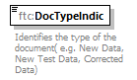
namespace | urn:lu:etat:acd:fatca:v2.0
type | ftc:FatcaDocTypeIndic_EnumType
properties | content simple
facets | Kind Value Annotation  enumeration FATCA1 documentation New Data  enumeration FATCA2 documentation Corrected Data  enumeration FATCA3 documentation Void Data  enumeration FATCA4 documentation Amended Data
annotation | documentation  Identifies the type of the document( e.g. New Data, New Test Data, Corrected Data)
source | <xsd:element name="DocTypeIndic" type="ftc:FatcaDocTypeIndic_EnumType">  <xsd:annotation>  <xsd:documentation xml:lang="en">Identifies the type of the document( e.g. New Data, New Test Data, Corrected Data)</xsd:documentation>  </xsd:annotation>  </xsd:element>

element DocSpec_Type/DocRefId
diagram | 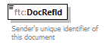
namespace | urn:lu:etat:acd:fatca:v2.0
type | sfa:StringMax200_Type
properties | content simple
facets | Kind Value Annotation  minLength 0  maxLength 200
annotation | documentation  Sender's unique identifier of this document
source | <xsd:element name="DocRefId" type="sfa:StringMax200_Type">  <xsd:annotation>  <xsd:documentation xml:lang="en">Sender's unique identifier of this document</xsd:documentation>  </xsd:annotation>  </xsd:element>

element DocSpec_Type/CorrMessageRefId
diagram | 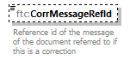
namespace | urn:lu:etat:acd:fatca:v2.0
type | sfa:StringMax200_Type
properties | minOcc 0  maxOcc 1  content simple
facets | Kind Value Annotation  minLength 0  maxLength 200
annotation | documentation  Reference id of the message of the document referred to if this is a correction
source | <xsd:element name="CorrMessageRefId" type="sfa:StringMax200_Type" minOccurs="0">  <xsd:annotation>  <xsd:documentation xml:lang="en">Reference id of the message of the document referred to if this is a correction</xsd:documentation>  </xsd:annotation>  </xsd:element>

element DocSpec_Type/CorrDocRefId
diagram | 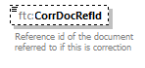
namespace | urn:lu:etat:acd:fatca:v2.0
type | sfa:StringMax200_Type
properties | minOcc 0  maxOcc 1  content simple
facets | Kind Value Annotation  minLength 0  maxLength 200
annotation | documentation  Reference id of the document referred to if this is correction
source | <xsd:element name="CorrDocRefId" type="sfa:StringMax200_Type" minOccurs="0">  <xsd:annotation>  <xsd:documentation xml:lang="en">Reference id of the document referred to if this is correction</xsd:documentation>  </xsd:annotation>  </xsd:element>

complexType Fatca_Type
diagram | 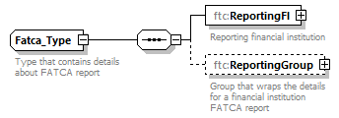
namespace | urn:lu:etat:acd:fatca:v2.0
children | ftc:ReportingFI ftc:ReportingGroup
used by | element FATCA_LUX/FATCA
annotation | documentation  Type that contains details about FATCA report
source | <xsd:complexType name="Fatca_Type">  <xsd:annotation>  <xsd:documentation xml:lang="en">Type that contains details about FATCA report</xsd:documentation>  </xsd:annotation>  <xsd:sequence>  <xsd:element name="ReportingFI" type="ftc:CorrectableReportOrganisation_Type">  <xsd:annotation>  <xsd:documentation xml:lang="en">Reporting financial institution</xsd:documentation>  </xsd:annotation>  </xsd:element>  <!-- restriction in Luxemburg Maximum occurrence is 1 so only maximum one sponsoring or intermediary unit is allowed ,  0 because in the case of a Reporting FI correction -->  <xsd:element name="ReportingGroup" minOccurs="0" maxOccurs="1">  <xsd:annotation>  <xsd:documentation xml:lang="en">Group that wraps the details for a financial institution FATCA report</xsd:documentation>  </xsd:annotation>  <xsd:complexType>  <xsd:sequence>  <xsd:element name="Sponsor" type="ftc:CorrectableReportOrganisation_Type" minOccurs="0">  <xsd:annotation>  <xsd:documentation>Detailed information about the Sponsoring Entity</xsd:documentation>  </xsd:annotation>  </xsd:element>  <xsd:element name="Intermediary" type="ftc:CorrectableReportOrganisation_Type" minOccurs="0">  <xsd:annotation>  <xsd:documentation>Detailed information about the Territory Financial Institute that is acting as an intermediary on behalf of the reported financial account or an entity.</xsd:documentation>  </xsd:annotation>  </xsd:element>  <xsd:choice>  <xsd:element name="NilReport" type="ftc:CorrectableNilReport_Type">  <xsd:annotation>  <xsd:documentation xml:lang="en">Nil Report indicates that financial institution does not have accounts to report</xsd:documentation>  </xsd:annotation>  </xsd:element>  <xsd:sequence>  <xsd:element name="AccountReport" type="ftc:CorrectableAccountReport_Type" minOccurs="0" maxOccurs="unbounded">  <xsd:annotation>  <xsd:documentation>Detailed information for account report, such as account number and account balance</xsd:documentation>  </xsd:annotation>  </xsd:element>  <xsd:element name="PoolReport" type="ftc:CorrectablePoolReport_Type" minOccurs="0" maxOccurs="unbounded">  <xsd:annotation>  <xsd:documentation>Information about the pool of account holders with similar characteristics</xsd:documentation>  </xsd:annotation>  </xsd:element>  </xsd:sequence>  </xsd:choice>  </xsd:sequence>  </xsd:complexType>  </xsd:element>  </xsd:sequence>  </xsd:complexType>

element Fatca_Type/ReportingFI
diagram | 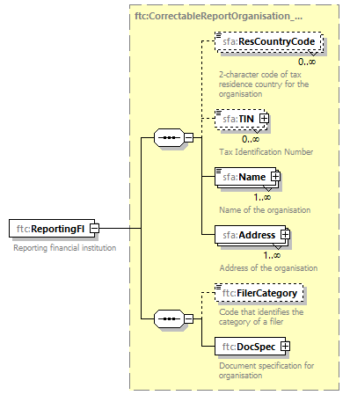
namespace | urn:lu:etat:acd:fatca:v2.0
type | ftc:CorrectableReportOrganisation_Type
properties | content complex
children | sfa:ResCountryCode sfa:TIN sfa:Name sfa:Address ftc:FilerCategory ftc:DocSpec
annotation | documentation  Reporting financial institution
source | <xsd:element name="ReportingFI" type="ftc:CorrectableReportOrganisation_Type">  <xsd:annotation>  <xsd:documentation xml:lang="en">Reporting financial institution</xsd:documentation>  </xsd:annotation>  </xsd:element>

element Fatca_Type/ReportingGroup
diagram | 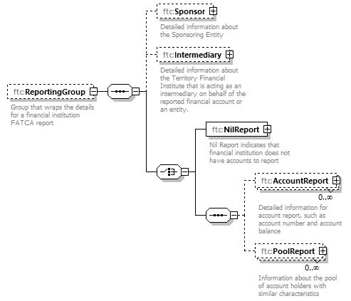
namespace | urn:lu:etat:acd:fatca:v2.0
properties | minOcc 0  maxOcc 1  content complex
children | ftc:Sponsor ftc:Intermediary ftc:NilReport ftc:AccountReport ftc:PoolReport
annotation | documentation  Group that wraps the details for a financial institution FATCA report
source | <xsd:element name="ReportingGroup" minOccurs="0" maxOccurs="1">  <xsd:annotation>  <xsd:documentation xml:lang="en">Group that wraps the details for a financial institution FATCA report</xsd:documentation>  </xsd:annotation>  <xsd:complexType>  <xsd:sequence>  <xsd:element name="Sponsor" type="ftc:CorrectableReportOrganisation_Type" minOccurs="0">  <xsd:annotation>  <xsd:documentation>Detailed information about the Sponsoring Entity</xsd:documentation>  </xsd:annotation>  </xsd:element>  <xsd:element name="Intermediary" type="ftc:CorrectableReportOrganisation_Type" minOccurs="0">  <xsd:annotation>  <xsd:documentation>Detailed information about the Territory Financial Institute that is acting as an intermediary on behalf of the reported financial account or an entity.</xsd:documentation>  </xsd:annotation>  </xsd:element>  <xsd:choice>  <xsd:element name="NilReport" type="ftc:CorrectableNilReport_Type">  <xsd:annotation>  <xsd:documentation xml:lang="en">Nil Report indicates that financial institution does not have accounts to report</xsd:documentation>  </xsd:annotation>  </xsd:element>  <xsd:sequence>  <xsd:element name="AccountReport" type="ftc:CorrectableAccountReport_Type" minOccurs="0" maxOccurs="unbounded">  <xsd:annotation>  <xsd:documentation>Detailed information for account report, such as account number and account balance</xsd:documentation>  </xsd:annotation>  </xsd:element>  <xsd:element name="PoolReport" type="ftc:CorrectablePoolReport_Type" minOccurs="0" maxOccurs="unbounded">  <xsd:annotation>  <xsd:documentation>Information about the pool of account holders with similar characteristics</xsd:documentation>  </xsd:annotation>  </xsd:element>  </xsd:sequence>  </xsd:choice>  </xsd:sequence>  </xsd:complexType>  </xsd:element>

element Fatca_Type/ReportingGroup/Sponsor
diagram | 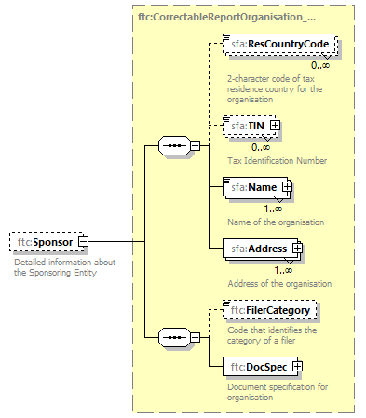
namespace | urn:lu:etat:acd:fatca:v2.0
type | ftc:CorrectableReportOrganisation_Type
properties | minOcc 0  maxOcc 1  content complex
children | sfa:ResCountryCode sfa:TIN sfa:Name sfa:Address ftc:FilerCategory ftc:DocSpec
annotation | documentation  Detailed information about the Sponsoring Entity
source | <xsd:element name="Sponsor" type="ftc:CorrectableReportOrganisation_Type" minOccurs="0">  <xsd:annotation>  <xsd:documentation>Detailed information about the Sponsoring Entity</xsd:documentation>  </xsd:annotation>  </xsd:element>

element Fatca_Type/ReportingGroup/Intermediary
diagram | 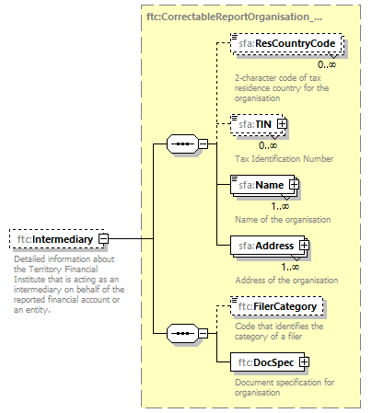
namespace | urn:lu:etat:acd:fatca:v2.0
type | ftc:CorrectableReportOrganisation_Type
properties | minOcc 0  maxOcc 1  content complex
children | sfa:ResCountryCode sfa:TIN sfa:Name sfa:Address ftc:FilerCategory ftc:DocSpec
annotation | documentation  Detailed information about the Territory Financial Institute that is acting as an intermediary on behalf of the reported financial account or an entity.
source | <xsd:element name="Intermediary" type="ftc:CorrectableReportOrganisation_Type" minOccurs="0">  <xsd:annotation>  <xsd:documentation>Detailed information about the Territory Financial Institute that is acting as an intermediary on behalf of the reported financial account or an entity.</xsd:documentation>  </xsd:annotation>  </xsd:element>

element Fatca_Type/ReportingGroup/NilReport
diagram | 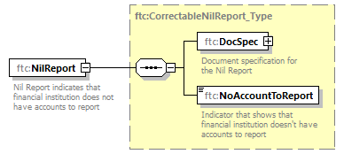
namespace | urn:lu:etat:acd:fatca:v2.0
type | ftc:CorrectableNilReport_Type
properties | content complex
children | ftc:DocSpec ftc:NoAccountToReport
annotation | documentation  Nil Report indicates that financial institution does not have accounts to report
source | <xsd:element name="NilReport" type="ftc:CorrectableNilReport_Type">  <xsd:annotation>  <xsd:documentation xml:lang="en">Nil Report indicates that financial institution does not have accounts to report</xsd:documentation>  </xsd:annotation>  </xsd:element>

element Fatca_Type/ReportingGroup/AccountReport
diagram | 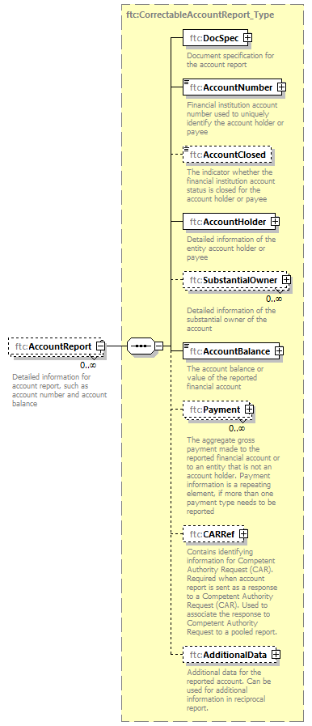
namespace | urn:lu:etat:acd:fatca:v2.0
type | ftc:CorrectableAccountReport_Type
properties | minOcc 0  maxOcc unbounded  content complex
children | ftc:DocSpec ftc:AccountNumber ftc:AccountClosed ftc:AccountHolder ftc:SubstantialOwner ftc:AccountBalance ftc:Payment ftc:CARRef ftc:AdditionalData
annotation | documentation  Detailed information for account report, such as account number and account balance
source | <xsd:element name="AccountReport" type="ftc:CorrectableAccountReport_Type" minOccurs="0" maxOccurs="unbounded">  <xsd:annotation>  <xsd:documentation>Detailed information for account report, such as account number and account balance</xsd:documentation>  </xsd:annotation>  </xsd:element>

element Fatca_Type/ReportingGroup/PoolReport
diagram | 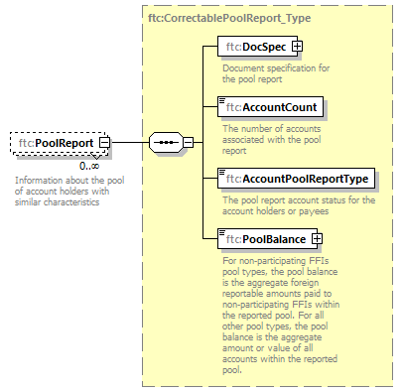
namespace | urn:lu:etat:acd:fatca:v2.0
type | ftc:CorrectablePoolReport_Type
properties | minOcc 0  maxOcc unbounded  content complex
children | ftc:DocSpec ftc:AccountCount ftc:AccountPoolReportType ftc:PoolBalance
annotation | documentation  Information about the pool of account holders with similar characteristics
source | <xsd:element name="PoolReport" type="ftc:CorrectablePoolReport_Type" minOccurs="0" maxOccurs="unbounded">  <xsd:annotation>  <xsd:documentation>Information about the pool of account holders with similar characteristics</xsd:documentation>  </xsd:annotation>  </xsd:element>

complexType FIAccountNumber_Type
diagram | 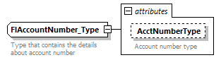
namespace | urn:lu:etat:acd:fatca:v2.0
type | extension of sfa:StringMax200_Type
properties | base sfa:StringMax200_Type
used by | element CorrectableAccountReport_Type/AccountNumber
facets | Kind Value Annotation  minLength 0  maxLength 200
attributes | Name Type Use Default Fixed Annotation  AcctNumberType stf:AcctNumberType_EnumType optional documentation Account number type
annotation | documentation  Type that contains the details about account number
source | <xsd:complexType name="FIAccountNumber_Type">  <xsd:annotation>  <xsd:documentation xml:lang="en">Type that contains the details about account number</xsd:documentation>  </xsd:annotation>  <xsd:simpleContent>  <xsd:extension base="sfa:StringMax200_Type">  <xsd:attribute name="AcctNumberType" type="stf:AcctNumberType_EnumType" use="optional">  <xsd:annotation>  <xsd:documentation xml:lang="en">Account number type</xsd:documentation>  </xsd:annotation>  </xsd:attribute>  </xsd:extension>  </xsd:simpleContent>  </xsd:complexType>

attribute FIAccountNumber_Type/@AcctNumberType
type | stf:AcctNumberType_EnumType
properties | use optional
facets | Kind Value Annotation  enumeration OECD601 documentation IBAN  enumeration OECD602 documentation OBAN  enumeration OECD603 documentation ISIN  enumeration OECD604 documentation OSIN  enumeration OECD605 documentation Other
annotation | documentation  Account number type
source | <xsd:attribute name="AcctNumberType" type="stf:AcctNumberType_EnumType" use="optional">  <xsd:annotation>  <xsd:documentation xml:lang="en">Account number type</xsd:documentation>  </xsd:annotation>  </xsd:attribute>

complexType Payment_Type
diagram | 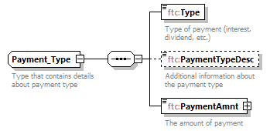
namespace | urn:lu:etat:acd:fatca:v2.0
children | ftc:Type ftc:PaymentTypeDesc ftc:PaymentAmnt
used by | element CorrectableAccountReport_Type/Payment
annotation | documentation  Type that contains details about payment type
source | <xsd:complexType name="Payment_Type">  <xsd:annotation>  <xsd:documentation xml:lang="en">Type that contains details about payment type</xsd:documentation>  </xsd:annotation>  <xsd:sequence>  <xsd:element name="Type" type="ftc:FatcaPaymentType_EnumType">  <xsd:annotation>  <xsd:documentation xml:lang="en">Type of payment (interest, dividend, etc.)</xsd:documentation>  </xsd:annotation>  </xsd:element>  <xsd:element name="PaymentTypeDesc" type="sfa:StringMax4000_Type" minOccurs="0">  <xsd:annotation>  <xsd:documentation xml:lang="en">Additional information about the payment type</xsd:documentation>  </xsd:annotation>  </xsd:element>  <xsd:element name="PaymentAmnt" type="sfa:MonAmnt_Type">  <xsd:annotation>  <xsd:documentation xml:lang="en">The amount of payment</xsd:documentation>  </xsd:annotation>  </xsd:element>  </xsd:sequence>  </xsd:complexType>

element Payment_Type/Type
diagram | 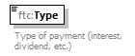
namespace | urn:lu:etat:acd:fatca:v2.0
type | ftc:FatcaPaymentType_EnumType
properties | content simple
facets | Kind Value Annotation  enumeration FATCA501 documentation Dividends  enumeration FATCA502 documentation Interest  enumeration FATCA503 documentation Gross Proceeds/Redemptions  enumeration FATCA504 documentation Other
annotation | documentation  Type of payment (interest, dividend, etc.)
source | <xsd:element name="Type" type="ftc:FatcaPaymentType_EnumType">  <xsd:annotation>  <xsd:documentation xml:lang="en">Type of payment (interest, dividend, etc.)</xsd:documentation>  </xsd:annotation>  </xsd:element>

element Payment_Type/PaymentTypeDesc
diagram | 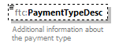
namespace | urn:lu:etat:acd:fatca:v2.0
type | sfa:StringMax4000_Type
properties | minOcc 0  maxOcc 1  content simple
facets | Kind Value Annotation  minLength 0  maxLength 4000
annotation | documentation  Additional information about the payment type
source | <xsd:element name="PaymentTypeDesc" type="sfa:StringMax4000_Type" minOccurs="0">  <xsd:annotation>  <xsd:documentation xml:lang="en">Additional information about the payment type</xsd:documentation>  </xsd:annotation>  </xsd:element>

element Payment_Type/PaymentAmnt
diagram | 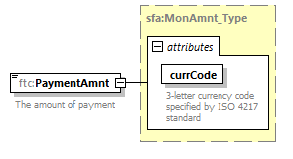
namespace | urn:lu:etat:acd:fatca:v2.0
type | sfa:MonAmnt_Type
properties | content complex
facets | Kind Value Annotation  fractionDigits 2
attributes | Name Type Use Default Fixed Annotation  currCode iso:currCode_Type required documentation 3-letter currency code specified by ISO 4217 standard
annotation | documentation  The amount of payment
source | <xsd:element name="PaymentAmnt" type="sfa:MonAmnt_Type">  <xsd:annotation>  <xsd:documentation xml:lang="en">The amount of payment</xsd:documentation>  </xsd:annotation>  </xsd:element>

complexType SubstantialOwner_Type
diagram | 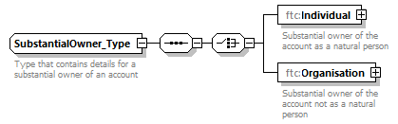
namespace | urn:lu:etat:acd:fatca:v2.0
children | ftc:Individual ftc:Organisation
used by | element CorrectableAccountReport_Type/SubstantialOwner
annotation | documentation  Type that contains details for a substantial owner of an account
source | <xsd:complexType name="SubstantialOwner_Type">  <xsd:annotation>  <xsd:documentation xml:lang="en">Type that contains details for a substantial owner of an account</xsd:documentation>  </xsd:annotation>  <xsd:sequence>  <xsd:choice>  <xsd:element name="Individual" type="sfa:PersonParty_Type">  <xsd:annotation>  <xsd:documentation xml:lang="en">Substantial owner of the account as a natural person</xsd:documentation>  </xsd:annotation>  </xsd:element>  <xsd:element name="Organisation" type="sfa:OrganisationParty_Type">  <xsd:annotation>  <xsd:documentation xml:lang="en">Substantial owner of the account not as a natural person</xsd:documentation>  </xsd:annotation>  </xsd:element>  </xsd:choice>  </xsd:sequence>  </xsd:complexType>

element SubstantialOwner_Type/Individual
diagram | 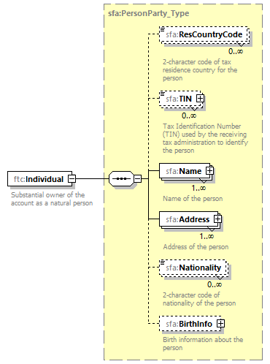
namespace | urn:lu:etat:acd:fatca:v2.0
type | sfa:PersonParty_Type
properties | content complex
children | sfa:ResCountryCode sfa:TIN sfa:Name sfa:Address sfa:Nationality sfa:BirthInfo
annotation | documentation  Substantial owner of the account as a natural person
source | <xsd:element name="Individual" type="sfa:PersonParty_Type">  <xsd:annotation>  <xsd:documentation xml:lang="en">Substantial owner of the account as a natural person</xsd:documentation>  </xsd:annotation>  </xsd:element>

element SubstantialOwner_Type/Organisation
diagram | 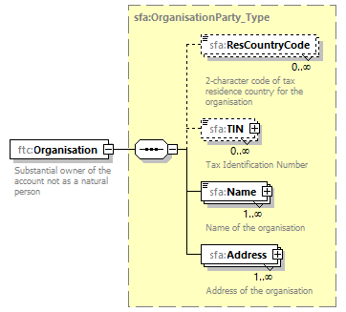
namespace | urn:lu:etat:acd:fatca:v2.0
type | sfa:OrganisationParty_Type
properties | content complex
children | sfa:ResCountryCode sfa:TIN sfa:Name sfa:Address
annotation | documentation  Substantial owner of the account not as a natural person
source | <xsd:element name="Organisation" type="sfa:OrganisationParty_Type">  <xsd:annotation>  <xsd:documentation xml:lang="en">Substantial owner of the account not as a natural person</xsd:documentation>  </xsd:annotation>  </xsd:element>

simpleType FatcaAcctHolderType_EnumType
namespace | urn:lu:etat:acd:fatca:v2.0
type | restriction of xsd:string
properties | base xsd:string
used by | element AccountHolder_Type/AcctHolderType
facets | Kind Value Annotation  enumeration FATCA101 documentation Owner-Documented FFI with specified U.S. owner(s)  enumeration FATCA102 documentation Passive NFFE with substantial U.S. owner(s)  enumeration FATCA103 documentation Non-Participating FFI  enumeration FATCA104 documentation Specified U.S. Person  enumeration FATCA105 documentation Direct Reporting NFFE  enumeration FATCA106 documentation For U.S. Government Use Only (Attention to FIs and HCTAs: Restricted, Do Not Use)
annotation | documentation  Account Holder Type
source | <xsd:simpleType name="FatcaAcctHolderType_EnumType">  <xsd:annotation>  <xsd:documentation xml:lang="en">Account Holder Type</xsd:documentation>  </xsd:annotation>  <xsd:restriction base="xsd:string">  <xsd:enumeration value="FATCA101">  <xsd:annotation>  <xsd:documentation>Owner-Documented FFI with specified U.S. owner(s)</xsd:documentation>  </xsd:annotation>  </xsd:enumeration>  <xsd:enumeration value="FATCA102">  <xsd:annotation>  <xsd:documentation>Passive NFFE with substantial U.S. owner(s)</xsd:documentation>  </xsd:annotation>  </xsd:enumeration>  <xsd:enumeration value="FATCA103">  <xsd:annotation>  <xsd:documentation>Non-Participating FFI</xsd:documentation>  </xsd:annotation>  </xsd:enumeration>  <xsd:enumeration value="FATCA104">  <xsd:annotation>  <xsd:documentation>Specified U.S. Person</xsd:documentation>  </xsd:annotation>  </xsd:enumeration>  <xsd:enumeration value="FATCA105">  <xsd:annotation>  <xsd:documentation>Direct Reporting NFFE</xsd:documentation>  </xsd:annotation>  </xsd:enumeration>  <xsd:enumeration value="FATCA106">  <xsd:annotation>  <xsd:documentation>For U.S. Government Use Only (Attention to FIs and HCTAs: Restricted, Do Not Use)</xsd:documentation>  </xsd:annotation>  </xsd:enumeration>  </xsd:restriction>  </xsd:simpleType>

simpleType FatcaAcctPoolReportType_EnumType
namespace | urn:lu:etat:acd:fatca:v2.0
type | restriction of xsd:string
properties | base xsd:string
used by | element CorrectablePoolReport_Type/AccountPoolReportType
facets | Kind Value Annotation  enumeration FATCA201 documentation Recalcitrant account holders with U.S. Indicia  enumeration FATCA202 documentation Recalcitrant account holders without US Indicia  enumeration FATCA203 documentation Dormant accounts  enumeration FATCA204 documentation Non-participating FFIs  enumeration FATCA205 documentation Recalcitrant account holders that are U.S. persons  enumeration FATCA206 documentation Recalcitrant account holders that are passive NFFEs
annotation | documentation  Account Pool Reporting Type
source | <xsd:simpleType name="FatcaAcctPoolReportType_EnumType">  <xsd:annotation>  <xsd:documentation xml:lang="en">Account Pool Reporting Type</xsd:documentation>  </xsd:annotation>  <xsd:restriction base="xsd:string">  <xsd:enumeration value="FATCA201">  <xsd:annotation>  <xsd:documentation>Recalcitrant account holders with U.S. Indicia</xsd:documentation>  </xsd:annotation>  </xsd:enumeration>  <xsd:enumeration value="FATCA202">  <xsd:annotation>  <xsd:documentation>Recalcitrant account holders without US Indicia</xsd:documentation>  </xsd:annotation>  </xsd:enumeration>  <xsd:enumeration value="FATCA203">  <xsd:annotation>  <xsd:documentation>Dormant accounts</xsd:documentation>  </xsd:annotation>  </xsd:enumeration>  <xsd:enumeration value="FATCA204">  <xsd:annotation>  <xsd:documentation>Non-participating FFIs</xsd:documentation>  </xsd:annotation>  </xsd:enumeration>  <xsd:enumeration value="FATCA205">  <xsd:annotation>  <xsd:documentation>Recalcitrant account holders that are U.S. persons</xsd:documentation>  </xsd:annotation>  </xsd:enumeration>  <xsd:enumeration value="FATCA206">  <xsd:annotation>  <xsd:documentation>Recalcitrant account holders that are passive NFFEs</xsd:documentation>  </xsd:annotation>  </xsd:enumeration>  </xsd:restriction>  </xsd:simpleType>

simpleType FatcaDocTypeIndic_EnumType
namespace | urn:lu:etat:acd:fatca:v2.0
type | restriction of xsd:string
properties | base xsd:string
used by | element DocSpec_Type/DocTypeIndic
facets | Kind Value Annotation  enumeration FATCA1 documentation New Data  enumeration FATCA2 documentation Corrected Data  enumeration FATCA3 documentation Void Data  enumeration FATCA4 documentation Amended Data
annotation | documentation  The element applies only to the document part in which it is included. In the case of repeated or corrected data elements CorrMessageRefId and CorrDocRefId must contain the identifiers MessageRefId and DocRefId respectively for the data referred to. In the case of a correction the unchanged elements shall be transmitted again - except for the element DocRefId.
source | <xsd:simpleType name="FatcaDocTypeIndic_EnumType">  <xsd:annotation>  <xsd:documentation xml:lang="en">The element applies only to the document part in which it is included. In the case of repeated or corrected data elements CorrMessageRefId and CorrDocRefId must contain the identifiers MessageRefId and DocRefId respectively for the data referred to. In the case of a correction the unchanged elements shall be transmitted again - except for the element DocRefId.</xsd:documentation>  </xsd:annotation>  <xsd:restriction base="xsd:string">  <xsd:enumeration value="FATCA1">  <xsd:annotation>  <xsd:documentation>New Data</xsd:documentation>  </xsd:annotation>  </xsd:enumeration>  <xsd:enumeration value="FATCA2">  <xsd:annotation>  <xsd:documentation>Corrected Data</xsd:documentation>  </xsd:annotation>  </xsd:enumeration>  <xsd:enumeration value="FATCA3">  <xsd:annotation>  <xsd:documentation>Void Data</xsd:documentation>  </xsd:annotation>  </xsd:enumeration>  <xsd:enumeration value="FATCA4">  <xsd:annotation>  <xsd:documentation>Amended Data</xsd:documentation>  </xsd:annotation>  </xsd:enumeration>  <!-- The test FATCA types 11-14 are not supported any longer by the ACD application since version 1.3 -->  <!-- <xsd:enumeration value="FATCA11"> <xsd:annotation> <xsd:documentation>New Test Data</xsd:documentation> </xsd:annotation> -->  <!-- </xsd:enumeration> <xsd:enumeration value="FATCA12"> <xsd:annotation> <xsd:documentation>Corrected Test Data</xsd:documentation> -->  <!-- </xsd:annotation> </xsd:enumeration> <xsd:enumeration value="FATCA13"> <xsd:annotation> <xsd:documentation>Void Test Data</xsd:documentation> -->  <!-- </xsd:annotation> </xsd:enumeration> <xsd:enumeration value="FATCA14"> <xsd:annotation> <xsd:documentation>Amended Test Data</xsd:documentation> -->  <!-- </xsd:annotation> </xsd:enumeration> -->  </xsd:restriction>  </xsd:simpleType>

simpleType FatcaFilerCategory_EnumType
namespace | urn:lu:etat:acd:fatca:v2.0
type | restriction of xsd:string
properties | base xsd:string
used by | element CorrectableReportOrganisation_Type/FilerCategory
facets | Kind Value Annotation  enumeration FATCA601 documentation PFFI (other than a Reporting Model 2 FFI and including a U.S. branch of a PFFI not treated as a U.S. person)  enumeration FATCA602 documentation RDC FFI  enumeration FATCA603 documentation Limited Branch or Limited FFI  enumeration FATCA604 documentation Reporting Model 2 FFI  enumeration FATCA605 documentation QI, WP, or WT  enumeration FATCA606 documentation Direct Reporting NFFE  enumeration FATCA607 documentation Sponsoring Entity of a Sponsored FFI  enumeration FATCA608 documentation Sponsoring Entity of a Sponsored Direct Reporting NFFE  enumeration FATCA609 documentation Trustee of a Trustee-Documented Trust  enumeration FATCA610 documentation Withholding Agent (including a U.S. branch of a PFFI, Reporting Model 1 FFI, Reporting Model 2 FFI, or RDC FFI treated as a U.S. person and a U.S. branch of a Reporting Model 1 FFI (including any other RDC FFI) or Limited FFI that is not treated as a U.S. person)  enumeration FATCA611 documentation Territory Financial Institution treated as a U.S. person
annotation | documentation  Filer Category
source | <xsd:simpleType name="FatcaFilerCategory_EnumType">  <xsd:annotation>  <xsd:documentation xml:lang="en">Filer Category</xsd:documentation>  </xsd:annotation>  <xsd:restriction base="xsd:string">  <xsd:enumeration value="FATCA601">  <xsd:annotation>  <xsd:documentation>PFFI (other than a Reporting Model 2 FFI and including a U.S. branch of a PFFI not treated as a U.S. person)</xsd:documentation>  </xsd:annotation>  </xsd:enumeration>  <xsd:enumeration value="FATCA602">  <xsd:annotation>  <xsd:documentation>RDC FFI</xsd:documentation>  </xsd:annotation>  </xsd:enumeration>  <xsd:enumeration value="FATCA603">  <xsd:annotation>  <xsd:documentation>Limited Branch or Limited FFI</xsd:documentation>  </xsd:annotation>  </xsd:enumeration>  <xsd:enumeration value="FATCA604">  <xsd:annotation>  <xsd:documentation>Reporting Model 2 FFI</xsd:documentation>  </xsd:annotation>  </xsd:enumeration>  <xsd:enumeration value="FATCA605">  <xsd:annotation>  <xsd:documentation>QI, WP, or WT</xsd:documentation>  </xsd:annotation>  </xsd:enumeration>  <xsd:enumeration value="FATCA606">  <xsd:annotation>  <xsd:documentation>Direct Reporting NFFE</xsd:documentation>  </xsd:annotation>  </xsd:enumeration>  <xsd:enumeration value="FATCA607">  <xsd:annotation>  <xsd:documentation>Sponsoring Entity of a Sponsored FFI</xsd:documentation>  </xsd:annotation>  </xsd:enumeration>  <xsd:enumeration value="FATCA608">  <xsd:annotation>  <xsd:documentation>Sponsoring Entity of a Sponsored Direct Reporting NFFE</xsd:documentation>  </xsd:annotation>  </xsd:enumeration>  <xsd:enumeration value="FATCA609">  <xsd:annotation>  <xsd:documentation>Trustee of a Trustee-Documented Trust</xsd:documentation>  </xsd:annotation>  </xsd:enumeration>  <xsd:enumeration value="FATCA610">  <xsd:annotation>  <xsd:documentation>Withholding Agent (including a U.S. branch of a PFFI, Reporting Model 1 FFI, Reporting Model 2 FFI, or RDC FFI treated as a U.S. person and a U.S. branch of a Reporting Model 1 FFI (including any other RDC FFI) or Limited FFI that is not treated as a U.S. person)</xsd:documentation>  </xsd:annotation>  </xsd:enumeration>  <xsd:enumeration value="FATCA611">  <xsd:annotation>  <xsd:documentation>Territory Financial Institution treated as a U.S. person</xsd:documentation>  </xsd:annotation>  </xsd:enumeration>  </xsd:restriction>  </xsd:simpleType>

simpleType FatcaPaymentType_EnumType
namespace | urn:lu:etat:acd:fatca:v2.0
type | restriction of xsd:string
properties | base xsd:string
used by | element Payment_Type/Type
facets | Kind Value Annotation  enumeration FATCA501 documentation Dividends  enumeration FATCA502 documentation Interest  enumeration FATCA503 documentation Gross Proceeds/Redemptions  enumeration FATCA504 documentation Other
annotation | documentation  The code describing the nature of the payments used in FATCA
source | <xsd:simpleType name="FatcaPaymentType_EnumType">  <xsd:annotation>  <xsd:documentation xml:lang="en">The code describing the nature of the payments used in FATCA</xsd:documentation>  </xsd:annotation>  <xsd:restriction base="xsd:string">  <xsd:enumeration value="FATCA501">  <xsd:annotation>  <xsd:documentation>Dividends</xsd:documentation>  </xsd:annotation>  </xsd:enumeration>  <xsd:enumeration value="FATCA502">  <xsd:annotation>  <xsd:documentation>Interest</xsd:documentation>  </xsd:annotation>  </xsd:enumeration>  <xsd:enumeration value="FATCA503">  <xsd:annotation>  <xsd:documentation>Gross Proceeds/Redemptions</xsd:documentation>  </xsd:annotation>  </xsd:enumeration>  <xsd:enumeration value="FATCA504">  <xsd:annotation>  <xsd:documentation>Other</xsd:documentation>  </xsd:annotation>  </xsd:enumeration>  </xsd:restriction>  </xsd:simpleType>

complexType AEOI_ADDRESS
diagram | 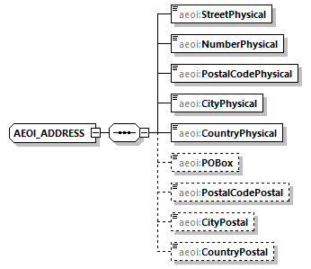
namespace | urn:lu:etat:acd:aeoi_lux:v3.0
children | aeoi:StreetPhysical aeoi:NumberPhysical aeoi:PostalCodePhysical aeoi:CityPhysical aeoi:CountryPhysical aeoi:POBox aeoi:PostalCodePostal aeoi:CityPostal aeoi:CountryPostal
used by | elements AEOI_Depositor/AddressDepositor AEOI_ReportingFI_Type/AddressReportingFI
source | <xsd:complexType name="AEOI_ADDRESS">  <xsd:sequence>  <xsd:element name="StreetPhysical" type="aeoi:Street" minOccurs="1" maxOccurs="1"/>  <xsd:element name="NumberPhysical" type="aeoi:Number" minOccurs="1" maxOccurs="1"/>  <xsd:element name="PostalCodePhysical" type="aeoi:PostalCode" minOccurs="1" maxOccurs="1"/>  <xsd:element name="CityPhysical" type="aeoi:City" minOccurs="1" maxOccurs="1"/>  <xsd:element name="CountryPhysical" type="isocntr:CountryCode_Type" minOccurs="1" maxOccurs="1"/>  <xsd:element name="POBox" type="aeoi:POBOX" minOccurs="0" maxOccurs="1"/>  <xsd:element name="PostalCodePostal" type="aeoi:PostalCode" minOccurs="0" maxOccurs="1"/>  <xsd:element name="CityPostal" type="aeoi:City" minOccurs="0" maxOccurs="1"/>  <xsd:element name="CountryPostal" type="isocntr:CountryCode_Type" minOccurs="0" maxOccurs="1"/>  </xsd:sequence>  </xsd:complexType>

element AEOI_ADDRESS/StreetPhysical
diagram | 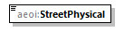
namespace | urn:lu:etat:acd:aeoi_lux:v3.0
type | aeoi:Street
properties | content simple
facets | Kind Value Annotation  maxLength 100
source | <xsd:element name="StreetPhysical" type="aeoi:Street" minOccurs="1" maxOccurs="1"/>

element AEOI_ADDRESS/NumberPhysical
diagram | 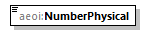
namespace | urn:lu:etat:acd:aeoi_lux:v3.0
type | aeoi:Number
properties | content simple
facets | Kind Value Annotation  maxLength 100
source | <xsd:element name="NumberPhysical" type="aeoi:Number" minOccurs="1" maxOccurs="1"/>

element AEOI_ADDRESS/PostalCodePhysical
diagram | 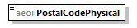
namespace | urn:lu:etat:acd:aeoi_lux:v3.0
type | aeoi:PostalCode
properties | content simple
facets | Kind Value Annotation  minLength 1  maxLength 16
source | <xsd:element name="PostalCodePhysical" type="aeoi:PostalCode" minOccurs="1" maxOccurs="1"/>

element AEOI_ADDRESS/CityPhysical
diagram | 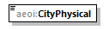
namespace | urn:lu:etat:acd:aeoi_lux:v3.0
type | aeoi:City
properties | content simple
facets | Kind Value Annotation  minLength 1  maxLength 75
source | <xsd:element name="CityPhysical" type="aeoi:City" minOccurs="1" maxOccurs="1"/>

element AEOI_ADDRESS/CountryPhysical
diagram | 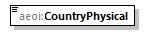
namespace | urn:lu:etat:acd:aeoi_lux:v3.0
type | CountryCode_Type
properties | content simple
facets | Kind Value Annotation  enumeration AF documentation AFGHANISTAN  enumeration AX documentation ALAND ISLANDS  …  enumeration ZW documentation ZIMBABWE
source | <xsd:element name="CountryPhysical" type="isocntr:CountryCode_Type" minOccurs="1" maxOccurs="1"/>

element AEOI_ADDRESS/POBox
diagram | 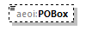
namespace | urn:lu:etat:acd:aeoi_lux:v3.0
type | aeoi:POBOX
properties | minOcc 0  maxOcc 1  content simple
facets | Kind Value Annotation  maxLength 16
source | <xsd:element name="POBox" type="aeoi:POBOX" minOccurs="0" maxOccurs="1"/>

element AEOI_ADDRESS/PostalCodePostal
diagram | 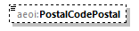
namespace | urn:lu:etat:acd:aeoi_lux:v3.0
type | aeoi:PostalCode
properties | minOcc 0  maxOcc 1  content simple
facets | Kind Value Annotation  minLength 1  maxLength 16
source | <xsd:element name="PostalCodePostal" type="aeoi:PostalCode" minOccurs="0" maxOccurs="1"/>

element AEOI_ADDRESS/CityPostal
diagram | 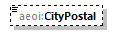
namespace | urn:lu:etat:acd:aeoi_lux:v3.0
type | aeoi:City
properties | minOcc 0  maxOcc 1  content simple
facets | Kind Value Annotation  minLength 1  maxLength 75
source | <xsd:element name="CityPostal" type="aeoi:City" minOccurs="0" maxOccurs="1"/>

element AEOI_ADDRESS/CountryPostal
diagram | 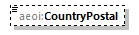
namespace | urn:lu:etat:acd:aeoi_lux:v3.0
type | CountryCode_Type
properties | minOcc 0  maxOcc 1  content simple
facets | Kind Value Annotation  enumeration AF documentation AFGHANISTAN  enumeration AX documentation ALAND ISLANDS  …  enumeration ZW documentation ZIMBABWE
source | <xsd:element name="CountryPostal" type="isocntr:CountryCode_Type" minOccurs="0" maxOccurs="1"/>

complexType AEOI_Depositor
diagram | 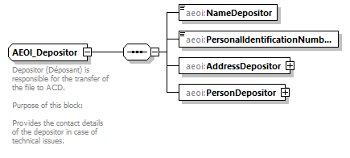
namespace | urn:lu:etat:acd:aeoi_lux:v3.0
children | aeoi:NameDepositor aeoi:PersonalIdentificationNumberDepositor aeoi:AddressDepositor aeoi:PersonDepositor
used by | element AEOI_FATCA/AEOI_Depositor
annotation | documentation  Depositor (Déposant) is responsible for the transfer of the file to ACD.  Purpose of this block:  Provides the contact details of the depositor in case of technical issues.
source | <xsd:complexType name="AEOI_Depositor">  <xsd:annotation>  <xsd:documentation>Depositor (Déposant) is responsible for the transfer of the file to ACD.  Purpose of this block:  Provides the contact details of the depositor in case of technical issues.  </xsd:documentation>  </xsd:annotation>  <xsd:sequence>  <xsd:element name="NameDepositor" type="aeoi:Name" minOccurs="1" maxOccurs="1"/>  <xsd:element name="PersonalIdentificationNumberDepositor" type="aeoi:PersonalIdentificationNumber" minOccurs="1" maxOccurs="1"/>  <xsd:element name="AddressDepositor" type="aeoi:AEOI_ADDRESS" minOccurs="1" maxOccurs="1"/>  <xsd:element name="PersonDepositor" type="aeoi:AEOI_PERSON" minOccurs="1" maxOccurs="1"/>  </xsd:sequence>  </xsd:complexType>

element AEOI_Depositor/NameDepositor
diagram | 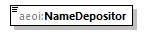
namespace | urn:lu:etat:acd:aeoi_lux:v3.0
type | aeoi:Name
properties | content simple
facets | Kind Value Annotation  minLength 1  maxLength 100
source | <xsd:element name="NameDepositor" type="aeoi:Name" minOccurs="1" maxOccurs="1"/>

element AEOI_Depositor/PersonalIdentificationNumberDepositor
diagram | 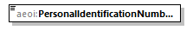
namespace | urn:lu:etat:acd:aeoi_lux:v3.0
type | aeoi:PersonalIdentificationNumber
properties | content simple
facets | Kind Value Annotation  pattern ((([0-2]){1}([0-9]{10})([0-9]{2}){0,1})\s*)|((\s*([Nn](/|\.)?(\s)*[Aa])(\.)?(\s)*))
source | <xsd:element name="PersonalIdentificationNumberDepositor" type="aeoi:PersonalIdentificationNumber" minOccurs="1" maxOccurs="1"/>

element AEOI_Depositor/AddressDepositor
diagram | 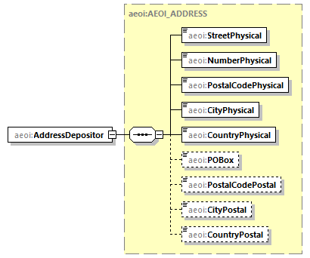
namespace | urn:lu:etat:acd:aeoi_lux:v3.0
type | aeoi:AEOI_ADDRESS
properties | content complex
children | aeoi:StreetPhysical aeoi:NumberPhysical aeoi:PostalCodePhysical aeoi:CityPhysical aeoi:CountryPhysical aeoi:POBox aeoi:PostalCodePostal aeoi:CityPostal aeoi:CountryPostal
source | <xsd:element name="AddressDepositor" type="aeoi:AEOI_ADDRESS" minOccurs="1" maxOccurs="1"/>

element AEOI_Depositor/PersonDepositor
diagram | 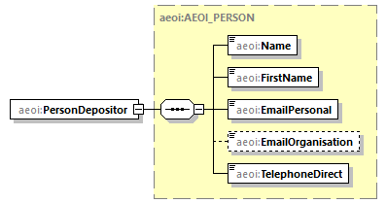
namespace | urn:lu:etat:acd:aeoi_lux:v3.0
type | aeoi:AEOI_PERSON
properties | content complex
children | aeoi:Name aeoi:FirstName aeoi:EmailPersonal aeoi:EmailOrganisation aeoi:TelephoneDirect
source | <xsd:element name="PersonDepositor" type="aeoi:AEOI_PERSON" minOccurs="1" maxOccurs="1"/>

complexType AEOI_PERSON
diagram | 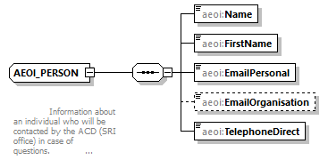
namespace | urn:lu:etat:acd:aeoi_lux:v3.0
children | aeoi:Name aeoi:FirstName aeoi:EmailPersonal aeoi:EmailOrganisation aeoi:TelephoneDirect
used by | elements AEOI_Depositor/PersonDepositor AEOI_ReportingFI_Type/PointOfContactReportingFI
annotation | documentation  Information about an individual who will be contacted by the ACD (SRI office) in case of questions.
source | <xsd:complexType name="AEOI_PERSON">  <xsd:annotation>  <xsd:documentation>  Information about an individual who will be contacted by the ACD (SRI office) in case of questions.  </xsd:documentation>  </xsd:annotation>  <xsd:sequence>  <xsd:element name="Name" type="aeoi:Name" minOccurs="1" maxOccurs="1"/>  <xsd:element name="FirstName" type="aeoi:FirstName" minOccurs="1" maxOccurs="1"/>  <xsd:element name="EmailPersonal" type="aeoi:EmailAddress" minOccurs="1" maxOccurs="1"/>  <xsd:element name="EmailOrganisation" type="aeoi:EmailAddress" minOccurs="0" maxOccurs="1"/>  <xsd:element name="TelephoneDirect" type="aeoi:Telephone" minOccurs="1" maxOccurs="1"/>  </xsd:sequence>  </xsd:complexType>

element AEOI_PERSON/Name
diagram | 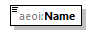
namespace | urn:lu:etat:acd:aeoi_lux:v3.0
type | aeoi:Name
properties | content simple
facets | Kind Value Annotation  minLength 1  maxLength 100
source | <xsd:element name="Name" type="aeoi:Name" minOccurs="1" maxOccurs="1"/>

element AEOI_PERSON/FirstName
diagram | 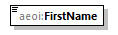
namespace | urn:lu:etat:acd:aeoi_lux:v3.0
type | aeoi:FirstName
properties | content simple
facets | Kind Value Annotation  minLength 1  maxLength 100
source | <xsd:element name="FirstName" type="aeoi:FirstName" minOccurs="1" maxOccurs="1"/>

element AEOI_PERSON/EmailPersonal
diagram | 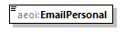
namespace | urn:lu:etat:acd:aeoi_lux:v3.0
type | aeoi:EmailAddress
properties | content simple
facets | Kind Value Annotation  maxLength 254  pattern \w+([-+.'_,;=:'()*!~$?&amp;]\w*)*@\w+([-.]\w+)*\.\w+([-.](\w)+)*
source | <xsd:element name="EmailPersonal" type="aeoi:EmailAddress" minOccurs="1" maxOccurs="1"/>

element AEOI_PERSON/EmailOrganisation
diagram | 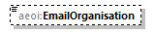
namespace | urn:lu:etat:acd:aeoi_lux:v3.0
type | aeoi:EmailAddress
properties | minOcc 0  maxOcc 1  content simple
facets | Kind Value Annotation  maxLength 254  pattern \w+([-+.'_,;=:'()*!~$?&amp;]\w*)*@\w+([-.]\w+)*\.\w+([-.](\w)+)*
source | <xsd:element name="EmailOrganisation" type="aeoi:EmailAddress" minOccurs="0" maxOccurs="1"/>

element AEOI_PERSON/TelephoneDirect
diagram | 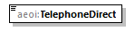
namespace | urn:lu:etat:acd:aeoi_lux:v3.0
type | aeoi:Telephone
properties | content simple
facets | Kind Value Annotation  minLength 1  maxLength 32
source | <xsd:element name="TelephoneDirect" type="aeoi:Telephone" minOccurs="1" maxOccurs="1"/>

complexType AEOI_ReportingFI_Type
diagram | 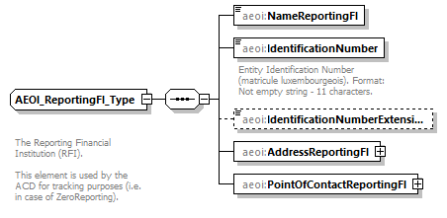
namespace | urn:lu:etat:acd:aeoi_lux:v3.0
children | aeoi:NameReportingFI aeoi:IdentificationNumber aeoi:IdentificationNumberExtension aeoi:AddressReportingFI aeoi:PointOfContactReportingFI
used by | element AEOI_FATCA/AEOI_ReportingFI
annotation | documentation  The Reporting Financial Institution (RFI).  This element is used by the ACD for tracking purposes (i.e. in case of ZeroReporting).
source | <xsd:complexType name="AEOI_ReportingFI_Type">  <xsd:annotation>  <xsd:documentation>  The Reporting Financial Institution (RFI).  This element is used by the ACD for tracking purposes (i.e. in case of ZeroReporting).  </xsd:documentation>  </xsd:annotation>  <xsd:sequence>  <xsd:element name="NameReportingFI" type="aeoi:Name" minOccurs="1" maxOccurs="1"/>  <xsd:element name="IdentificationNumber" type="aeoi:PersonalIdentificationNumber" minOccurs="1" maxOccurs="1">  <xsd:annotation>  <xsd:documentation xml:lang="en">Entity Identification Number (matricule luxembourgeois). Format: Not empty string - 11 characters.</xsd:documentation>  </xsd:annotation>  </xsd:element>  <xsd:element name="IdentificationNumberExtension" type="aeoi:Identifier_Extension_Type" minOccurs="0" maxOccurs="1"/>  <xsd:element name="AddressReportingFI" type="aeoi:AEOI_ADDRESS" minOccurs="1" maxOccurs="1"/>  <xsd:element name="PointOfContactReportingFI" type="aeoi:AEOI_PERSON" minOccurs="1" maxOccurs="1"/>  </xsd:sequence>  </xsd:complexType>

element AEOI_ReportingFI_Type/NameReportingFI
diagram | 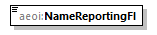
namespace | urn:lu:etat:acd:aeoi_lux:v3.0
type | aeoi:Name
properties | content simple
facets | Kind Value Annotation  minLength 1  maxLength 100
source | <xsd:element name="NameReportingFI" type="aeoi:Name" minOccurs="1" maxOccurs="1"/>

element AEOI_ReportingFI_Type/IdentificationNumber
diagram | 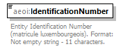
namespace | urn:lu:etat:acd:aeoi_lux:v3.0
type | aeoi:PersonalIdentificationNumber
properties | content simple
facets | Kind Value Annotation  pattern ((([0-2]){1}([0-9]{10})([0-9]{2}){0,1})\s*)|((\s*([Nn](/|\.)?(\s)*[Aa])(\.)?(\s)*))
annotation | documentation  Entity Identification Number (matricule luxembourgeois). Format: Not empty string - 11 characters.
source | <xsd:element name="IdentificationNumber" type="aeoi:PersonalIdentificationNumber" minOccurs="1" maxOccurs="1">  <xsd:annotation>  <xsd:documentation xml:lang="en">Entity Identification Number (matricule luxembourgeois). Format: Not empty string - 11 characters.</xsd:documentation>  </xsd:annotation>  </xsd:element>

element AEOI_ReportingFI_Type/IdentificationNumberExtension
diagram | 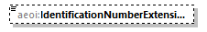
namespace | urn:lu:etat:acd:aeoi_lux:v3.0
type | aeoi:Identifier_Extension_Type
properties | minOcc 0  maxOcc 1  content simple
facets | Kind Value Annotation  pattern (([A-Z])([0-9]{8}))
source | <xsd:element name="IdentificationNumberExtension" type="aeoi:Identifier_Extension_Type" minOccurs="0" maxOccurs="1"/>

element AEOI_ReportingFI_Type/AddressReportingFI
diagram | 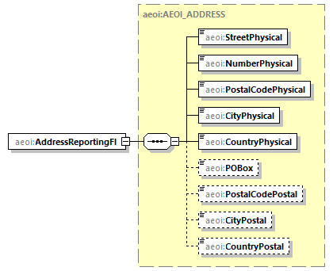
namespace | urn:lu:etat:acd:aeoi_lux:v3.0
type | aeoi:AEOI_ADDRESS
properties | content complex
children | aeoi:StreetPhysical aeoi:NumberPhysical aeoi:PostalCodePhysical aeoi:CityPhysical aeoi:CountryPhysical aeoi:POBox aeoi:PostalCodePostal aeoi:CityPostal aeoi:CountryPostal
source | <xsd:element name="AddressReportingFI" type="aeoi:AEOI_ADDRESS" minOccurs="1" maxOccurs="1"/>

element AEOI_ReportingFI_Type/PointOfContactReportingFI
diagram | 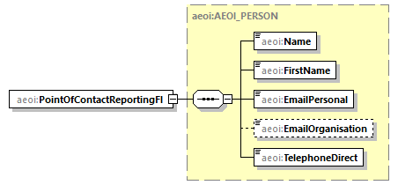
namespace | urn:lu:etat:acd:aeoi_lux:v3.0
type | aeoi:AEOI_PERSON
properties | content complex
children | aeoi:Name aeoi:FirstName aeoi:EmailPersonal aeoi:EmailOrganisation aeoi:TelephoneDirect
source | <xsd:element name="PointOfContactReportingFI" type="aeoi:AEOI_PERSON" minOccurs="1" maxOccurs="1"/>

simpleType City
namespace | urn:lu:etat:acd:aeoi_lux:v3.0
type | restriction of xsd:string
properties | base xsd:string
used by | elements AEOI_ADDRESS/CityPhysical AEOI_ADDRESS/CityPostal
facets | Kind Value Annotation  minLength 1  maxLength 75
annotation | documentation  City, town,Format: Not empty string - up to 75 characters
source | <xsd:simpleType name="City">  <xsd:annotation>  <xsd:documentation>City, town,Format: Not empty string - up to 75 characters</xsd:documentation>  </xsd:annotation>  <xsd:restriction base="xsd:string">  <xsd:maxLength value="75"/>  <xsd:minLength value="1"/>  </xsd:restriction>  </xsd:simpleType>

simpleType EmailAddress
namespace | urn:lu:etat:acd:aeoi_lux:v3.0
type | restriction of xsd:string
properties | base xsd:string
used by | elements AEOI_PERSON/EmailOrganisation AEOI_PERSON/EmailPersonal
facets | Kind Value Annotation  maxLength 254  pattern \w+([-+.'_,;=:'()*!~$?&amp;]\w*)*@\w+([-.]\w+)*\.\w+([-.](\w)+)*
annotation | documentation  Explanation: email address,Format: String - up to 254 characters,Restrictions and form of the  address defined in the regular expression specified (standard grammar of an email address)  e.g.: mon_adresse@mondomaine.lu
source | <xsd:simpleType name="EmailAddress">  <xsd:annotation>  <xsd:documentation>Explanation: email address,Format: String - up to 254 characters,Restrictions and form of the  address defined in the regular expression specified (standard grammar of an email address)  e.g.: mon_adresse@mondomaine.lu  </xsd:documentation>  </xsd:annotation>  <xsd:restriction base="xsd:string">  <xsd:maxLength value="254"/>  <xsd:pattern value="\w+([-+.'_,;=:'()*!~$?&amp;]\w*)*@\w+([-.]\w+)*\.\w+([-.](\w)+)*"/>  </xsd:restriction>  </xsd:simpleType>

simpleType FirstName
namespace | urn:lu:etat:acd:aeoi_lux:v3.0
type | restriction of xsd:string
properties | base xsd:string
used by | element AEOI_PERSON/FirstName
facets | Kind Value Annotation  minLength 1  maxLength 100
annotation | documentation  First name,Format: Not empty string - up to 100 characters
source | <xsd:simpleType name="FirstName">  <xsd:annotation>  <xsd:documentation>First name,Format: Not empty string - up to 100 characters</xsd:documentation>  </xsd:annotation>  <xsd:restriction base="xsd:string">  <xsd:minLength value="1"/>  <xsd:maxLength value="100"/>  </xsd:restriction>  </xsd:simpleType>

simpleType GIIN_Identifier_Type
namespace | urn:lu:etat:acd:aeoi_lux:v3.0
type | restriction of xsd:string
properties | base xsd:string
used by | element AEOI_FATCA/RFI_Identifier
facets | Kind Value Annotation  pattern ([A-NP-Z0-9]{6})(\.)([A-NP-Z0-9]{5})(\.)([A-Z]){2}(\.)(\d){3}
annotation | documentation  The RFI_Identifier defines the overall RFI Identification Number which is used in all RefId's  (AEOI_RefId, DocRefId, MessageRefId...) and also used as ID inside the file name. In the context of the FATCA  exchange this ID must be the RFI GIIN.  GIIN means a Global Intermediary Identification Number assigned to the  Reporting Luxembourg Financial Institution by the IRS.  Format: Compliant to the IRS GIIN definition see URL:  http://www.irs.gov/PUP/businesses/corporations/giin_composition.pdf
source | <xsd:simpleType name="GIIN_Identifier_Type">  <xsd:annotation>  <xsd:documentation>The RFI_Identifier defines the overall RFI Identification Number which is used in all RefId's  (AEOI_RefId, DocRefId, MessageRefId...) and also used as ID inside the file name. In the context of the FATCA  exchange this ID must be the RFI GIIN.  GIIN means a Global Intermediary Identification Number assigned to the  Reporting Luxembourg Financial Institution by the IRS.  Format: Compliant to the IRS GIIN definition see URL:  http://www.irs.gov/PUP/businesses/corporations/giin_composition.pdf  </xsd:documentation>  </xsd:annotation>  <xsd:restriction base="xsd:string">  <xsd:pattern value="([A-NP-Z0-9]{6})(\.)([A-NP-Z0-9]{5})(\.)([A-Z]){2}(\.)(\d){3}"/>  </xsd:restriction>  </xsd:simpleType>

simpleType Id_with_Extension_Type
namespace | urn:lu:etat:acd:aeoi_lux:v3.0
type | restriction of xsd:string
properties | base xsd:string
facets | Kind Value Annotation  pattern (([0-2]){1}([0-9]{10})([0-9]{2}){0,1})([A-Z])([0-9]{8})
annotation | documentation  Identification Number plus Extension. Please refer to the official documentation
source | <xsd:simpleType name="Id_with_Extension_Type">  <xsd:annotation>  <xsd:documentation>Identification Number plus Extension. Please refer to the official documentation  </xsd:documentation>  </xsd:annotation>  <xsd:restriction base="xsd:string">  <xsd:pattern value="(([0-2]){1}([0-9]{10})([0-9]{2}){0,1})([A-Z])([0-9]{8})"/>  </xsd:restriction>  </xsd:simpleType>

simpleType Identifier_Extension_Type
namespace | urn:lu:etat:acd:aeoi_lux:v3.0
type | restriction of xsd:string
properties | base xsd:string
used by | element AEOI_ReportingFI_Type/IdentificationNumberExtension
facets | Kind Value Annotation  pattern (([A-Z])([0-9]{8}))
annotation | documentation  Identification Number Extension. Please refer to the official documentation
source | <xsd:simpleType name="Identifier_Extension_Type">  <xsd:annotation>  <xsd:documentation>Identification Number Extension. Please refer to the official documentation  </xsd:documentation>  </xsd:annotation>  <xsd:restriction base="xsd:string">  <xsd:pattern value="(([A-Z])([0-9]{8}))"/>  </xsd:restriction>  </xsd:simpleType>

simpleType Name
namespace | urn:lu:etat:acd:aeoi_lux:v3.0
type | restriction of xsd:string
properties | base xsd:string
used by | elements AEOI_PERSON/Name AEOI_Depositor/NameDepositor AEOI_ReportingFI_Type/NameReportingFI
facets | Kind Value Annotation  minLength 1  maxLength 100
annotation | documentation  Personal name or company name, Format: Not empty string - up to 100 characters
source | <xsd:simpleType name="Name">  <xsd:annotation>  <xsd:documentation> Personal name or company name, Format: Not empty string - up to 100 characters  </xsd:documentation>  </xsd:annotation>  <xsd:restriction base="xsd:string">  <xsd:minLength value="1"/>  <xsd:maxLength value="100"/>  </xsd:restriction>  </xsd:simpleType>

simpleType Number
namespace | urn:lu:etat:acd:aeoi_lux:v3.0
type | restriction of xsd:string
properties | base xsd:string
used by | element AEOI_ADDRESS/NumberPhysical
facets | Kind Value Annotation  maxLength 100
annotation | documentation  Building, house or apartment number,Format: Not empty string - up to 100 characters
source | <xsd:simpleType name="Number">  <xsd:annotation>  <xsd:documentation>Building, house or apartment number,Format: Not empty string - up to 100 characters  </xsd:documentation>  </xsd:annotation>  <xsd:restriction base="xsd:string">  <xsd:maxLength value="100"/>  </xsd:restriction>  </xsd:simpleType>

simpleType PersonalIdentificationNumber
namespace | urn:lu:etat:acd:aeoi_lux:v3.0
type | restriction of xsd:string
properties | base xsd:string
used by | elements AEOI_ReportingFI_Type/IdentificationNumber AEOI_Depositor/PersonalIdentificationNumberDepositor
facets | Kind Value Annotation  pattern ((([0-2]){1}([0-9]{10})([0-9]{2}){0,1})\s*)|((\s*([Nn](/|\.)?(\s)*[Aa])(\.)?(\s)*))
annotation | documentation  Identification number (matricule) Format: Not empty string - up to 13 characters.
source | <xsd:simpleType name="PersonalIdentificationNumber">  <xsd:annotation>  <xsd:documentation>Identification number (matricule) Format: Not empty string - up to 13 characters.  </xsd:documentation>  </xsd:annotation>  <xsd:restriction base="xsd:string">  <xsd:pattern value="((([0-2]){1}([0-9]{10})([0-9]{2}){0,1})\s*)|((\s*([Nn](/|\.)?(\s)*[Aa])(\.)?(\s)*))"/>  </xsd:restriction>  </xsd:simpleType>

simpleType POBOX
namespace | urn:lu:etat:acd:aeoi_lux:v3.0
type | restriction of xsd:string
properties | base xsd:string
used by | element AEOI_ADDRESS/POBox
facets | Kind Value Annotation  maxLength 16
annotation | documentation  PO Box, Format: String - up to 16 characters
source | <xsd:simpleType name="POBOX">  <xsd:annotation>  <xsd:documentation> PO Box, Format: String - up to 16 characters  </xsd:documentation>  </xsd:annotation>  <xsd:restriction base="xsd:string">  <xsd:maxLength value="16"/>  </xsd:restriction>  </xsd:simpleType>

simpleType PostalCode
namespace | urn:lu:etat:acd:aeoi_lux:v3.0
type | restriction of xsd:string
properties | base xsd:string
used by | elements AEOI_ADDRESS/PostalCodePhysical AEOI_ADDRESS/PostalCodePostal
facets | Kind Value Annotation  minLength 1  maxLength 16
annotation | documentation  Postal code, ZIP code  Format: Not empty string - up to 16 characters  No restriction on the characters - not necessarily contain only numbers  Warning: the country code should not be included! (see Type "country_code")
source | <xsd:simpleType name="PostalCode">  <xsd:annotation>  <xsd:documentation>Postal code, ZIP code  Format: Not empty string - up to 16 characters  No restriction on the characters - not necessarily contain only numbers  Warning: the country code should not be included! (see Type "country_code")  </xsd:documentation>  </xsd:annotation>  <xsd:restriction base="xsd:string">  <xsd:minLength value="1"/>  <xsd:maxLength value="16"/>  </xsd:restriction>  </xsd:simpleType>

simpleType ReportingPeriod
namespace | urn:lu:etat:acd:aeoi_lux:v3.0
type | restriction of xsd:string
properties | base xsd:string
used by | element AEOI_FATCA/ReportContent/ReportingPeriod
facets | Kind Value Annotation  pattern ((2)[0-9]{3})(-)([0-1][0-9])(-)(([0-3])([0-9]))
annotation | documentation  The reporting calendar year for which information is transmitted in documents of the current  message. Format: YYYY-MM-DD e.g.: “2014-12-31” for calendar year 2014.
source | <xsd:simpleType name="ReportingPeriod">  <xsd:annotation>  <xsd:documentation>The reporting calendar year for which information is transmitted in documents of the current  message. Format: YYYY-MM-DD e.g.: “2014-12-31” for calendar year 2014.  </xsd:documentation>  </xsd:annotation>  <xsd:restriction base="xsd:string">  <xsd:pattern value="((2)[0-9]{3})(-)([0-1][0-9])(-)(([0-3])([0-9]))"/>  </xsd:restriction>  </xsd:simpleType>

simpleType ReportRefId_Type
namespace | urn:lu:etat:acd:aeoi_lux:v3.0
type | restriction of xsd:string
properties | base xsd:string
used by | element AEOI_FATCA/AEOI_RefId
facets | Kind Value Annotation  minLength 1  maxLength 100
annotation | documentation  The AEOI_RefId is the Automatic Exchange Of Information main identifier on file level and must for  each produced report be unique.  Expected Format:  FATCA: $GIIN_$YEAR_$RP_$ID, where: $GINN is the Global IRS identifier, $YEAR is the reporting year (YYYY), $RP is the  block for the report (HL for this bloc), and $ID identification defined by the financial institution.  CRS/DAC2: $LU$YYYY$LU_$RPC_$IDMatric$Ext_$ID where LU = country code ISO 3166-1 alpha-2 of Luxembourg  $YYYY = reporting financial year,$BLOC $RP is the block for the report (HL for this bloc) $IDMatric the personal  Identification Number of the RFI, $Ext the Identification Number Extension (Please refer to the official documentation),  and the $ID identification defined by the financial institution.  The $ID identification should not include special characters (Please refer to the official documentation)
source | <xsd:simpleType name="ReportRefId_Type">  <xsd:annotation>  <xsd:documentation>The AEOI_RefId is the Automatic Exchange Of Information main identifier on file level and must for  each produced report be unique.  Expected Format:  FATCA: $GIIN_$YEAR_$RP_$ID, where: $GINN is the Global IRS identifier, $YEAR is the reporting year (YYYY), $RP is the  block for the report (HL for this bloc), and $ID identification defined by the financial institution.  CRS/DAC2: $LU$YYYY$LU_$RPC_$IDMatric$Ext_$ID where LU = country code ISO 3166-1 alpha-2 of Luxembourg  $YYYY = reporting financial year,$BLOC $RP is the block for the report (HL for this bloc) $IDMatric the personal  Identification Number of the RFI, $Ext the Identification Number Extension (Please refer to the official documentation),  and the $ID identification defined by the financial institution.  The $ID identification should not include special characters (Please refer to the official documentation)  </xsd:documentation>  </xsd:annotation>  <xsd:restriction base="xsd:string">  <xsd:minLength value="1"/>  <xsd:maxLength value="100"/>  </xsd:restriction>  </xsd:simpleType>

simpleType Street
namespace | urn:lu:etat:acd:aeoi_lux:v3.0
type | restriction of xsd:string
properties | base xsd:string
used by | element AEOI_ADDRESS/StreetPhysical
facets | Kind Value Annotation  maxLength 100
annotation | documentation  Street name or local name Format: Not empty string - up to 100 characters
source | <xsd:simpleType name="Street">  <xsd:annotation>  <xsd:documentation>Street name or local name Format: Not empty string - up to 100 characters  </xsd:documentation>  </xsd:annotation>  <xsd:restriction base="xsd:string">  <xsd:maxLength value="100"/>  </xsd:restriction>  </xsd:simpleType>

simpleType Telephone
namespace | urn:lu:etat:acd:aeoi_lux:v3.0
type | restriction of xsd:string
properties | base xsd:string
used by | element AEOI_PERSON/TelephoneDirect
facets | Kind Value Annotation  minLength 1  maxLength 32
annotation | documentation  Phone numberExplanation: Phone number, Format: Not empty string - up to 32 characters,  e.g.: +352 25123456
source | <xsd:simpleType name="Telephone">  <xsd:annotation>  <xsd:documentation>Phone numberExplanation: Phone number, Format: Not empty string - up to 32 characters,  e.g.: +352 25123456  </xsd:documentation>  </xsd:annotation>  <xsd:restriction base="xsd:string">  <xsd:minLength value="1"/>  <xsd:maxLength value="32"/>  </xsd:restriction>  </xsd:simpleType>

simpleType ZeroReport
namespace | urn:lu:etat:acd:aeoi_lux:v3.0
type | restriction of xsd:boolean
properties | base xsd:boolean
used by | element AEOI_FATCA/ReportContent/ZeroReporting
facets | Kind Value Annotation  pattern true|1
annotation | documentation  Indicates if this report is a Zero Report. Boolean type: Legal values for this boolean is only  true,TRUE,1(which indicates true)
source | <xsd:simpleType name="ZeroReport">  <xsd:annotation>  <xsd:documentation>Indicates if this report is a Zero Report. Boolean type: Legal values for this boolean is only  true,TRUE,1(which indicates true)  </xsd:documentation>  </xsd:annotation>  <xsd:restriction base="xsd:boolean">  <xsd:pattern value="true|1"/>  </xsd:restriction>  </xsd:simpleType>

simpleType CountryCode_Type
namespace | urn:oecd:ties:isofatcatypes:v1
type | restriction of xsd:string
properties | base xsd:string
used by | elements Address_Type/CountryCode PersonParty_Type/BirthInfo/CountryInfo/CountryCode PersonParty_Type/Nationality MessageSpec_Type/ReceivingCountry OrganisationParty_Type/ResCountryCode PersonParty_Type/ResCountryCode MessageSpec_Type/TransmittingCountry  attribute TIN_Type/@issuedBy
facets | Kind Value Annotation  enumeration AF documentation AFGHANISTAN  enumeration AX documentation ALAND ISLANDS  …  enumeration ZW documentation ZIMBABWE
annotation | documentation  ISO-3166 Alpha 2 country codes
source | <xsd:simpleType name="CountryCode_Type">  <xsd:annotation>  <xsd:documentation xml:lang="en">ISO-3166 Alpha 2 country codes</xsd:documentation>  </xsd:annotation>  <xsd:restriction base="xsd:string">  <xsd:enumeration value="AF">  <xsd:annotation>  <xsd:documentation>AFGHANISTAN</xsd:documentation>  </xsd:annotation>  </xsd:enumeration>  …  <xsd:enumeration value="LU">  <xsd:annotation>  <xsd:documentation>LUXEMBOURG</xsd:documentation>  </xsd:annotation>  …  </xsd:enumeration>  <xsd:enumeration value="US">  <xsd:annotation>  <xsd:documentation>UNITED STATES</xsd:documentation>  </xsd:annotation>  …  </xsd:enumeration>  <xsd:enumeration value="ZW">  <xsd:annotation>  <xsd:documentation>ZIMBABWE</xsd:documentation>  </xsd:annotation>  </xsd:enumeration>  </xsd:restriction>  </xsd:simpleType>

simpleType currCode_Type
namespace | urn:oecd:ties:isofatcatypes:v1
type | restriction of xsd:string
properties | base xsd:string
used by | attribute MonAmnt_Type/@currCode
facets | Kind Value Annotation  enumeration AED documentation UAE Dirham: UNITED ARAB EMIRATES  enumeration AFN documentation Afghani: AFGHANISTAN  …  enumeration ZWL documentation Zimbabwe Dollar: ZIMBABWE
annotation | documentation  The appropriate three-byte alpha currency code from ISO 4217 list to express currency for monetary amount.  The former DEM - Germany, Deutsche Mark - was temporarily added to allow data from earlier years still to be transmitted.
source | <xsd:enumeration value="ZWL">  <xsd:annotation>  <xsd:documentation>Zimbabwe Dollar: ZIMBABWE</xsd:documentation>  </xsd:annotation>  </xsd:enumeration>  </xsd:restriction>  </xsd:simpleType>

complexType Address_Type
diagram | 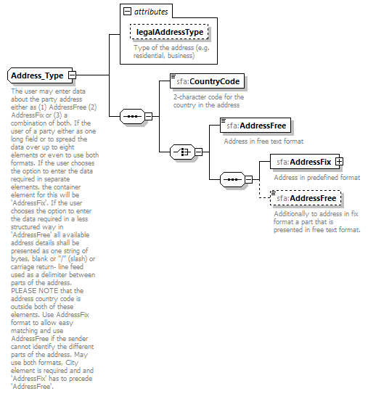
namespace | urn:oecd:ties:stffatcatypes:v2
children | sfa:CountryCode sfa:AddressFree sfa:AddressFix sfa:AddressFree
used by | elements OrganisationParty_Type/Address PersonParty_Type/Address
attributes | Name Type Use Default Fixed Annotation  legalAddressType stf:OECDLegalAddressType_EnumType optional documentation Type of the address (e.g. residential, business)
annotation | documentation  The user may enter data about the party address either as (1) AddressFree (2) AddressFix or (3) a combination of both. If the user of a party either as one long field or to spread the data over up to eight elements or even to use both formats. If the user chooses the option to enter the data required in separate elements, the container element for this will be 'AddressFix'. If the user chooses the option to enter the data required in a less structured way in 'AddressFree' all available address details shall be presented as one string of bytes, blank or "/" (slash) or carriage return- line feed used as a delimiter between parts of the address. PLEASE NOTE that the address country code is outside both of these elements. Use AddressFix format to allow easy matching and use AddressFree if the sender cannot identify the different parts of the address. May use both formats, City element is required and and 'AddressFix' has to precede 'AddressFree'.
source | <xsd:complexType name="Address_Type">  <xsd:annotation>  <xsd:documentation xml:lang="en">The user may enter data about the party address either as (1) AddressFree (2) AddressFix or (3) a combination of both. If the user of a party either as one long field or to spread the data over up to eight elements or even to use both formats. If the user chooses the option to enter the data required in separate elements, the container element for this will be 'AddressFix'. If the user chooses the option to enter the data required in a less structured way in 'AddressFree' all available address details shall be presented as one string of bytes, blank or "/" (slash) or carriage return- line feed used as a delimiter between parts of the address. PLEASE NOTE that the address country code is outside both of these elements. Use AddressFix format to allow easy matching and use AddressFree if the sender cannot identify the different parts of the address. May use both formats, City element is required and and 'AddressFix' has to precede 'AddressFree'.</xsd:documentation>  </xsd:annotation>  <xsd:sequence>  <xsd:element name="CountryCode" type="iso:CountryCode_Type">  <xsd:annotation>  <xsd:documentation xml:lang="en">2-character code for the country in the address</xsd:documentation>  </xsd:annotation>  </xsd:element>  <xsd:choice>  <xsd:element name="AddressFree" type="sfa:StringMax4000_Type">  <xsd:annotation>  <xsd:documentation xml:lang="en">Address in free text format</xsd:documentation>  </xsd:annotation>  </xsd:element>  <xsd:sequence>  <xsd:element name="AddressFix" type="sfa:AddressFix_Type">  <xsd:annotation>  <xsd:documentation xml:lang="en">Address in predefined format</xsd:documentation>  </xsd:annotation>  </xsd:element>  <xsd:element name="AddressFree" type="sfa:StringMax4000_Type" minOccurs="0">  <xsd:annotation>  <xsd:documentation xml:lang="en">Additionally to address in fix format a part that is presented in free text format.</xsd:documentation>  </xsd:annotation>  </xsd:element>  </xsd:sequence>  </xsd:choice>  </xsd:sequence>  <xsd:attribute name="legalAddressType" type="stf:OECDLegalAddressType_EnumType" use="optional">  <xsd:annotation>  <xsd:documentation xml:lang="en">Type of the address (e.g. residential, business)</xsd:documentation>  </xsd:annotation>  </xsd:attribute>  </xsd:complexType>

attribute Address_Type/@legalAddressType
type | stf:OECDLegalAddressType_EnumType
properties | use optional
facets | Kind Value Annotation  enumeration OECD301  enumeration OECD302  enumeration OECD303  enumeration OECD304  enumeration OECD305
annotation | documentation  Type of the address (e.g. residential, business)
source | <xsd:attribute name="legalAddressType" type="stf:OECDLegalAddressType_EnumType" use="optional">  <xsd:annotation>  <xsd:documentation xml:lang="en">Type of the address (e.g. residential, business)</xsd:documentation>  </xsd:annotation>  </xsd:attribute>

element Address_Type/CountryCode
diagram | 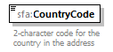
namespace | urn:oecd:ties:stffatcatypes:v2
type | iso:CountryCode_Type
properties | content simple
facets | Kind Value Annotation  enumeration AF documentation AFGHANISTAN  …  enumeration LU documentation LUXEMBOURG  …  enumeration US documentation UNITED STATES  …  enumeration ZW documentation ZIMBABWE
annotation | documentation  2-character code for the country in the address
source | <xsd:element name="CountryCode" type="iso:CountryCode_Type">  <xsd:annotation>  <xsd:documentation xml:lang="en">2-character code for the country in the address</xsd:documentation>  </xsd:annotation>  </xsd:element>

element Address_Type/AddressFree
diagram | 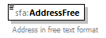
namespace | urn:oecd:ties:stffatcatypes:v2
type | sfa:StringMax4000_Type
properties | content simple
facets | Kind Value Annotation  minLength 0  maxLength 4000
annotation | documentation  Address in free text format
source | <xsd:element name="AddressFree" type="sfa:StringMax4000_Type">  <xsd:annotation>  <xsd:documentation xml:lang="en">Address in free text format</xsd:documentation>  </xsd:annotation>  </xsd:element>

element Address_Type/AddressFix
diagram | 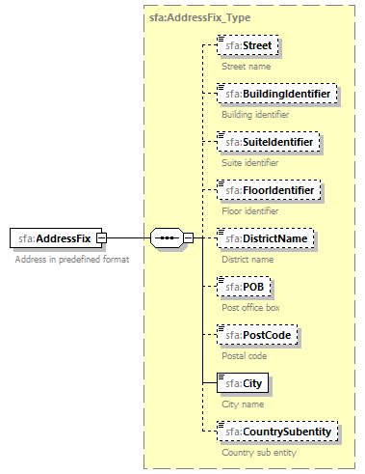
namespace | urn:oecd:ties:stffatcatypes:v2
type | sfa:AddressFix_Type
properties | content complex
children | sfa:Street sfa:BuildingIdentifier sfa:SuiteIdentifier sfa:FloorIdentifier sfa:DistrictName sfa:POB sfa:PostCode sfa:City sfa:CountrySubentity
annotation | documentation  Address in predefined format
source | <xsd:element name="AddressFix" type="sfa:AddressFix_Type">  <xsd:annotation>  <xsd:documentation xml:lang="en">Address in predefined format</xsd:documentation>  </xsd:annotation>  </xsd:element>

element Address_Type/AddressFree
diagram | 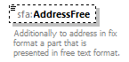
namespace | urn:oecd:ties:stffatcatypes:v2
type | sfa:StringMax4000_Type
properties | minOcc 0  maxOcc 1  content simple
facets | Kind Value Annotation  minLength 0  maxLength 4000
annotation | documentation  Additionally to address in fix format a part that is presented in free text format.
source | <xsd:element name="AddressFree" type="sfa:StringMax4000_Type" minOccurs="0">  <xsd:annotation>  <xsd:documentation xml:lang="en">Additionally to address in fix format a part that is presented in free text format.</xsd:documentation>  </xsd:annotation>  </xsd:element>

complexType AddressFix_Type
diagram | 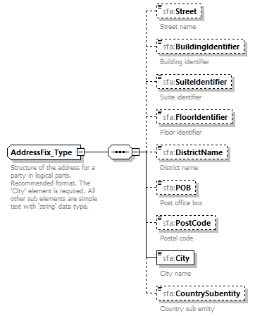
namespace | urn:oecd:ties:stffatcatypes:v2
children | sfa:Street sfa:BuildingIdentifier sfa:SuiteIdentifier sfa:FloorIdentifier sfa:DistrictName sfa:POB sfa:PostCode sfa:City sfa:CountrySubentity
used by | element Address_Type/AddressFix
annotation | documentation  Structure of the address for a party in logical parts. Recommended format. The 'City' element is required. All other sub elements are simple text with 'string' data type.
source | <xsd:complexType name="AddressFix_Type">  <xsd:annotation>  <xsd:documentation xml:lang="en">Structure of the address for a party in logical parts. Recommended format. The 'City' element is required. All other sub elements are simple text with 'string' data type.</xsd:documentation>  </xsd:annotation>  <xsd:sequence>  <xsd:element name="Street" type="sfa:StringMax200_Type" minOccurs="0">  <xsd:annotation>  <xsd:documentation xml:lang="en">Street name</xsd:documentation>  </xsd:annotation>  </xsd:element>  <xsd:element name="BuildingIdentifier" type="sfa:StringMax200_Type" minOccurs="0">  <xsd:annotation>  <xsd:documentation xml:lang="en">Building identifier</xsd:documentation>  </xsd:annotation>  </xsd:element>  <xsd:element name="SuiteIdentifier" type="sfa:StringMax200_Type" minOccurs="0">  <xsd:annotation>  <xsd:documentation xml:lang="en">Suite identifier</xsd:documentation>  </xsd:annotation>  </xsd:element>  <xsd:element name="FloorIdentifier" type="sfa:StringMax200_Type" minOccurs="0">  <xsd:annotation>  <xsd:documentation xml:lang="en">Floor identifier</xsd:documentation>  </xsd:annotation>  </xsd:element>  <xsd:element name="DistrictName" type="sfa:StringMax200_Type" minOccurs="0">  <xsd:annotation>  <xsd:documentation xml:lang="en">District name</xsd:documentation>  </xsd:annotation>  </xsd:element>  <xsd:element name="POB" type="sfa:StringMax200_Type" minOccurs="0">  <xsd:annotation>  <xsd:documentation xml:lang="en">Post office box</xsd:documentation>  </xsd:annotation>  </xsd:element>  <xsd:element name="PostCode" type="sfa:StringMax200_Type" minOccurs="0">  <xsd:annotation>  <xsd:documentation xml:lang="en">Postal code</xsd:documentation>  </xsd:annotation>  </xsd:element>  <xsd:element name="City" type="sfa:StringMax200_Type">  <xsd:annotation>  <xsd:documentation xml:lang="en">City name</xsd:documentation>  </xsd:annotation>  </xsd:element>  <xsd:element name="CountrySubentity" type="sfa:StringMax200_Type" minOccurs="0">  <xsd:annotation>  <xsd:documentation xml:lang="en">Country sub entity</xsd:documentation>  </xsd:annotation>  </xsd:element>  </xsd:sequence>  </xsd:complexType>

element AddressFix_Type/Street
diagram | 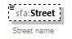
namespace | urn:oecd:ties:stffatcatypes:v2
type | sfa:StringMax200_Type
properties | minOcc 0  maxOcc 1  content simple
facets | Kind Value Annotation  minLength 0  maxLength 200
annotation | documentation  Street name
source | <xsd:element name="Street" type="sfa:StringMax200_Type" minOccurs="0">  <xsd:annotation>  <xsd:documentation xml:lang="en">Street name</xsd:documentation>  </xsd:annotation>  </xsd:element>

element AddressFix_Type/BuildingIdentifier
diagram | 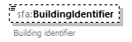
namespace | urn:oecd:ties:stffatcatypes:v2
type | sfa:StringMax200_Type
properties | minOcc 0  maxOcc 1  content simple
facets | Kind Value Annotation  minLength 0  maxLength 200
annotation | documentation  Building identifier
source | <xsd:element name="BuildingIdentifier" type="sfa:StringMax200_Type" minOccurs="0">  <xsd:annotation>  <xsd:documentation xml:lang="en">Building identifier</xsd:documentation>  </xsd:annotation>  </xsd:element>

element AddressFix_Type/SuiteIdentifier
diagram | 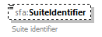
namespace | urn:oecd:ties:stffatcatypes:v2
type | sfa:StringMax200_Type
properties | minOcc 0  maxOcc 1  content simple
facets | Kind Value Annotation  minLength 0  maxLength 200
annotation | documentation  Suite identifier
source | <xsd:element name="SuiteIdentifier" type="sfa:StringMax200_Type" minOccurs="0">  <xsd:annotation>  <xsd:documentation xml:lang="en">Suite identifier</xsd:documentation>  </xsd:annotation>  </xsd:element>

element AddressFix_Type/FloorIdentifier
diagram | 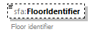
namespace | urn:oecd:ties:stffatcatypes:v2
type | sfa:StringMax200_Type
properties | minOcc 0  maxOcc 1  content simple
facets | Kind Value Annotation  minLength 0  maxLength 200
annotation | documentation  Floor identifier
source | <xsd:element name="FloorIdentifier" type="sfa:StringMax200_Type" minOccurs="0">  <xsd:annotation>  <xsd:documentation xml:lang="en">Floor identifier</xsd:documentation>  </xsd:annotation>  </xsd:element>

element AddressFix_Type/DistrictName
diagram | 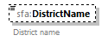
namespace | urn:oecd:ties:stffatcatypes:v2
type | sfa:StringMax200_Type
properties | minOcc 0  maxOcc 1  content simple
facets | Kind Value Annotation  minLength 0  maxLength 200
annotation | documentation  District name
source | <xsd:element name="DistrictName" type="sfa:StringMax200_Type" minOccurs="0">  <xsd:annotation>  <xsd:documentation xml:lang="en">District name</xsd:documentation>  </xsd:annotation>  </xsd:element>

element AddressFix_Type/POB
diagram
namespace | urn:oecd:ties:stffatcatypes:v2
type | sfa:StringMax200_Type
properties | minOcc 0  maxOcc 1  content simple
facets | Kind Value Annotation  minLength 0  maxLength 200
annotation | documentation  Post office box
source | <xsd:element name="POB" type="sfa:StringMax200_Type" minOccurs="0">  <xsd:annotation>  <xsd:documentation xml:lang="en">Post office box</xsd:documentation>  </xsd:annotation>  </xsd:element>

element AddressFix_Type/PostCode
diagram | 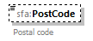
namespace | urn:oecd:ties:stffatcatypes:v2
type | sfa:StringMax200_Type
properties | minOcc 0  maxOcc 1  content simple
facets | Kind Value Annotation  minLength 0  maxLength 200
annotation | documentation  Postal code
source | <xsd:element name="PostCode" type="sfa:StringMax200_Type" minOccurs="0">  <xsd:annotation>  <xsd:documentation xml:lang="en">Postal code</xsd:documentation>  </xsd:annotation>  </xsd:element>

element AddressFix_Type/City
diagram | 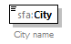
namespace | urn:oecd:ties:stffatcatypes:v2
type | sfa:StringMax200_Type
properties | content simple
facets | Kind Value Annotation  minLength 0  maxLength 200
annotation | documentation  City name
source | <xsd:element name="City" type="sfa:StringMax200_Type">  <xsd:annotation>  <xsd:documentation xml:lang="en">City name</xsd:documentation>  </xsd:annotation>  </xsd:element>

element AddressFix_Type/CountrySubentity
diagram | 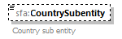
namespace | urn:oecd:ties:stffatcatypes:v2
type | sfa:StringMax200_Type
properties | minOcc 0  maxOcc 1  content simple
facets | Kind Value Annotation  minLength 0  maxLength 200
annotation | documentation  Country sub entity
source | <xsd:element name="CountrySubentity" type="sfa:StringMax200_Type" minOccurs="0">  <xsd:annotation>  <xsd:documentation xml:lang="en">Country sub entity</xsd:documentation>  </xsd:annotation>  </xsd:element>

complexType MessageSpec_Type
diagram | 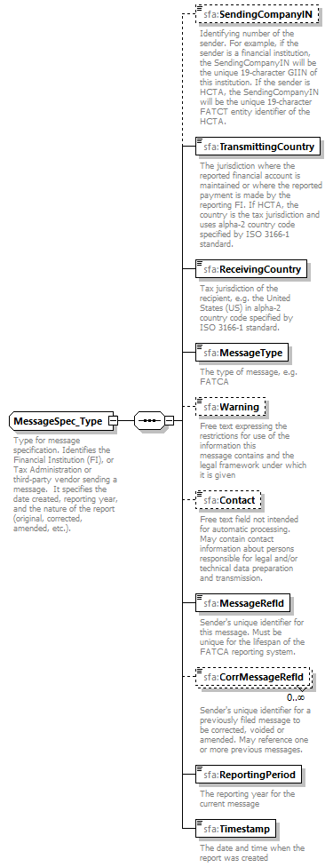
namespace | urn:oecd:ties:stffatcatypes:v2
children | sfa:SendingCompanyIN sfa:TransmittingCountry sfa:ReceivingCountry sfa:MessageType sfa:Warning sfa:Contact sfa:MessageRefId sfa:CorrMessageRefId sfa:ReportingPeriod sfa:Timestamp
used by | element FATCA_LUX/MessageSpec
annotation | documentation  Type for message specification. Identifies the Financial Institution (FI), or Tax Administration or third-party vendor sending a message. It specifies the date created, reporting year, and the nature of the report (original, corrected, amended, etc.).
source | <xsd:complexType name="MessageSpec_Type">  <xsd:annotation>  <xsd:documentation xml:lang="en">Type for message specification. Identifies the Financial Institution (FI), or Tax Administration or third-party vendor sending a message. It specifies the date created, reporting year, and the nature of the report (original, corrected, amended, etc.).</xsd:documentation>  </xsd:annotation>  <xsd:sequence>  <xsd:element name="SendingCompanyIN" type="sfa:StringMax200_Type" minOccurs="0">  <xsd:annotation>  <xsd:documentation xml:lang="en">Identifying number of the sender. For example, if the sender is a financial institution, the SendingCompanyIN will be the unique 19-character GIIN of this institution. If the sender is HCTA, the SendingCompanyIN will be the unique 19-character FATCT entity identifier of the HCTA.</xsd:documentation>  </xsd:annotation>  </xsd:element>  <xsd:element name="TransmittingCountry" type="iso:CountryCode_Type">  <xsd:annotation>  <xsd:documentation xml:lang="en">The jurisdiction where the reported financial account is maintained or where the reported payment is made by the reporting FI. If HCTA, the country is the tax jurisdiction and uses alpha-2 country code specified by ISO 3166-1 standard.</xsd:documentation>  </xsd:annotation>  </xsd:element>  <xsd:element name="ReceivingCountry" type="iso:CountryCode_Type">  <xsd:annotation>  <xsd:documentation xml:lang="en">Tax jurisdiction of the recipient, e.g. the United States (US) in alpha-2 country code specified by ISO 3166-1 standard.</xsd:documentation>  </xsd:annotation>  </xsd:element>  <xsd:element name="MessageType" type="sfa:MessageType_EnumType">  <xsd:annotation>  <xsd:documentation xml:lang="en">The type of message, e.g. FATCA</xsd:documentation>  </xsd:annotation>  </xsd:element>  <xsd:element name="Warning" type="sfa:StringMax4000_Type" minOccurs="0">  <xsd:annotation>  <xsd:documentation xml:lang="en">Free text expressing the restrictions for use of the information this  message contains and the legal framework under which it is given</xsd:documentation>  </xsd:annotation>  </xsd:element>  <xsd:element name="Contact" type="sfa:StringMax200_Type" minOccurs="0">  <xsd:annotation>  <xsd:documentation xml:lang="en">Free text field not intended for automatic processing. May contain contact information about persons responsible for legal and/or technical data preparation and transmission.</xsd:documentation>  </xsd:annotation>  <!-- changed to optional -->  </xsd:element>  <xsd:element name="MessageRefId" type="sfa:StringMax200_Type">  <xsd:annotation>  <xsd:documentation xml:lang="en">Sender's unique identifier for this message. Must be unique for the lifespan of the FATCA reporting system.</xsd:documentation>  </xsd:annotation>  </xsd:element>  <xsd:element name="CorrMessageRefId" type="sfa:StringMax200_Type" minOccurs="0" maxOccurs="unbounded">  <xsd:annotation>  <xsd:documentation xml:lang="en">Sender's unique identifier for a previously filed message to be corrected, voided or amended. May reference one or more previous messages.</xsd:documentation>  </xsd:annotation>  </xsd:element>  <xsd:element name="ReportingPeriod" type="xsd:date">  <xsd:annotation>  <xsd:documentation xml:lang="en">The reporting year for the current message</xsd:documentation>  </xsd:annotation>  </xsd:element>  <xsd:element name="Timestamp" type="xsd:dateTime">  <xsd:annotation>  <xsd:documentation xml:lang="en">The date and time when the report was created</xsd:documentation>  </xsd:annotation>  </xsd:element>  </xsd:sequence>  </xsd:complexType>

element MessageSpec_Type/SendingCompanyIN
diagram | 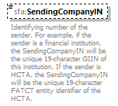
namespace | urn:oecd:ties:stffatcatypes:v2
type | sfa:StringMax200_Type
properties | minOcc 0  maxOcc 1  content simple
facets | Kind Value Annotation  minLength 0  maxLength 200
annotation | documentation  Identifying number of the sender. For example, if the sender is a financial institution, the SendingCompanyIN will be the unique 19-character GIIN of this institution. If the sender is HCTA, the SendingCompanyIN will be the unique 19-character FATCT entity identifier of the HCTA.
source | <xsd:element name="SendingCompanyIN" type="sfa:StringMax200_Type" minOccurs="0">  <xsd:annotation>  <xsd:documentation xml:lang="en">Identifying number of the sender. For example, if the sender is a financial institution, the SendingCompanyIN will be the unique 19-character GIIN of this institution. If the sender is HCTA, the SendingCompanyIN will be the unique 19-character FATCT entity identifier of the HCTA.</xsd:documentation>  </xsd:annotation>  </xsd:element>

element MessageSpec_Type/TransmittingCountry
diagram | 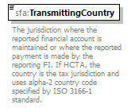
namespace | urn:oecd:ties:stffatcatypes:v2
type | iso:CountryCode_Type
properties | content simple
facets | enumeration PR documentation PUERTO RICO  enumeration ZW documentation ZIMBABWE
annotation | documentation  The jurisdiction where the reported financial account is maintained or where the reported payment is made by the reporting FI. If HCTA, the country is the tax jurisdiction and uses alpha-2 country code specified by ISO 3166-1 standard.
source | <xsd:element name="TransmittingCountry" type="iso:CountryCode_Type">  <xsd:annotation>  <xsd:documentation xml:lang="en">The jurisdiction where the reported financial account is maintained or where the reported payment is made by the reporting FI. If HCTA, the country is the tax jurisdiction and uses alpha-2 country code specified by ISO 3166-1 standard.</xsd:documentation>  </xsd:annotation>  </xsd:element>

element MessageSpec_Type/ReceivingCountry
diagram | 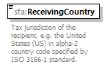
namespace | urn:oecd:ties:stffatcatypes:v2
type | iso:CountryCode_Type
properties | content simple
facets | Kind Value Annotation  enumeration AF documentation AFGHANISTAN  …  enumeration ZW documentation ZIMBABWE
annotation | documentation  Tax jurisdiction of the recipient, e.g. the United States (US) in alpha-2 country code specified by ISO 3166-1 standard.
source | <xsd:element name="ReceivingCountry" type="iso:CountryCode_Type">  <xsd:annotation>  <xsd:documentation xml:lang="en">Tax jurisdiction of the recipient, e.g. the United States (US) in alpha-2 country code specified by ISO 3166-1 standard.</xsd:documentation>  </xsd:annotation>  </xsd:element>

element MessageSpec_Type/MessageType
diagram | 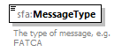
namespace | urn:oecd:ties:stffatcatypes:v2
type | sfa:MessageType_EnumType
properties | content simple
facets | Kind Value Annotation  enumeration FATCA
annotation | documentation  The type of message, e.g. FATCA
source | <xsd:element name="MessageType" type="sfa:MessageType_EnumType">  <xsd:annotation>  <xsd:documentation xml:lang="en">The type of message, e.g. FATCA</xsd:documentation>  </xsd:annotation>  </xsd:element>

element MessageSpec_Type/Warning
diagram | 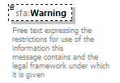
namespace | urn:oecd:ties:stffatcatypes:v2
type | sfa:StringMax4000_Type
properties | minOcc 0  maxOcc 1  content simple
facets | Kind Value Annotation  minLength 0  maxLength 4000
annotation | documentation  Free text expressing the restrictions for use of the information this  message contains and the legal framework under which it is given
source | <xsd:element name="Warning" type="sfa:StringMax4000_Type" minOccurs="0">  <xsd:annotation>  <xsd:documentation xml:lang="en">Free text expressing the restrictions for use of the information this  message contains and the legal framework under which it is given</xsd:documentation>  </xsd:annotation>  </xsd:element>

element MessageSpec_Type/Contact
diagram | 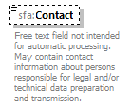
namespace | urn:oecd:ties:stffatcatypes:v2
type | sfa:StringMax200_Type
properties | minOcc 0  maxOcc 1  content simple
facets | Kind Value Annotation  minLength 0  maxLength 200
annotation | documentation  Free text field not intended for automatic processing. May contain contact information about persons responsible for legal and/or technical data preparation and transmission.
source | <xsd:element name="Contact" type="sfa:StringMax200_Type" minOccurs="0">  <xsd:annotation>  <xsd:documentation xml:lang="en">Free text field not intended for automatic processing. May contain contact information about persons responsible for legal and/or technical data preparation and transmission.</xsd:documentation>  </xsd:annotation>  <!-- changed to optional -->  </xsd:element>

element MessageSpec_Type/MessageRefId
diagram | 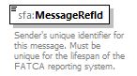
namespace | urn:oecd:ties:stffatcatypes:v2
type | sfa:StringMax200_Type
properties | content simple
facets | Kind Value Annotation  minLength 0  maxLength 200
annotation | documentation  Sender's unique identifier for this message. Must be unique for the lifespan of the FATCA reporting system.
source | <xsd:element name="MessageRefId" type="sfa:StringMax200_Type">  <xsd:annotation>  <xsd:documentation xml:lang="en">Sender's unique identifier for this message. Must be unique for the lifespan of the FATCA reporting system.</xsd:documentation>  </xsd:annotation>  </xsd:element>

element MessageSpec_Type/CorrMessageRefId
diagram | 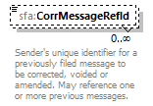
namespace | urn:oecd:ties:stffatcatypes:v2
type | sfa:StringMax200_Type
properties | minOcc 0  maxOcc unbounded  content simple
facets | Kind Value Annotation  minLength 0  maxLength 200
annotation | documentation  Sender's unique identifier for a previously filed message to be corrected, voided or amended. May reference one or more previous messages.
source | <xsd:element name="CorrMessageRefId" type="sfa:StringMax200_Type" minOccurs="0" maxOccurs="unbounded">  <xsd:annotation>  <xsd:documentation xml:lang="en">Sender's unique identifier for a previously filed message to be corrected, voided or amended. May reference one or more previous messages.</xsd:documentation>  </xsd:annotation>  </xsd:element>

element MessageSpec_Type/ReportingPeriod
diagram
namespace | urn:oecd:ties:stffatcatypes:v2
type | xsd:date
properties | content simple
annotation | documentation  The reporting year for the current message
source | <xsd:element name="ReportingPeriod" type="xsd:date">  <xsd:annotation>  <xsd:documentation xml:lang="en">The reporting year for the current message</xsd:documentation>  </xsd:annotation>  </xsd:element>

element MessageSpec_Type/Timestamp
diagram | 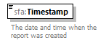
namespace | urn:oecd:ties:stffatcatypes:v2
type | xsd:dateTime
properties | content simple
annotation | documentation  The date and time when the report was created
source | <xsd:element name="Timestamp" type="xsd:dateTime">  <xsd:annotation>  <xsd:documentation xml:lang="en">The date and time when the report was created</xsd:documentation>  </xsd:annotation>  </xsd:element>

complexType MonAmnt_Type
diagram | 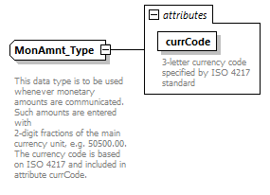
namespace | urn:oecd:ties:stffatcatypes:v2
type | extension of sfa:TwoDigFract_Type
properties | base sfa:TwoDigFract_Type
used by | elements CorrectableAccountReport_Type/AccountBalance Payment_Type/PaymentAmnt CorrectablePoolReport_Type/PoolBalance
facets | Kind Value Annotation  fractionDigits 2
attributes | Name Type Use Default Fixed Annotation  currCode iso:currCode_Type required documentation 3-letter currency code specified by ISO 4217 standard
annotation | documentation  This data type is to be used whenever monetary amounts are communicated. Such amounts are entered with  2-digit fractions of the main currency unit, e.g. 50500.00. The currency code is based on ISO 4217 and included in attribute currCode.
source | <xsd:complexType name="MonAmnt_Type">  <xsd:annotation>  <xsd:documentation xml:lang="en">  This data type is to be used whenever monetary amounts are communicated. Such amounts are entered with  2-digit fractions of the main currency unit, e.g. 50500.00. The currency code is based on ISO 4217 and included in attribute currCode.  </xsd:documentation>  </xsd:annotation>  <xsd:simpleContent>  <xsd:extension base="sfa:TwoDigFract_Type">  <xsd:attribute name="currCode" type="iso:currCode_Type" use="required">  <xsd:annotation>  <xsd:documentation xml:lang="en">3-letter currency code specified by ISO 4217 standard</xsd:documentation>  </xsd:annotation>  </xsd:attribute>  </xsd:extension>  </xsd:simpleContent>  </xsd:complexType>

attribute MonAmnt_Type/@currCode
type | iso:currCode_Type
properties | use required
facets | Kind Value Annotation  enumeration AED documentation UAE Dirham: UNITED ARAB EMIRATES  …  enumeration ZWL documentation Zimbabwe Dollar: ZIMBABWE
annotation | documentation  3-letter currency code specified by ISO 4217 standard
source | <xsd:attribute name="currCode" type="iso:currCode_Type" use="required">  <xsd:annotation>  <xsd:documentation xml:lang="en">3-letter currency code specified by ISO 4217 standard</xsd:documentation>  </xsd:annotation>  </xsd:attribute>

complexType NameOrganisation_Type
diagram | 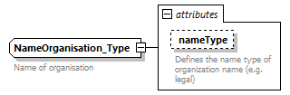
namespace | urn:oecd:ties:stffatcatypes:v2
type | extension of sfa:StringMax200_Type
properties | base sfa:StringMax200_Type
used by | element OrganisationParty_Type/Name
facets | Kind Value Annotation  minLength 0  maxLength 200
attributes | Name Type Use Default Fixed Annotation  nameType stf:OECDNameType_EnumType optional documentation Defines the name type of organization name (e.g. legal)
annotation | documentation  Name of organisation
source | <xsd:complexType name="NameOrganisation_Type">  <xsd:annotation>  <xsd:documentation xml:lang="en">Name of organisation</xsd:documentation>  </xsd:annotation>  <xsd:simpleContent>  <xsd:extension base="sfa:StringMax200_Type">  <xsd:attribute name="nameType" type="stf:OECDNameType_EnumType" use="optional">  <xsd:annotation>  <xsd:documentation xml:lang="en">Defines the name type of organization name (e.g. legal)</xsd:documentation>  </xsd:annotation>  </xsd:attribute>  </xsd:extension>  </xsd:simpleContent>  </xsd:complexType>

attribute NameOrganisation_Type/@nameType
type | stf:OECDNameType_EnumType
properties | use optional
facets | Kind Value Annotation  enumeration OECD201  enumeration OECD202  enumeration OECD203  enumeration OECD204  enumeration OECD205  enumeration OECD206  enumeration OECD207  enumeration OECD208
annotation | documentation  Defines the name type of organization name (e.g. legal)
source | <xsd:attribute name="nameType" type="stf:OECDNameType_EnumType" use="optional">  <xsd:annotation>  <xsd:documentation xml:lang="en">Defines the name type of organization name (e.g. legal)</xsd:documentation>  </xsd:annotation>  </xsd:attribute>

complexType NamePerson_Type
diagram | 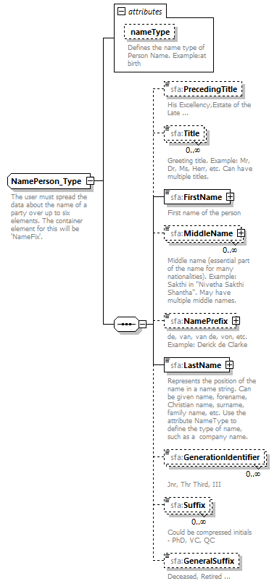
namespace | urn:oecd:ties:stffatcatypes:v2
children | sfa:PrecedingTitle sfa:Title sfa:FirstName sfa:MiddleName sfa:NamePrefix sfa:LastName sfa:GenerationIdentifier sfa:Suffix sfa:GeneralSuffix
used by | element PersonParty_Type/Name
attributes | Name Type Use Default Fixed Annotation  nameType stf:OECDNameType_EnumType optional documentation Defines the name type of Person Name. Example:at birth
annotation | documentation  The user must spread the data about the name of a party over up to six elements. The container element for this will be 'NameFix'.
source | <xsd:complexType name="NamePerson_Type">  <xsd:annotation>  <xsd:documentation xml:lang="en">The user must spread the data about the name of a party over up to six elements. The container element for this will be 'NameFix'. </xsd:documentation>  </xsd:annotation>  <xsd:sequence>  <xsd:element name="PrecedingTitle" type="sfa:StringMax200_Type" minOccurs="0">  <xsd:annotation>  <xsd:documentation xml:lang="en">His Excellency,Estate of the Late ...</xsd:documentation>  </xsd:annotation>  </xsd:element>  <xsd:element name="Title" type="sfa:StringMax200_Type" minOccurs="0" maxOccurs="unbounded">  <xsd:annotation>  <xsd:documentation xml:lang="en">Greeting title. Example: Mr, Dr, Ms, Herr, etc. Can have multiple titles.</xsd:documentation>  </xsd:annotation>  </xsd:element>  <xsd:element name="FirstName">  <xsd:annotation>  <xsd:documentation xml:lang="en">First name of the person</xsd:documentation>  </xsd:annotation>  <xsd:complexType>  <xsd:simpleContent>  <xsd:extension base="sfa:StringMax200_Type">  <xsd:attribute name="xnlNameType" type="sfa:StringMax200_Type">  <xsd:annotation>  <xsd:documentation xml:lang="en">Defines the name type of FirstName. Example: Given name, forename, Christian name, father's name, etc. In some countries, the first name could be a family name or a surname.</xsd:documentation>  </xsd:annotation>  </xsd:attribute>  </xsd:extension>  </xsd:simpleContent>  </xsd:complexType>  </xsd:element>  <xsd:element name="MiddleName" minOccurs="0" maxOccurs="unbounded">  <xsd:annotation>  <xsd:documentation xml:lang="en">Middle name (essential part of the name for many nationalities). Example: Sakthi in "Nivetha Sakthi Shantha". May have multiple middle names.</xsd:documentation>  </xsd:annotation>  <xsd:complexType>  <xsd:simpleContent>  <xsd:extension base="sfa:StringMax200_Type">  <xsd:attribute name="xnlNameType" type="sfa:StringMax200_Type">  <xsd:annotation>  <xsd:documentation xml:lang="en">Defines the name type of Middle Name. Example: First name, middle name, maiden name, father's name, given name, etc.</xsd:documentation>  </xsd:annotation>  </xsd:attribute>  </xsd:extension>  </xsd:simpleContent>  </xsd:complexType>  </xsd:element>  <xsd:element name="NamePrefix" minOccurs="0">  <xsd:annotation>  <xsd:documentation xml:lang="en">de, van, van de, von, etc. Example: Derick de Clarke</xsd:documentation>  </xsd:annotation>  <xsd:complexType>  <xsd:simpleContent>  <xsd:extension base="sfa:StringMax200_Type">  <xsd:attribute name="xnlNameType" type="sfa:StringMax200_Type">  <xsd:annotation>  <xsd:documentation xml:lang="en">Defines the type of name associated with the NamePrefix. For example the type of name is LastName and this prefix is the prefix for this last name.</xsd:documentation>  </xsd:annotation>  </xsd:attribute>  </xsd:extension>  </xsd:simpleContent>  </xsd:complexType>  </xsd:element>  <xsd:element name="LastName">  <xsd:annotation>  <xsd:documentation xml:lang="en">Represents the position of the name in a name string. Can be given name, forename, Christian name, surname, family name, etc. Use the attribute NameType to define the type of name, such as a company name. </xsd:documentation>  </xsd:annotation>  <xsd:complexType>  <xsd:simpleContent>  <xsd:extension base="sfa:StringMax200_Type">  <xsd:attribute name="xnlNameType" type="sfa:StringMax200_Type">  <xsd:annotation>  <xsd:documentation xml:lang="en">Defines the name type of LastName. Example: father's name, family name, surname, mother's name, etc. In some countries, the LastName may be the given name or first name.</xsd:documentation>  </xsd:annotation>  </xsd:attribute>  </xsd:extension>  </xsd:simpleContent>  </xsd:complexType>  </xsd:element>  <xsd:element name="GenerationIdentifier" type="sfa:StringMax200_Type" minOccurs="0" maxOccurs="unbounded">  <xsd:annotation>  <xsd:documentation xml:lang="en">Jnr, Thr Third, III</xsd:documentation>  </xsd:annotation>  </xsd:element>  <xsd:element name="Suffix" type="sfa:StringMax200_Type" minOccurs="0" maxOccurs="unbounded">  <xsd:annotation>  <xsd:documentation xml:lang="en">Could be compressed initials - PhD, VC, QC</xsd:documentation>  </xsd:annotation>  </xsd:element>  <xsd:element name="GeneralSuffix" type="sfa:StringMax200_Type" minOccurs="0">  <xsd:annotation>  <xsd:documentation xml:lang="en">Deceased, Retired ...</xsd:documentation>  </xsd:annotation>  </xsd:element>  </xsd:sequence>  <xsd:attribute name="nameType" type="stf:OECDNameType_EnumType" use="optional">  <xsd:annotation>  <xsd:documentation xml:lang="en">Defines the name type of Person Name. Example:at birth</xsd:documentation>  </xsd:annotation>  </xsd:attribute>  </xsd:complexType>

attribute NamePerson_Type/@nameType
type | stf:OECDNameType_EnumType
properties | use optional
facets | Kind Value Annotation  enumeration OECD201  enumeration OECD202  enumeration OECD203  enumeration OECD204  enumeration OECD205  enumeration OECD206  enumeration OECD207  enumeration OECD208
annotation | documentation  Defines the name type of Person Name. Example:at birth
source | <xsd:attribute name="nameType" type="stf:OECDNameType_EnumType" use="optional">  <xsd:annotation>  <xsd:documentation xml:lang="en">Defines the name type of Person Name. Example:at birth</xsd:documentation>  </xsd:annotation>  </xsd:attribute>

element NamePerson_Type/PrecedingTitle
diagram | 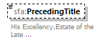
namespace | urn:oecd:ties:stffatcatypes:v2
type | sfa:StringMax200_Type
properties | minOcc 0  maxOcc 1  content simple
facets | Kind Value Annotation  minLength 0  maxLength 200
annotation | documentation  His Excellency,Estate of the Late ...
source | <xsd:element name="PrecedingTitle" type="sfa:StringMax200_Type" minOccurs="0">  <xsd:annotation>  <xsd:documentation xml:lang="en">His Excellency,Estate of the Late ...</xsd:documentation>  </xsd:annotation>  </xsd:element>

element NamePerson_Type/Title
diagram | 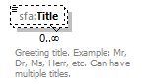
namespace | urn:oecd:ties:stffatcatypes:v2
type | sfa:StringMax200_Type
properties | minOcc 0  maxOcc unbounded  content simple
facets | Kind Value Annotation  minLength 0  maxLength 200
annotation | documentation  Greeting title. Example: Mr, Dr, Ms, Herr, etc. Can have multiple titles.
source | <xsd:element name="Title" type="sfa:StringMax200_Type" minOccurs="0" maxOccurs="unbounded">  <xsd:annotation>  <xsd:documentation xml:lang="en">Greeting title. Example: Mr, Dr, Ms, Herr, etc. Can have multiple titles.</xsd:documentation>  </xsd:annotation>  </xsd:element>

element NamePerson_Type/FirstName
diagram | 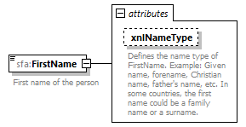
namespace | urn:oecd:ties:stffatcatypes:v2
type | extension of sfa:StringMax200_Type
properties | content complex
facets | Kind Value Annotation  minLength 0  maxLength 200
attributes | Name Type Use Default Fixed Annotation  xnlNameType sfa:StringMax200_Type documentation Defines the name type of FirstName. Example: Given name, forename, Christian name, father's name, etc. In some countries, the first name could be a family name or a surname.
annotation | documentation  First name of the person
source | <xsd:element name="FirstName">  <xsd:annotation>  <xsd:documentation xml:lang="en">First name of the person</xsd:documentation>  </xsd:annotation>  <xsd:complexType>  <xsd:simpleContent>  <xsd:extension base="sfa:StringMax200_Type">  <xsd:attribute name="xnlNameType" type="sfa:StringMax200_Type">  <xsd:annotation>  <xsd:documentation xml:lang="en">Defines the name type of FirstName. Example: Given name, forename, Christian name, father's name, etc. In some countries, the first name could be a family name or a surname.</xsd:documentation>  </xsd:annotation>  </xsd:attribute>  </xsd:extension>  </xsd:simpleContent>  </xsd:complexType>  </xsd:element>

attribute NamePerson_Type/FirstName/@xnlNameType
type | sfa:StringMax200_Type
facets | Kind Value Annotation  minLength 0  maxLength 200
annotation | documentation  Defines the name type of FirstName. Example: Given name, forename, Christian name, father's name, etc. In some countries, the first name could be a family name or a surname.
source | <xsd:attribute name="xnlNameType" type="sfa:StringMax200_Type">  <xsd:annotation>  <xsd:documentation xml:lang="en">Defines the name type of FirstName. Example: Given name, forename, Christian name, father's name, etc. In some countries, the first name could be a family name or a surname.</xsd:documentation>  </xsd:annotation>  </xsd:attribute>

element NamePerson_Type/MiddleName
diagram | 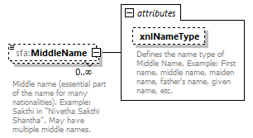
namespace | urn:oecd:ties:stffatcatypes:v2
type | extension of sfa:StringMax200_Type
properties | minOcc 0  maxOcc unbounded  content complex
facets | Kind Value Annotation  minLength 0  maxLength 200
attributes | Name Type Use Default Fixed Annotation  xnlNameType sfa:StringMax200_Type documentation Defines the name type of Middle Name. Example: First name, middle name, maiden name, father's name, given name, etc.
annotation | documentation  Middle name (essential part of the name for many nationalities). Example: Sakthi in "Nivetha Sakthi Shantha". May have multiple middle names.
source | <xsd:element name="MiddleName" minOccurs="0" maxOccurs="unbounded">  <xsd:annotation>  <xsd:documentation xml:lang="en">Middle name (essential part of the name for many nationalities). Example: Sakthi in "Nivetha Sakthi Shantha". May have multiple middle names.</xsd:documentation>  </xsd:annotation>  <xsd:complexType>  <xsd:simpleContent>  <xsd:extension base="sfa:StringMax200_Type">  <xsd:attribute name="xnlNameType" type="sfa:StringMax200_Type">  <xsd:annotation>  <xsd:documentation xml:lang="en">Defines the name type of Middle Name. Example: First name, middle name, maiden name, father's name, given name, etc.</xsd:documentation>  </xsd:annotation>  </xsd:attribute>  </xsd:extension>  </xsd:simpleContent>  </xsd:complexType>  </xsd:element>

attribute NamePerson_Type/MiddleName/@xnlNameType
type | sfa:StringMax200_Type
facets | Kind Value Annotation  minLength 0  maxLength 200
annotation | documentation  Defines the name type of Middle Name. Example: First name, middle name, maiden name, father's name, given name, etc.
source | <xsd:attribute name="xnlNameType" type="sfa:StringMax200_Type">  <xsd:annotation>  <xsd:documentation xml:lang="en">Defines the name type of Middle Name. Example: First name, middle name, maiden name, father's name, given name, etc.</xsd:documentation>  </xsd:annotation>  </xsd:attribute>

element NamePerson_Type/NamePrefix
diagram | 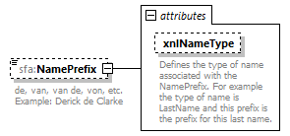
namespace | urn:oecd:ties:stffatcatypes:v2
type | extension of sfa:StringMax200_Type
properties | minOcc 0  maxOcc 1  content complex
facets | Kind Value Annotation  minLength 0  maxLength 200
attributes | Name Type Use Default Fixed Annotation  xnlNameType sfa:StringMax200_Type documentation Defines the type of name associated with the NamePrefix. For example the type of name is LastName and this prefix is the prefix for this last name.
annotation | documentation  de, van, van de, von, etc. Example: Derick de Clarke
source | <xsd:element name="NamePrefix" minOccurs="0">  <xsd:annotation>  <xsd:documentation xml:lang="en">de, van, van de, von, etc. Example: Derick de Clarke</xsd:documentation>  </xsd:annotation>  <xsd:complexType>  <xsd:simpleContent>  <xsd:extension base="sfa:StringMax200_Type">  <xsd:attribute name="xnlNameType" type="sfa:StringMax200_Type">  <xsd:annotation>  <xsd:documentation xml:lang="en">Defines the type of name associated with the NamePrefix. For example the type of name is LastName and this prefix is the prefix for this last name.</xsd:documentation>  </xsd:annotation>  </xsd:attribute>  </xsd:extension>  </xsd:simpleContent>  </xsd:complexType>  </xsd:element>

attribute NamePerson_Type/NamePrefix/@xnlNameType
type | sfa:StringMax200_Type
facets | Kind Value Annotation  minLength 0  maxLength 200
annotation | documentation  Defines the type of name associated with the NamePrefix. For example the type of name is LastName and this prefix is the prefix for this last name.
source | <xsd:attribute name="xnlNameType" type="sfa:StringMax200_Type">  <xsd:annotation>  <xsd:documentation xml:lang="en">Defines the type of name associated with the NamePrefix. For example the type of name is LastName and this prefix is the prefix for this last name.</xsd:documentation>  </xsd:annotation>  </xsd:attribute>

element NamePerson_Type/LastName
diagram | 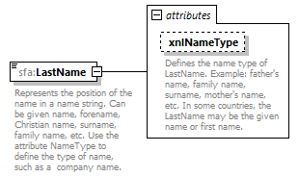
namespace | urn:oecd:ties:stffatcatypes:v2
type | extension of sfa:StringMax200_Type
properties | content complex
facets | Kind Value Annotation  minLength 0  maxLength 200
attributes | Name Type Use Default Fixed Annotation  xnlNameType sfa:StringMax200_Type documentation Defines the name type of LastName. Example: father's name, family name, surname, mother's name, etc. In some countries, the LastName may be the given name or first name.
annotation | documentation  Represents the position of the name in a name string. Can be given name, forename, Christian name, surname, family name, etc. Use the attribute NameType to define the type of name, such as a company name.
source | <xsd:element name="LastName">  <xsd:annotation>  <xsd:documentation xml:lang="en">Represents the position of the name in a name string. Can be given name, forename, Christian name, surname, family name, etc. Use the attribute NameType to define the type of name, such as a company name. </xsd:documentation>  </xsd:annotation>  <xsd:complexType>  <xsd:simpleContent>  <xsd:extension base="sfa:StringMax200_Type">  <xsd:attribute name="xnlNameType" type="sfa:StringMax200_Type">  <xsd:annotation>  <xsd:documentation xml:lang="en">Defines the name type of LastName. Example: father's name, family name, surname, mother's name, etc. In some countries, the LastName may be the given name or first name.</xsd:documentation>  </xsd:annotation>  </xsd:attribute>  </xsd:extension>  </xsd:simpleContent>  </xsd:complexType>  </xsd:element>

attribute NamePerson_Type/LastName/@xnlNameType
type | sfa:StringMax200_Type
facets | Kind Value Annotation  minLength 0  maxLength 200
annotation | documentation  Defines the name type of LastName. Example: father's name, family name, surname, mother's name, etc. In some countries, the LastName may be the given name or first name.
source | <xsd:attribute name="xnlNameType" type="sfa:StringMax200_Type">  <xsd:annotation>  <xsd:documentation xml:lang="en">Defines the name type of LastName. Example: father's name, family name, surname, mother's name, etc. In some countries, the LastName may be the given name or first name.</xsd:documentation>  </xsd:annotation>  </xsd:attribute>

element NamePerson_Type/GenerationIdentifier
diagram | 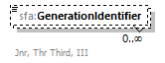
namespace | urn:oecd:ties:stffatcatypes:v2
type | sfa:StringMax200_Type
properties | minOcc 0  maxOcc unbounded  content simple
facets | Kind Value Annotation  minLength 0  maxLength 200
annotation | documentation  Jnr, Thr Third, III
source | <xsd:element name="GenerationIdentifier" type="sfa:StringMax200_Type" minOccurs="0" maxOccurs="unbounded">  <xsd:annotation>  <xsd:documentation xml:lang="en">Jnr, Thr Third, III</xsd:documentation>  </xsd:annotation>  </xsd:element>

element NamePerson_Type/Suffix
diagram | 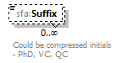
namespace | urn:oecd:ties:stffatcatypes:v2
type | sfa:StringMax200_Type
properties | minOcc 0  maxOcc unbounded  content simple
facets | Kind Value Annotation  minLength 0  maxLength 200
annotation | documentation  Could be compressed initials - PhD, VC, QC
source | <xsd:element name="Suffix" type="sfa:StringMax200_Type" minOccurs="0" maxOccurs="unbounded">  <xsd:annotation>  <xsd:documentation xml:lang="en">Could be compressed initials - PhD, VC, QC</xsd:documentation>  </xsd:annotation>  </xsd:element>

element NamePerson_Type/GeneralSuffix
diagram | 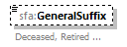
namespace | urn:oecd:ties:stffatcatypes:v2
type | sfa:StringMax200_Type
properties | minOcc 0  maxOcc 1  content simple
facets | Kind Value Annotation  minLength 0  maxLength 200
annotation | documentation  Deceased, Retired ...
source | <xsd:element name="GeneralSuffix" type="sfa:StringMax200_Type" minOccurs="0">  <xsd:annotation>  <xsd:documentation xml:lang="en">Deceased, Retired ...</xsd:documentation>  </xsd:annotation>  </xsd:element>

complexType OrganisationParty_Type
diagram | 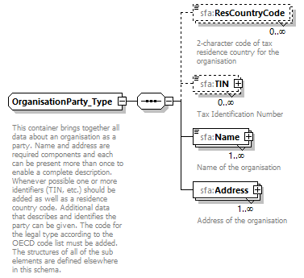
namespace | urn:oecd:ties:stffatcatypes:v2
children | sfa:ResCountryCode sfa:TIN sfa:Name sfa:Address
used by | elements AccountHolder_Type/Organisation SubstantialOwner_Type/Organisation  complexType CorrectableReportOrganisation_Type
annotation | documentation  This container brings together all data about an organisation as a party. Name and address are required components and each can be present more than once to enable a complete description. Whenever possible one or more identifiers (TIN, etc.) should be added as well as a residence country code. Additional data that describes and identifies the party can be given. The code for the legal type according to the OECD code list must be added. The structures of all of the sub elements are defined elsewhere in this schema.
source | <xsd:complexType name="OrganisationParty_Type">  <xsd:annotation>  <xsd:documentation xml:lang="en">  This container brings together all data about an organisation as a party. Name and address are required components and each can be present more than once to enable a complete description. Whenever possible one or more identifiers (TIN, etc.) should be added as well as a residence country code. Additional data that describes and identifies the party can be given. The code for the legal type according to the OECD code list must be added. The structures of all of the sub elements are defined elsewhere in this schema.</xsd:documentation>  </xsd:annotation>  <xsd:sequence>  <xsd:element name="ResCountryCode" type="iso:CountryCode_Type" minOccurs="0" maxOccurs="unbounded">  <xsd:annotation>  <xsd:documentation xml:lang="en">2-character code of tax residence country for the organisation</xsd:documentation>  </xsd:annotation>  </xsd:element>  <xsd:element name="TIN" type="sfa:TIN_Type" minOccurs="0" maxOccurs="unbounded">  <xsd:annotation>  <xsd:documentation xml:lang="en">Tax Identification Number</xsd:documentation>  </xsd:annotation>  </xsd:element>  <xsd:element name="Name" type="sfa:NameOrganisation_Type" maxOccurs="unbounded">  <xsd:annotation>  <xsd:documentation xml:lang="en">Name of the organisation</xsd:documentation>  </xsd:annotation>  </xsd:element>  <xsd:element name="Address" type="sfa:Address_Type" maxOccurs="unbounded">  <xsd:annotation>  <xsd:documentation xml:lang="en">Address of the organisation</xsd:documentation>  </xsd:annotation>  </xsd:element>  </xsd:sequence>  </xsd:complexType>

element OrganisationParty_Type/ResCountryCode
diagram | 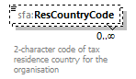
namespace | urn:oecd:ties:stffatcatypes:v2
type | iso:CountryCode_Type
properties | minOcc 0  maxOcc unbounded  content simple
facets | enumeration ZW documentation ZIMBABWE
annotation | documentation  2-character code of tax residence country for the organisation
source | <xsd:element name="ResCountryCode" type="iso:CountryCode_Type" minOccurs="0" maxOccurs="unbounded">  <xsd:annotation>  <xsd:documentation xml:lang="en">2-character code of tax residence country for the organisation</xsd:documentation>  </xsd:annotation>  </xsd:element>

element OrganisationParty_Type/TIN
diagram | 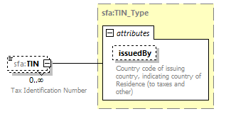
namespace | urn:oecd:ties:stffatcatypes:v2
type | sfa:TIN_Type
properties | minOcc 0  maxOcc unbounded  content complex
facets | Kind Value Annotation  minLength 1  maxLength 200
attributes | Name Type Use Default Fixed Annotation  issuedBy iso:CountryCode_Type optional documentation Country code of issuing country, indicating country of Residence (to taxes and other)
annotation | documentation  Tax Identification Number
source | <xsd:element name="TIN" type="sfa:TIN_Type" minOccurs="0" maxOccurs="unbounded">  <xsd:annotation>  <xsd:documentation xml:lang="en">Tax Identification Number</xsd:documentation>  </xsd:annotation>  </xsd:element>

element OrganisationParty_Type/Name
diagram | 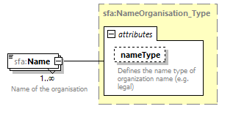
namespace | urn:oecd:ties:stffatcatypes:v2
type | sfa:NameOrganisation_Type
properties | minOcc 1  maxOcc unbounded  content complex
facets | Kind Value Annotation  minLength 0  maxLength 200
attributes | Name Type Use Default Fixed Annotation  nameType stf:OECDNameType_EnumType optional documentation Defines the name type of organization name (e.g. legal)
annotation | documentation  Name of the organisation
source | <xsd:element name="Name" type="sfa:NameOrganisation_Type" maxOccurs="unbounded">  <xsd:annotation>  <xsd:documentation xml:lang="en">Name of the organisation</xsd:documentation>  </xsd:annotation>  </xsd:element>

element OrganisationParty_Type/Address
diagram | 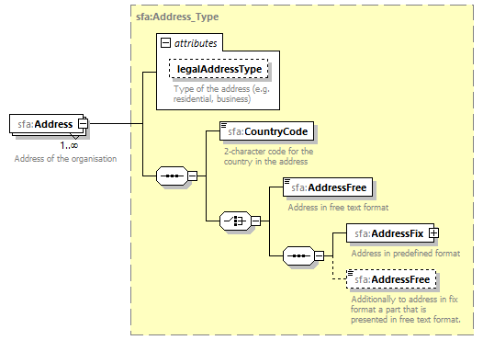
namespace | urn:oecd:ties:stffatcatypes:v2
type | sfa:Address_Type
properties | minOcc 1  maxOcc unbounded  content complex
children | sfa:CountryCode sfa:AddressFree sfa:AddressFix sfa:AddressFree
attributes | Name Type Use Default Fixed Annotation  legalAddressType stf:OECDLegalAddressType_EnumType optional documentation Type of the address (e.g. residential, business)
annotation | documentation  Address of the organisation
source | <xsd:element name="Address" type="sfa:Address_Type" maxOccurs="unbounded">  <xsd:annotation>  <xsd:documentation xml:lang="en">Address of the organisation</xsd:documentation>  </xsd:annotation>  </xsd:element>

complexType PersonParty_Type
diagram | 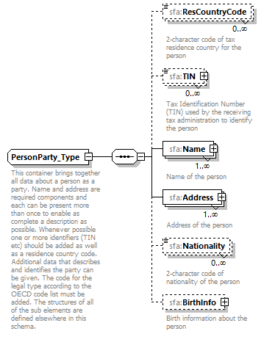
namespace | urn:oecd:ties:stffatcatypes:v2
children | sfa:ResCountryCode sfa:TIN sfa:Name sfa:Address sfa:Nationality sfa:BirthInfo
used by | elements AccountHolder_Type/Individual SubstantialOwner_Type/Individual
annotation | documentation  This container brings together all data about a person as a party. Name and address are required components and each can be present more than once to enable as complete a description as possible. Whenever possible one or more identifiers (TIN etc) should be added as well as a residence country code. Additional data that describes and identifies the party can be given. The code for the legal type according to the OECD code list must be added. The structures of all of the sub elements are defined elsewhere in this schema.
source | <xsd:complexType name="PersonParty_Type">  <xsd:annotation>  <xsd:documentation xml:lang="en">This container brings together all data about a person as a party. Name and address are required components and each can be present more than once to enable as complete a description as possible. Whenever possible one or more identifiers (TIN etc) should be added as well as a residence country code. Additional data that describes and identifies the party can be given. The code for the legal type according to the OECD code list must be added. The structures of all of the sub elements are defined elsewhere in this schema.</xsd:documentation>  </xsd:annotation>  <xsd:sequence>  <xsd:element name="ResCountryCode" type="iso:CountryCode_Type" minOccurs="0" maxOccurs="unbounded">  <xsd:annotation>  <xsd:documentation xml:lang="en">2-character code of tax residence country for the person</xsd:documentation>  </xsd:annotation>  </xsd:element>  <xsd:element name="TIN" type="sfa:TIN_Type" minOccurs="0" maxOccurs="unbounded">  <xsd:annotation>  <xsd:documentation xml:lang="en">Tax Identification Number (TIN) used by the receiving tax administration to identify the person</xsd:documentation>  </xsd:annotation>  </xsd:element>  <xsd:element name="Name" type="sfa:NamePerson_Type" maxOccurs="unbounded">  <xsd:annotation>  <xsd:documentation xml:lang="en">Name of the person</xsd:documentation>  </xsd:annotation>  </xsd:element>  <xsd:element name="Address" type="sfa:Address_Type" maxOccurs="unbounded">  <xsd:annotation>  <xsd:documentation xml:lang="en">Address of the person</xsd:documentation>  </xsd:annotation>  </xsd:element>  <xsd:element name="Nationality" type="iso:CountryCode_Type" minOccurs="0" maxOccurs="unbounded">  <xsd:annotation>  <xsd:documentation xml:lang="en">2-character code of nationality of the person</xsd:documentation>  </xsd:annotation>  </xsd:element>  <xsd:element name="BirthInfo" minOccurs="0">  <xsd:annotation>  <xsd:documentation xml:lang="en">Birth information about the person</xsd:documentation>  </xsd:annotation>  <xsd:complexType>  <xsd:sequence>  <xsd:element name="BirthDate" type="xsd:date" minOccurs="0">  <xsd:annotation>  <xsd:documentation xml:lang="en">Data of birth</xsd:documentation>  </xsd:annotation>  </xsd:element>  <xsd:element name="City" type="sfa:StringMax200_Type" minOccurs="0">  <xsd:annotation>  <xsd:documentation xml:lang="en">City where the person was born</xsd:documentation>  </xsd:annotation>  </xsd:element>  <xsd:element name="CitySubentity" type="sfa:StringMax200_Type" minOccurs="0">  <xsd:annotation>  <xsd:documentation xml:lang="en">City subentity where the person was born</xsd:documentation>  </xsd:annotation>  </xsd:element>  <xsd:element name="CountryInfo" minOccurs="0">  <xsd:annotation>  <xsd:documentation xml:lang="en">Information about a country where the person was born.</xsd:documentation>  </xsd:annotation>  <xsd:complexType>  <xsd:choice>  <xsd:element name="CountryCode" type="iso:CountryCode_Type">  <xsd:annotation>  <xsd:documentation xml:lang="en">2-character country code based on ISO-3166.</xsd:documentation>  </xsd:annotation>  </xsd:element>  <xsd:element name="FormerCountryName" type="sfa:StringMax200_Type">  <xsd:annotation>  <xsd:documentation xml:lang="en">The name of the country where the person was born.</xsd:documentation>  </xsd:annotation>  </xsd:element>  </xsd:choice>  </xsd:complexType>  </xsd:element>  </xsd:sequence>  </xsd:complexType>  </xsd:element>  </xsd:sequence>  </xsd:complexType>

element PersonParty_Type/ResCountryCode
diagram | 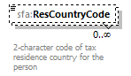
namespace | urn:oecd:ties:stffatcatypes:v2
type | iso:CountryCode_Type
properties | minOcc 0  maxOcc unbounded  content simple
facets | Kind Value Annotation  enumeration AF documentation AFGHANISTAN  …  enumeration ZW documentation ZIMBABWE
annotation | documentation  2-character code of tax residence country for the person
source | <xsd:element name="ResCountryCode" type="iso:CountryCode_Type" minOccurs="0" maxOccurs="unbounded">  <xsd:annotation>  <xsd:documentation xml:lang="en">2-character code of tax residence country for the person</xsd:documentation>  </xsd:annotation>  </xsd:element>

element PersonParty_Type/TIN
diagram | 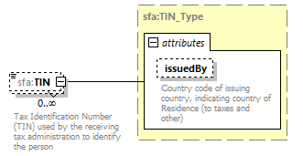
namespace | urn:oecd:ties:stffatcatypes:v2
type | sfa:TIN_Type
properties | minOcc 0  maxOcc unbounded  content complex
facets | Kind Value Annotation  minLength 1  maxLength 200
attributes | Name Type Use Default Fixed Annotation  issuedBy iso:CountryCode_Type optional documentation Country code of issuing country, indicating country of Residence (to taxes and other)
annotation | documentation  Tax Identification Number (TIN) used by the receiving tax administration to identify the person
source | <xsd:element name="TIN" type="sfa:TIN_Type" minOccurs="0" maxOccurs="unbounded">  <xsd:annotation>  <xsd:documentation xml:lang="en">Tax Identification Number (TIN) used by the receiving tax administration to identify the person</xsd:documentation>  </xsd:annotation>  </xsd:element>

element PersonParty_Type/Name
diagram | 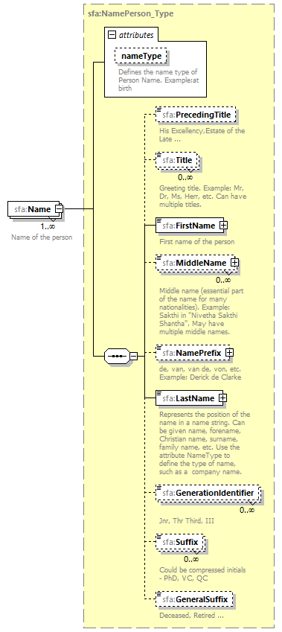
namespace | urn:oecd:ties:stffatcatypes:v2
type | sfa:NamePerson_Type
properties | minOcc 1  maxOcc unbounded  content complex
children | sfa:PrecedingTitle sfa:Title sfa:FirstName sfa:MiddleName sfa:NamePrefix sfa:LastName sfa:GenerationIdentifier sfa:Suffix sfa:GeneralSuffix
attributes | Name Type Use Default Fixed Annotation  nameType stf:OECDNameType_EnumType optional documentation Defines the name type of Person Name. Example:at birth
annotation | documentation  Name of the person
source | <xsd:element name="Name" type="sfa:NamePerson_Type" maxOccurs="unbounded">  <xsd:annotation>  <xsd:documentation xml:lang="en">Name of the person</xsd:documentation>  </xsd:annotation>  </xsd:element>

element PersonParty_Type/Address
diagram | 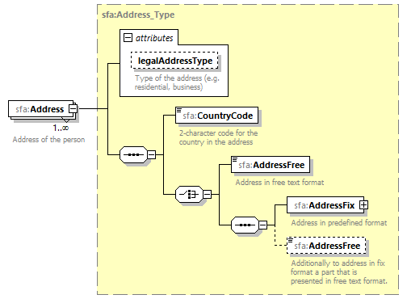
namespace | urn:oecd:ties:stffatcatypes:v2
type | sfa:Address_Type
properties | minOcc 1  maxOcc unbounded  content complex
children | sfa:CountryCode sfa:AddressFree sfa:AddressFix sfa:AddressFree
attributes | Name Type Use Default Fixed Annotation  legalAddressType stf:OECDLegalAddressType_EnumType optional documentation Type of the address (e.g. residential, business)
annotation | documentation  Address of the person
source | <xsd:element name="Address" type="sfa:Address_Type" maxOccurs="unbounded">  <xsd:annotation>  <xsd:documentation xml:lang="en">Address of the person</xsd:documentation>  </xsd:annotation>  </xsd:element>

element PersonParty_Type/Nationality
diagram | 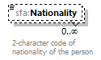
namespace | urn:oecd:ties:stffatcatypes:v2
type | iso:CountryCode_Type
properties | minOcc 0  maxOcc unbounded  content simple
facets | Kind Value Annotation  enumeration AF documentation AFGHANISTAN  …  enumeration ZW documentation ZIMBABWE
annotation | documentation  2-character code of nationality of the person
source | <xsd:element name="Nationality" type="iso:CountryCode_Type" minOccurs="0" maxOccurs="unbounded">  <xsd:annotation>  <xsd:documentation xml:lang="en">2-character code of nationality of the person</xsd:documentation>  </xsd:annotation>  </xsd:element>

element PersonParty_Type/BirthInfo
diagram | 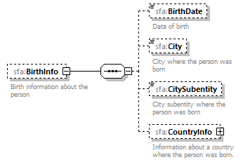
namespace | urn:oecd:ties:stffatcatypes:v2
properties | minOcc 0  maxOcc 1  content complex
children | sfa:BirthDate sfa:City sfa:CitySubentity sfa:CountryInfo
annotation | documentation  Birth information about the person
source | <xsd:element name="BirthInfo" minOccurs="0">  <xsd:annotation>  <xsd:documentation xml:lang="en">Birth information about the person</xsd:documentation>  </xsd:annotation>  <xsd:complexType>  <xsd:sequence>  <xsd:element name="BirthDate" type="xsd:date" minOccurs="0">  <xsd:annotation>  <xsd:documentation xml:lang="en">Data of birth</xsd:documentation>  </xsd:annotation>  </xsd:element>  <xsd:element name="City" type="sfa:StringMax200_Type" minOccurs="0">  <xsd:annotation>  <xsd:documentation xml:lang="en">City where the person was born</xsd:documentation>  </xsd:annotation>  </xsd:element>  <xsd:element name="CitySubentity" type="sfa:StringMax200_Type" minOccurs="0">  <xsd:annotation>  <xsd:documentation xml:lang="en">City subentity where the person was born</xsd:documentation>  </xsd:annotation>  </xsd:element>  <xsd:element name="CountryInfo" minOccurs="0">  <xsd:annotation>  <xsd:documentation xml:lang="en">Information about a country where the person was born.</xsd:documentation>  </xsd:annotation>  <xsd:complexType>  <xsd:choice>  <xsd:element name="CountryCode" type="iso:CountryCode_Type">  <xsd:annotation>  <xsd:documentation xml:lang="en">2-character country code based on ISO-3166.</xsd:documentation>  </xsd:annotation>  </xsd:element>  <xsd:element name="FormerCountryName" type="sfa:StringMax200_Type">  <xsd:annotation>  <xsd:documentation xml:lang="en">The name of the country where the person was born.</xsd:documentation>  </xsd:annotation>  </xsd:element>  </xsd:choice>  </xsd:complexType>  </xsd:element>  </xsd:sequence>  </xsd:complexType>  </xsd:element>

element PersonParty_Type/BirthInfo/BirthDate
diagram | 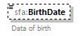
namespace | urn:oecd:ties:stffatcatypes:v2
type | xsd:date
properties | minOcc 0  maxOcc 1  content simple
annotation | documentation  Data of birth
source | <xsd:element name="BirthDate" type="xsd:date" minOccurs="0">  <xsd:annotation>  <xsd:documentation xml:lang="en">Data of birth</xsd:documentation>  </xsd:annotation>  </xsd:element>

element PersonParty_Type/BirthInfo/City
diagram | 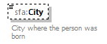
namespace | urn:oecd:ties:stffatcatypes:v2
type | sfa:StringMax200_Type
properties | minOcc 0  maxOcc 1  content simple
facets | Kind Value Annotation  minLength 0  maxLength 200
annotation | documentation  City where the person was born
source | <xsd:element name="City" type="sfa:StringMax200_Type" minOccurs="0">  <xsd:annotation>  <xsd:documentation xml:lang="en">City where the person was born</xsd:documentation>  </xsd:annotation>  </xsd:element>

element PersonParty_Type/BirthInfo/CitySubentity
diagram | 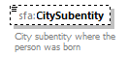
namespace | urn:oecd:ties:stffatcatypes:v2
type | sfa:StringMax200_Type
properties | minOcc 0  maxOcc 1  content simple
facets | Kind Value Annotation  minLength 0  maxLength 200
annotation | documentation  City subentity where the person was born
source | <xsd:element name="CitySubentity" type="sfa:StringMax200_Type" minOccurs="0">  <xsd:annotation>  <xsd:documentation xml:lang="en">City subentity where the person was born</xsd:documentation>  </xsd:annotation>  </xsd:element>

element PersonParty_Type/BirthInfo/CountryInfo
diagram | 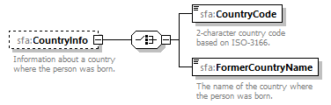
namespace | urn:oecd:ties:stffatcatypes:v2
properties | minOcc 0  maxOcc 1  content complex
children | sfa:CountryCode sfa:FormerCountryName
annotation | documentation  Information about a country where the person was born.
source | <xsd:element name="CountryInfo" minOccurs="0">  <xsd:annotation>  <xsd:documentation xml:lang="en">Information about a country where the person was born.</xsd:documentation>  </xsd:annotation>  <xsd:complexType>  <xsd:choice>  <xsd:element name="CountryCode" type="iso:CountryCode_Type">  <xsd:annotation>  <xsd:documentation xml:lang="en">2-character country code based on ISO-3166.</xsd:documentation>  </xsd:annotation>  </xsd:element>  <xsd:element name="FormerCountryName" type="sfa:StringMax200_Type">  <xsd:annotation>  <xsd:documentation xml:lang="en">The name of the country where the person was born.</xsd:documentation>  </xsd:annotation>  </xsd:element>  </xsd:choice>  </xsd:complexType>  </xsd:element>

element PersonParty_Type/BirthInfo/CountryInfo/CountryCode
diagram | 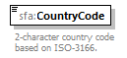
namespace | urn:oecd:ties:stffatcatypes:v2
type | iso:CountryCode_Type
properties | content simple
facets | Kind Value Annotation  enumeration AF documentation AFGHANISTAN  …  enumeration ZW documentation ZIMBABWE
annotation | documentation  2-character country code based on ISO-3166.
source | <xsd:element name="CountryCode" type="iso:CountryCode_Type">  <xsd:annotation>  <xsd:documentation xml:lang="en">2-character country code based on ISO-3166.</xsd:documentation>  </xsd:annotation>  </xsd:element>

element PersonParty_Type/BirthInfo/CountryInfo/FormerCountryName
diagram | 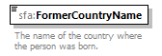
namespace | urn:oecd:ties:stffatcatypes:v2
type | sfa:StringMax200_Type
properties | content simple
facets | Kind Value Annotation  minLength 0  maxLength 200
annotation | documentation  The name of the country where the person was born.
source | <xsd:element name="FormerCountryName" type="sfa:StringMax200_Type">  <xsd:annotation>  <xsd:documentation xml:lang="en">The name of the country where the person was born.</xsd:documentation>  </xsd:annotation>  </xsd:element>

complexType TIN_Type
diagram | 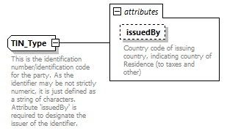
namespace | urn:oecd:ties:stffatcatypes:v2
type | extension of sfa:StringMin1Max200_Type
properties | base sfa:StringMin1Max200_Type
used by | elements OrganisationParty_Type/TIN PersonParty_Type/TIN
facets | Kind Value Annotation  minLength 1  maxLength 200
attributes | Name Type Use Default Fixed Annotation  issuedBy iso:CountryCode_Type optional documentation Country code of issuing country, indicating country of Residence (to taxes and other)
annotation | documentation  This is the identification number/identification code for the party. As the identifier may be not strictly numeric, it is just defined as a string of characters. Attribute 'issuedBy' is required to designate the issuer of the identifier.
source | <xsd:complexType name="TIN_Type">  <xsd:annotation>  <xsd:documentation xml:lang="en">This is the identification number/identification code for the party. As the identifier may be not strictly numeric, it is just defined as a string of characters. Attribute 'issuedBy' is required to designate the issuer of the identifier. </xsd:documentation>  </xsd:annotation>  <xsd:simpleContent>  <xsd:extension base="sfa:StringMin1Max200_Type">  <xsd:attribute name="issuedBy" type="iso:CountryCode_Type" use="optional">  <xsd:annotation>  <xsd:documentation xml:lang="en">Country code of issuing country, indicating country of Residence (to taxes and other)</xsd:documentation>  </xsd:annotation>  </xsd:attribute>  </xsd:extension>  </xsd:simpleContent>  </xsd:complexType>

attribute TIN_Type/@issuedBy
type | iso:CountryCode_Type
properties | use optional
facets | Kind Value Annotation  enumeration AF documentation AFGHANISTAN  …  enumeration ZM documentation ZAMBIA  enumeration ZW documentation ZIMBABWE
annotation | documentation  Country code of issuing country, indicating country of Residence (to taxes and other)
source | <xsd:attribute name="issuedBy" type="iso:CountryCode_Type" use="optional">  <xsd:annotation>  <xsd:documentation xml:lang="en">Country code of issuing country, indicating country of Residence (to taxes and other)</xsd:documentation>  </xsd:annotation>  </xsd:attribute>

simpleType MessageType_EnumType
namespace | urn:oecd:ties:stffatcatypes:v2
type | restriction of xsd:string
properties | base xsd:string
used by | element MessageSpec_Type/MessageType
facets | Kind Value Annotation  enumeration FATCA
annotation | documentation  Message type defines the type of reporting
source | <xsd:simpleType name="MessageType_EnumType">  <xsd:annotation>  <xsd:documentation xml:lang="en">Message type defines the type of reporting </xsd:documentation>  </xsd:annotation>  <xsd:restriction base="xsd:string">  <xsd:enumeration value="FATCA"/>  </xsd:restriction>  </xsd:simpleType>

simpleType StringMax10_Type
namespace | urn:oecd:ties:stffatcatypes:v2
type | restriction of xsd:string
properties | base xsd:string
used by | attribute FATCA_LUX/@version
facets | Kind Value Annotation  minLength 0  maxLength 10
annotation | documentation  Defines a string with maximum length of 10
source | <xsd:simpleType name="StringMax10_Type">  <xsd:annotation>  <xsd:documentation>Defines a string with maximum length of 10</xsd:documentation>  </xsd:annotation>  <xsd:restriction base="xsd:string">  <xsd:minLength value="0"/>  <xsd:maxLength value="10"/>  </xsd:restriction>  </xsd:simpleType>

simpleType StringMax200_Type
namespace | urn:oecd:ties:stffatcatypes:v2
type | restriction of xsd:string
properties | base xsd:string
used by | elements DocSpec_Type/CorrDocRefId DocSpec_Type/CorrMessageRefId DocSpec_Type/DocRefId AdditionalData_Type/AdditionalItem/ItemName CARRef_Type/PoolReportDocRefId CARRef_Type/PoolReportMessageRefId CARRef_Type/PoolReportReportingFIGIIN AddressFix_Type/BuildingIdentifier AddressFix_Type/City PersonParty_Type/BirthInfo/City PersonParty_Type/BirthInfo/CitySubentity MessageSpec_Type/Contact MessageSpec_Type/CorrMessageRefId AddressFix_Type/CountrySubentity AddressFix_Type/DistrictName NamePerson_Type/FirstName AddressFix_Type/FloorIdentifier PersonParty_Type/BirthInfo/CountryInfo/FormerCountryName NamePerson_Type/GeneralSuffix NamePerson_Type/GenerationIdentifier NamePerson_Type/LastName MessageSpec_Type/MessageRefId NamePerson_Type/MiddleName NamePerson_Type/NamePrefix AddressFix_Type/POB AddressFix_Type/PostCode NamePerson_Type/PrecedingTitle MessageSpec_Type/SendingCompanyIN AddressFix_Type/Street NamePerson_Type/Suffix AddressFix_Type/SuiteIdentifier NamePerson_Type/Title  complexTypes FIAccountNumber_Type NameOrganisation_Type  attributes NamePerson_Type/FirstName/@xnlNameType NamePerson_Type/MiddleName/@xnlNameType NamePerson_Type/NamePrefix/@xnlNameType NamePerson_Type/LastName/@xnlNameType
facets | Kind Value Annotation  minLength 0  maxLength 200
annotation | documentation  Defines a string with maximum length of 200
source | <xsd:simpleType name="StringMax200_Type">  <xsd:annotation>  <xsd:documentation>Defines a string with maximum length of 200</xsd:documentation>  </xsd:annotation>  <xsd:restriction base="xsd:string">  <xsd:minLength value="0"/>  <xsd:maxLength value="200"/>  </xsd:restriction>  </xsd:simpleType>

simpleType StringMax4000_Type
namespace | urn:oecd:ties:stffatcatypes:v2
type | restriction of xsd:string
properties | base xsd:string
used by | elements AdditionalData_Type/AdditionalItem/ItemContent Payment_Type/PaymentTypeDesc Address_Type/AddressFree Address_Type/AddressFree MessageSpec_Type/Warning
facets | Kind Value Annotation  minLength 0  maxLength 4000
annotation | documentation  Defines a string with maximum length of 4000
source | <xsd:simpleType name="StringMax4000_Type">  <xsd:annotation>  <xsd:documentation>Defines a string with maximum length of 4000</xsd:documentation>  </xsd:annotation>  <xsd:restriction base="xsd:string">  <xsd:minLength value="0"/>  <xsd:maxLength value="4000"/>  </xsd:restriction>  </xsd:simpleType>

simpleType StringMin1Max200_Type
namespace | urn:oecd:ties:stffatcatypes:v2
type | restriction of xsd:string
properties | base xsd:string
used by | complexType TIN_Type
facets | Kind Value Annotation  minLength 1  maxLength 200
annotation | documentation  Defines a string with minimum length 1 and maximum length of 200
source | <xsd:simpleType name="StringMin1Max200_Type">  <xsd:annotation>  <xsd:documentation xml:lang="en">Defines a string with minimum length 1 and maximum length of 200</xsd:documentation>  </xsd:annotation>  <xsd:restriction base="xsd:string">  <xsd:minLength value="1"/>  <xsd:maxLength value="200"/>  </xsd:restriction>  </xsd:simpleType>

simpleType TwoDigFract_Type
namespace | urn:oecd:ties:stffatcatypes:v2
type | restriction of xsd:decimal
properties | base xsd:decimal
used by | complexType MonAmnt_Type
facets | Kind Value Annotation  fractionDigits 2
annotation | documentation  Data type for any kind of numeric data with two decimal fraction digits, especially monetary amounts
source | <xsd:simpleType name="TwoDigFract_Type">  <xsd:annotation>  <xsd:documentation xml:lang="en">Data type for any kind of numeric data with two decimal fraction digits, especially monetary amounts</xsd:documentation>  </xsd:annotation>  <xsd:restriction base="xsd:decimal">  <xsd:fractionDigits value="2"/>  </xsd:restriction>  </xsd:simpleType>

simpleType AcctNumberType_EnumType
namespace | urn:oecd:ties:stf:v4
type | restriction of xsd:string
properties | base xsd:string
used by | attribute FIAccountNumber_Type/@AcctNumberType
facets | Kind Value Annotation  enumeration OECD601 documentation IBAN  enumeration OECD602 documentation OBAN  enumeration OECD603 documentation ISIN  enumeration OECD604 documentation OSIN  enumeration OECD605 documentation Other
annotation | documentation  Account Number Type
source | <xsd:simpleType name="AcctNumberType_EnumType">  <xsd:annotation>  <xsd:documentation xml:lang="en">Account Number Type</xsd:documentation>  </xsd:annotation>  <xsd:restriction base="xsd:string">  <xsd:enumeration value="OECD601">  <xsd:annotation>  <xsd:documentation>IBAN</xsd:documentation>  </xsd:annotation>  </xsd:enumeration>  <xsd:enumeration value="OECD602">  <xsd:annotation>  <xsd:documentation>OBAN</xsd:documentation>  </xsd:annotation>  </xsd:enumeration>  <xsd:enumeration value="OECD603">  <xsd:annotation>  <xsd:documentation>ISIN</xsd:documentation>  </xsd:annotation>  </xsd:enumeration>  <xsd:enumeration value="OECD604">  <xsd:annotation>  <xsd:documentation>OSIN</xsd:documentation>  </xsd:annotation>  </xsd:enumeration>  <xsd:enumeration value="OECD605">  <xsd:annotation>  <xsd:documentation>Other</xsd:documentation>  </xsd:annotation>  </xsd:enumeration>  </xsd:restriction>  </xsd:simpleType>

simpleType OECDLegalAddressType_EnumType
namespace | urn:oecd:ties:stf:v4
type | restriction of xsd:token
properties | base xsd:token
used by | attribute Address_Type/@legalAddressType
facets | Kind Value Annotation  enumeration OECD301  enumeration OECD302  enumeration OECD303  enumeration OECD304  enumeration OECD305
annotation | documentation  Datatype for an attribute to an address. It indicates the legal character of that address (residential, business etc.)  Possible values are:  OECD301=residential or business  OECD302=residential  OECD303=business  OECD304=registered office  OECD305=unspecified
source | <xsd:simpleType name="OECDLegalAddressType_EnumType">  <xsd:annotation>  <xsd:documentation xml:lang="en">Datatype for an attribute to an address. It indicates the legal character of that address (residential, business etc.)  Possible values are:  OECD301=residential or business  OECD302=residential  OECD303=business  OECD304=registered office  OECD305=unspecified  </xsd:documentation>  </xsd:annotation>  <xsd:restriction base="xsd:token">  <xsd:enumeration value="OECD301"/>  <xsd:enumeration value="OECD302"/>  <xsd:enumeration value="OECD303"/>  <xsd:enumeration value="OECD304"/>  <xsd:enumeration value="OECD305"/>  </xsd:restriction>  </xsd:simpleType>

simpleType OECDNameType_EnumType
namespace | urn:oecd:ties:stf:v4
type | restriction of xsd:string
properties | base xsd:string
used by | attributes NameOrganisation_Type/@nameType NamePerson_Type/@nameType
facets | Kind Value Annotation  enumeration OECD201  enumeration OECD202  enumeration OECD203  enumeration OECD204  enumeration OECD205  enumeration OECD206  enumeration OECD207  enumeration OECD208
annotation | documentation  It is possible for stf documents to contain several names for the same party. This is a qualifier to indicate the type of a particular name. Such types include nicknames ('nick'), names under which a party does business ('dba' doing business as or a name that is used for public acquaintance instead of the official business name). Examples: in the United States, DaimlerChrysler is still known simply as Chrysler, Dr. William Black dba Quality Pediatrics, Inc. 'SMFAliasOrOther' should be chosen if the document is generated from a legacy SMF record, where no further distinction is possible.  Possible values are:  OECD201=SMFAliasOrOther  OECD202=indiv  OECD203=alias  OECD204=nick  OECD205=aka  OECD206=dba  OECD207=legal  OECD208=at birth
source | <xsd:simpleType name="OECDNameType_EnumType">  <xsd:annotation>  <xsd:documentation xml:lang="en">It is possible for stf documents to contain several names for the same party. This is a qualifier to indicate the type of a particular name. Such types include nicknames ('nick'), names under which a party does business ('dba' doing business as or a name that is used for public acquaintance instead of the official business name). Examples: in the United States, DaimlerChrysler is still known simply as Chrysler, Dr. William Black dba Quality Pediatrics, Inc. 'SMFAliasOrOther' should be chosen if the document is generated from a legacy SMF record, where no further distinction is possible.  Possible values are:  OECD201=SMFAliasOrOther  OECD202=indiv  OECD203=alias  OECD204=nick  OECD205=aka  OECD206=dba  OECD207=legal  OECD208=at birth  </xsd:documentation>  </xsd:annotation>  <xsd:restriction base="xsd:string">  <xsd:enumeration value="OECD201"/>  <xsd:enumeration value="OECD202"/>  <xsd:enumeration value="OECD203"/>  <xsd:enumeration value="OECD204"/>  <xsd:enumeration value="OECD205"/>  <xsd:enumeration value="OECD206"/>  <xsd:enumeration value="OECD207"/>  <xsd:enumeration value="OECD208"/>  </xsd:restriction>  </xsd:simpleType>

simpleType CountryCode_Type
namespace | urn:lu:etat:acd:aeoi:iso_cntry:v2
type | restriction of xsd:string
properties | base xsd:string
used by | elements AEOI_ADDRESS/CountryPhysical AEOI_ADDRESS/CountryPostal
facets | Kind Value Annotation  enumeration AF documentation AFGHANISTAN  …  enumeration ZW documentation ZIMBABWE
annotation | documentation  ISO-3166 Alpha 2 country codes
source | <xsd:simpleType name="CountryCode_Type">  <xsd:annotation>  <xsd:documentation xml:lang="en">ISO-3166 Alpha 2 country codes</xsd:documentation>  </xsd:annotation>  <xsd:restriction base="xsd:string">  <xsd:enumeration value="AF">  <xsd:annotation>  <xsd:documentation>AFGHANISTAN</xsd:documentation>  </xsd:annotation>  </xsd:enumeration>  …  <xsd:enumeration value="ZW">  <xsd:annotation>  <xsd:documentation>ZIMBABWE</xsd:documentation>  </xsd:annotation>  </xsd:enumeration>  </xsd:restriction>  </xsd:simpleType>

XML Schema documentation generated by XMLSpy Schema Editor http://www.altova.com/xmlspy

La présente annexe de la circulaire remplace celle de la circulaire ECHA - n° 3 annexe 1 du 19 janvier 2017 à partir 06 janvier 202.-

